Preliminary Design of Aerial Spraying System for Microlight Aircraft

Zamri Omar¹, Nurfazliawati Idris², M.Zulafif Rahim³
^{1,2,3} Faculty of Mechanical and Manufacturing Engineering
Universiti Tun Hussein Onn Malaysia
86400 Parit Raja, Batu Pahat, Johor, Malaysia
E-mail: nurfazliawati.idris@gmail.com

Abstract. Undoubtedly agricultural is an important sector because it provides essential nutrients for human, and consequently is among the biggest sector for economic growth worldwide. It is crucial to ensure crops production is protected from any plant diseases and pests. Thus aerial spraying system on crops is developed to facilitate farmers to for crops pests control and it is very effective spraying method especially for large and hilly crop areas. However, the use of large aircraft for aerial spaying has a relatively high operational cost. Therefore, microlight aircraft is proposed to be used for crops aerial spraying works for several good reasons. In this paper, a preliminary design of aerial spraying system for microlight aircraft is proposed. Engineering design methodology is adopted in the development of the aerial sprayer and steps involved design are discussed thoroughly. A preliminary design for the microlight to be attached with an aerial spraying system is proposed.
- Introduction

Aerial spraying is the most efficient and practical technique for pesticide application on large crop area. Because of the importance of agricultural sectors in providing nutrients for human, it is crucial to ensure crops production is protected from any plant diseases and pests. Depending on which part on the globe, there are diverse range of crops production in very large area such as soybean, corn and wheat in North America, wheat, wool and sugarcane in Australia, and oil palm, paddy and banana in Southeast Asia. Aerial application of spraying is very effective way to deliver the treatments to large crops or plantation areas in very short time. Typical aircraft carrying the spraying chemical is able to spray the crop of several hectares in just one hour, whereas it may takes around two weeks if using ground-based spraying system.
Most of the aerial application providers are using high horse power turbine engine aircraft with high cruise speed to carry out the task. Hence, the fuel consumption, maintenance and other operational cost of the aircraft are relatively high. The labour cost would be higher because greater horse power and higher speed aircraft requires more experience pilot to operate. Furthermore, a longer, wider and costly runway is required for the aforesaid aircraft to take off and landing.
Besides, spray drift is another major problem of today's agricultural aerial spraying works. It is a very undesirable situation where the chemicals are deposited on the wrong areas that can cause serious lost such as wasted spray material, damage of sensitive adjoining crops, damage to susceptible off-target areas, environmental contamination, illegal chemical residues and health risks to human and animals. The spraying variables that affecting the spray drift are spray release height, airspeed and propeller wash effect.
Therefore, microlight aircraft has a good potential to be used for aerial spraying in order to minimize all these challenges. The use of microlight aircraft for aerial spraying is because it can move at low speed and ease of spraying evenly on the crop. Microlight aircraft can usually land on a relatively small site to refill the chemical tank rather than flying back to an airport. Furthermore the use of microlight aircraft is expected to increase spraying effectiveness because the ability of low flying speed and low altitude allows the spraying can be done more evenly on the crops and minimize the spray drift. Additionally, because of microlight aircraft is using normal gasoline fuel, this will further reduce the operational cost. The feasibility of using Microlight for aerial spraying is discussed in [7,8].
The paper is to present a preliminary design of aerial spraying system that is to be used on a microlight aircraft. Suitable components of aerial spraying system are reviewed and selected, and the CAD model of aerial spraying system is developed into Solidworks®. The platform that is suitable to be attached the aerial spraying system is basically any two tandem seats microlight aircraft such as the Quicksilver GT500 and Challanger microlight. These microlights are the most suitable platform for aerial spraying system because tandem arrangement of the seats allows the spraying tank to be placed on the passenger seat behind the pilot. In the effort to achieve the aforementioned objectives, the scope of this study is to develop the CAD model for aerial spraying system until the embodiment design stage.

- Design Methodology

Function structure is compulsory for the design of aerial sprayer system as it will illustrate all functions of the designed product. The function of the system is designed based on the problem statement. The strengths and weaknesses of the functional synthesis can be obtained as strength shown by creating function structures forces representation into a language that is useful for the manipulation for mechanical design problems.
The function structure is a flow diagram where it is the connection of different functions performed by the system. Figure 1 is the black box of aerial spraying system structure where it shows the input-output relationship. Here the system is having the wind energy which drives the pump to generate pressurised spray chemical to be sprayed on the target area. The detail process of the aerial spraying system is describes in the function structure diagram as shown in Figure 2.

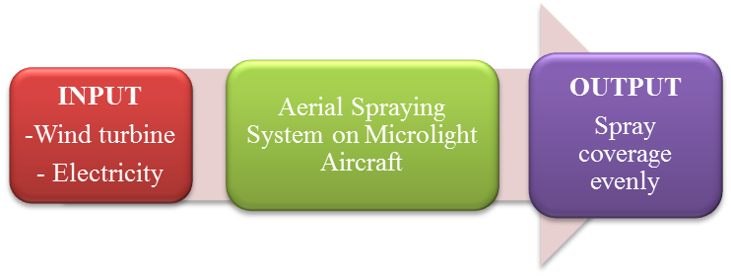
Figure 1. Black box of crop sprayer system on microlight aircraft.

  - Concept Generation by Morphological Chart
A morphological chart is a table based on the function analysis. It is recommended to generate several feasible designs by using different mechanisms for each function of the proposed concepts. The morphological chart enables these solutions to be expressed and provides the structure for considering alternative combinations. This can enable the early consideration of the product architecture through the generation and consideration of different combinations of sub-solutions that have not previously been identified [3]. Table 1 shows the morphological chart of aerial spraying system where it provides options for types and material for the six components of the aerial spraying system which are tank, pump, boom, control valve, spray nozzle and power source.

  - Concept Generation by Brainstorming
Brainstorming is a group creativity technique by which efforts are made to find a conclusion for a specific problem by gathering a list of ideas spontaneously contributed by its members. Analysis, discussion, or criticism of the proposed ideas is allowed when the brainstorming session is over and evaluation session begins. Figure 3 shows the map concept of design product. Here we are focusing on five elements in the design process which are functionality, safety, innovative design, low cost and ergonomic.

Switch on
Convert mechanical to electrical.
Recirculation agitation back into the tank
Pump will keep running to maintain a vacuum in the boom to prevent dribble and loss of chemical while in flight
The control valve is operated by positive cable-control lever in cockpit and it will be manually operated.
The pump is driven by wind turbine propeller in the aircraft slip stream.
The valve directs the flow from the pump back into the tank through venture, which causes reduced pressure (due to acceleration of liquid) at venturi throat.
Provide emergency valve and can be activate if the valve cannot be function to turn off the sprayer
The flow-control screw used to limit the flow back to the tank.
Figure 2. The function structure of aerial spraying system.
  - Concept Evaluation
The concept evaluation stage represents the convergence stage of design development so we will start by evaluating the concepts developed for the lowest level of function decomposition. As we progress, we will begin to combine the best concepts into sub-systems and then to evaluate the sub-systems using the same procedures. Weighted rating method is technique used to rank the options from highest priority to lowest priority as indicated by the assigned values of Importance Weight. Table 2 shows the weighted rating method of the aerial spraying system design. The rating criteria included in Table 2 are for each map concept elements presented in Figure 3. By using weighted rating method, it is found that the maximum score is 4.61, therefore the combination 2 of the concept alternative is selected.
  - Concept Selection
Concept selection is the result of the best selection that is obtained from the weighted rating method which in our case it has the score of 4.61 as depicted in Table 2. The selected concept of the design of aerial spraying system is given in Table 2. The selected material for tank is polyethylene, wind driven centrifugal pump is used and controlled by 3-ways valve, stainless steel boom and single nozzle sprayer are selected.
  - Spraying Performance Calculation
The required capacity of the spray pump is the total rate of nozzle discharge required at a given swath width and rate of travel as shown in Eq. (1).
$$Q_{T}= \frac{SQ_{A}V}{600}$$ | (1)

where,

$$Q_{T} = Total output in litres per minute$$
$$Q_{A }= Applied rate in litres per hectare$$
$V = Aircraft velocity in kilometres per hour$
$S = Swath width in metres$

Table 1. Morphological chart of aerial spraying system.

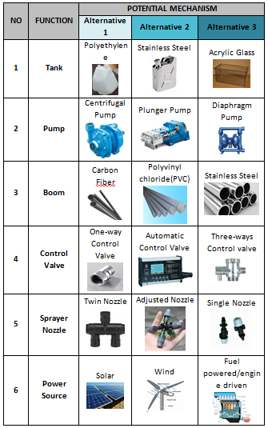
  - Design Sketching
As a tool or skill, sketching has its role in the design process. That role will vary depending on the end-product being created, the size and scope of the project, the individual designer's style, experience, and workflow, and the client's expectations [4]. Figure 4 shows the sketching of various views of the aerial spraying system that has been selected by using weighted rating method. In Figure 4(a), it shows the perspective view of the aerial spraying when attached on the microlight aircraft. Figure 4(b) shows the proposed wind-driven centrifugal pump that attached under the belly of the microlight. Figure 4(c) and 4(d) show the front and side views of the spraying system where the assembly of all components are clearly seen.

Figure 3. Map concept of aerial spraying system design.
Table 2. Weighted rating method of the design of aerial spraying system.
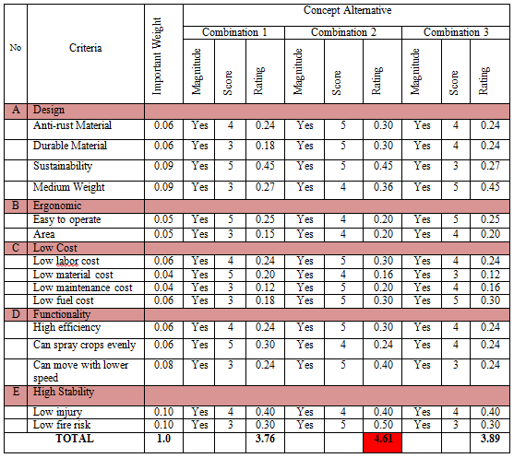

Table 3. Selected concept of the design of aerial spraying system.
NO | FUNCTION | SPECIFICATION
1 | Tank | Polyethylene
2 | Pump | Centrifugal Pump
3 | Power Source | Wind
4 | Control Valve | Three-ways control valve
5 | Boom | Stainless Steel
6 | Sprayer Nozzle | Single Nozzle

- Results and Discussion
  - Bill of Material (BOM)

Bill of materials or most often called as BOM is a list of parts, components, sub-assemblies and assemblies required in developing the product. The BOM is always the core for any manufacturing process as it provides all information required to build the product. Developed to provide manufacturing information, the Manufacturing Bill of Materials (MBOM) differs from the Engineering Bill of Materials, which is prepared to describe the design intent of the product [5]. Table 4 shows the list of components.
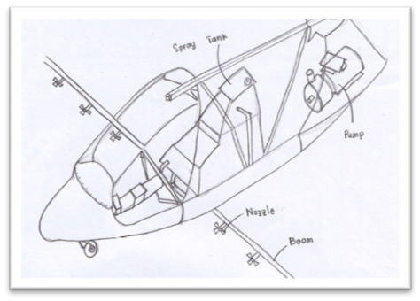  (a) Perspective view. | 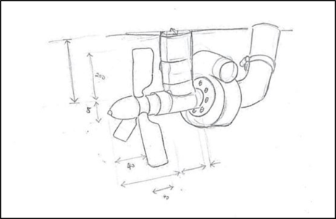  (b) Wind driven pump.
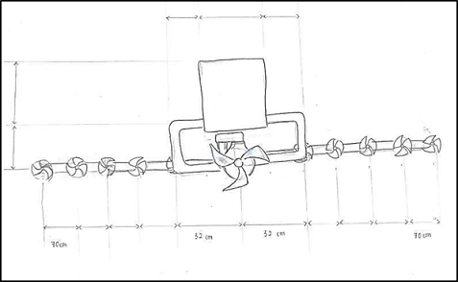  (c) Front view. | 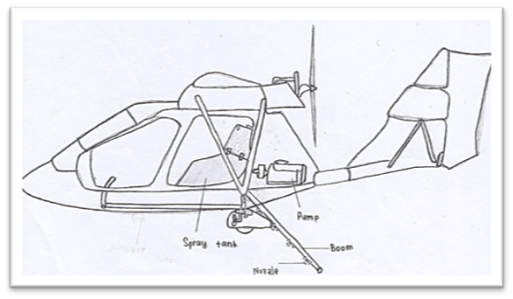  (d) Side view of assembly sketch.
Figure 4 The sketch of aerial sprayer system.

  - CAD Model and Design Review of Aerial Spraying System
A design review is a milestone within a product development process whereby a design is evaluated against its requirements in order to verify the outcomes of previous methods and identify issues before committing to and if need to be reprioritize for further work. The ultimate of design review, if successful would be triggers the product launch or product release. The conduct of design reviews is compulsory as part of design controls [6].
Table 4. List of components

No. | Components | Quantity
1 | Tank | 1
2 | Hose | 4
3 | Boom | 1
4 | Pump | 1
5 | Wind-driven Pump | 1
6 | Nozzle | 10
7 | Three-ways Valve | 1
8 | Emergency Valve | 1
9 | Clip | 4
10 | Atomizer | 10

Figures 8 to 14 show the computer-aided-design (CAD) model of the components for aerial spraying system developed by using Solidwork®. The tank shown in Figure 8(a) is designed to be able to carry 140 liters spraying liquid. The selection of tank capacity is based on the allowable microlight payload. It is designed in that shape in order to accommodate the rear seat of the microlight aircraft. The tank is secured in place by using existing seat harness on the rear seat. As stated previously, the material for the spraying tank should be polyethylene.

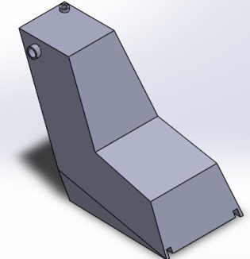  - Tank | 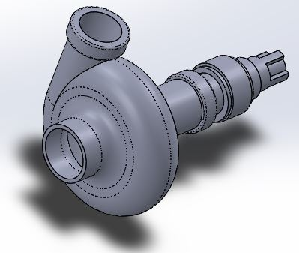  - Centrifugal Pump
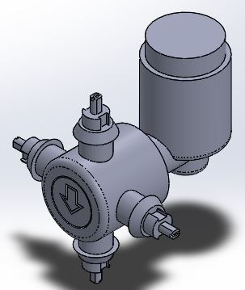  - Nozzle. | 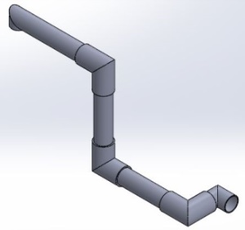  - Hose.
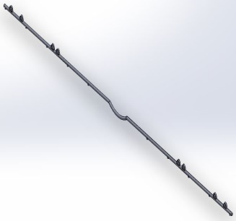  - Boom. | 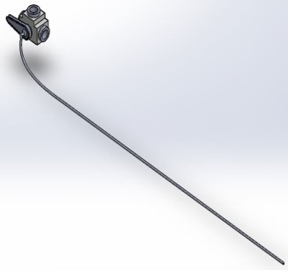  - Three-way control valve.
Figure 8. CAD Model of Aerial Spraying System.
  - Assembly Model of Aerial Spraying System
Assembly model is completed drawings that are put together after each of the aerial sprayer system parts is produced. It is the components combination drawings that shows an overview on how the system would be attached on the microlight aircraft as shown in Figure-15. The aerial sprayer system that is installed on this aircraft is user-friendly to setup and easily handled. The sprayer tank that replaced the rear seat eases the farmer to do the spraying without disassemble or reconfigure the existing aircraft system.

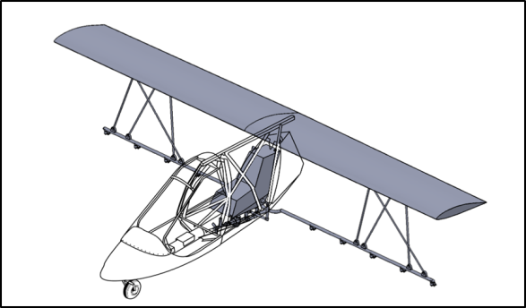
Figure 15. Assembly and position of aerial sprayer system on microlight aircraft.

  - Final Design Specification
The crops aerial sprayer that is to be attached on microlight aircraft has been designed to make the farmer getting easy to do their works on spraying. The spraying equipment are selected based on suitable criteria that have been analyzed. Table 5 shows the final design specification of the aerial sprayer.

Table 5. Final Design Specification

Criteria | Product Specifications
Performance | Produce a more uniform spray and has four types of spraying that can be changed without removing the nozzle.
Operation Temperature | 17°C to 40°C
Material | Fiber Glass, Carbon fiber, Nylon
Power Source | Air (Wind Turbine)
Maintenance | Less (E.g. : Filter conversion)
Safety | There is an open-close emergency valve that are made of materials that are not harmful
Ergonomic | Easy to operate, disassembled and assembled. Tank that can be separated.
User targets | Farmers who have acreage that is not too broad

- Conclusion and Recommendation

Design is a subject of vital importance. The preliminary design of aerial sprayer system for microlight aircraft project is intended to achieve the main objectives which are to increase the spray coverage area and improvement of existing spray equipment that available in the market.

This study set out to determine and solving the problems that has been faced by the farmers. The development of aerial sprayer system on microlight aircraft need to be followed by the right design methods. The idea of this design would be compared to the existing system used on typical light aircraft to identify the advantages and disadvantages of that system. The project can be summarized as follows;

- The spraying from the existing sprayer system is uneven and not fully sprays to the crops.
- Most of the aerial application providers are using a minimum, high horsepower turbine engine aircraft with high cruise speed of to carry out the task. Hence, fuel consumption, maintenance and cost of aircraft are relatively high.
- The hilly and large acreage of the farms cause a difficult process of spraying to the crops.
- The existing sprayer is difficult to assemble and dismantle.
- A conventional spraying process requires more labor to do the spraying.
- The knapsack sprayer is ineffective and does not have ergonomic features that can cause pain in the waist and back bone. Also, it could not accommodate the works in spraying on large acreage.

To identify the problems encountered, the proposed system is developed based on the methods of engineering design. The results obtained in the process of designing the aerial sprayer applied on microlight aircraft can be shown by;

- The use of the aerial spraying system on microlight aircraft can move at low speed and ease of spraying evenly on the crop.
- Microlight aircraft can usually land on a relatively small site to refill the chemical tank rather than flying back to an airport.
- The spraying works can be done in a short time so it will be more economic such as it will increase the crops in the country.
- The sprayer system development by wind turbine to run the pump will reduce the usage of fuel.
- Make a detailed drawings and matrix calculation to determine the types of material that is needed to design this aerial sprayer system.
- Less of workers are needed to handle the crop management when the aerial sprayer system is attached on microlight aircraft.

Finally, this study can conclude that the design of aerial spraying system for microlight aircraft has achieved the objectives. It also fulfills the farmer needs. This sprayer system is ergonomic compared than conventional spraying methods. Besides that, the aerial sprayer system on microlight aircraft will easily get a place in the market due to the needs of higher crop yield nowadays in addition to further facilitate the spraying process.
There are some suggestions that can be taken into consideration for improvements to enhance the operability and effectiveness of the attached spraying system. The suggestions include designing a liquid storage tank that can accommodate a large volume of liquid to avoid refilling work done in many times. In addition, the existing tank fastener can be replaced by the passenger belt with a sturdier and neat design. We can also create a design of aerial sprayer system that can be applied to several aircraft without changing the shape of the sprayer. Besides that, the idea of innovate the nozzles can be done by design it to have a multiple choices on the boom so it can be switch to any mode when to make spraying in a different conditions.

- References

- Silviculture Section, Ministry of Natural Resources and Forestry “Aerial Spraying for Forest Management” , Ontario, June 1991
- Spectrum Electrostatic Sprayers, Inc “Spectrum – Aerial Sprayer System” , Texas USA, 1987.
- James Moultrie, Design Management Group “Morphological Charts” , Cambridge
- Sean Hodge, “The Role of Sketching in Design Process” , Orlando. 2008.
- Alpesh Patel, Engineering Exchange, “Importance of Manufacturing Bill of Materials (MBOM)”, 2015.
- George E.Dieter, “Engineering Design-A Material and Processing Approach”, McGraw Hill, New York, 1999.
- Omar Z, Qiang KY, Mohd S and Rosly, “CFD Simulation of Aerial Crop Spraying”. In IOP Conference Series: Materials Science and Engineering Vol. 160, No. 1, p. 012028, 2016.
- A.A Wahab, “The Design of UTMAS-1 Spraying Mechanism For Microlight”, Universiti Teknologi Malaysia, Jurnal Teknologi, Bil. 28, p. 73-81, 1998.

Acknowledgments
The authors would like to acknowledge assistance or encouragement from colleagues, special work by technical staff or financial support from UTHM and Ministry of Higher Education. Specifically, this project is funded under Fundamental Research Grant Scheme Vot number 1548.

