Developing new designs of Tool Holder for Ultrasonic Vibration Assisted Turning in 2-dimensional using Finite Element Analysis
Rino Andias Anugraha^{1,2}, Rasidi Ibrahim¹, Haris Rachmat¹²,
¹FKMP UTHM, Parit Raja, Batu Pahat, Johor Bahru, Malaysia. 86400. rasidi@uthm.edu.my
²FRI Universitas Telkom, Jl. Telekomunikasi no. 1, Bandung, Indonesia. 40257. rinoandias@telkomuniversity.ac.id

Abstract. Machine design technology has changed rapidly in the past decade in response to ever more demanding machining process requirements in relation to supply high precision and high technology production. The aim of the research in this paper is to design and develop tool holder for ultrasonic vibration-assisted turning (UVAT) in two-dimensional. Finite Element Analysis models are used to predict the effect of vibration in tool holder design so that is it can be applied in two-dimensional UVAT. Three simulations are performed with ANSYS Workbench: Modal Analysis, Harmonic Vibration Response and Static Structure Analysis. Vibration has generated by using two piezoelectric that mounted orthogonally in body of tool holder to produce an elliptical trajectory in tool tip. In the harmonic vibration analysis and static structure simulation, force from piezoelectric to be used static load to get a prediction of tool tip displacement and Von Misses Criteria (stress tensile equivalent). Amount of tool tip displacement and von-Mises criteria determine the strength of tool holder design. Finally, the result of dynamic analysis of tool holder is discussed.
Keywords: tool holder design, two-dimensional UVAT, FEM
1 Introduction
Today, industry requires cutting machines that have produced quality of accuracy and surface roughness. Many new manufacturing technologies were developed to improve cutting quality. One of the technologies is cutting process by using ultrasonic vibration to assist machining. In many research, the ultrasonic vibration has proven to improve machining process quality, reduce cutting force, cutting temperature, improve surface roughness and tool wear.
Many research of Ultrasonic Vibration Assisted Machining (UVAM) have generated various cutting machines, namely: ultrasonic assisted grinding [8], ultrasonic assisted turning [1], ultrasonic assisted milling [11], Ultrasonic assisted drilling [6]. Previous studies have shown that tool life and surface roughness can improve levels compared with conventional machining [5]. Moriwaki, T. and Shamoto, E. (1995), successfully increase the beneficial the cutting process, more effective and reliable by using two-dimensional Ultrasonic Vibration Assisted Turning. I Rasidi et al., 2015 wrote the 2d-UVAM produced smaller and shorter chips because the tool motion operates with lower average force for much larger cumulative distance in repetitive passes [13], and cutting temperature will constant and reduced 30%-40% [14] its indicates 2D-UVAM can improve machining quality and tool wear.
There is a lot of technology that is used to generate elliptical trajectory in two-dimensional UVAT, which are orthogonal ultrasonic vibration [4], one driven ultrasonic vibration [5], parallel ultrasonic vibration [7], rotary ultrasonic vibration, form V ultrasonic vibration [3], and 3D vibration [9]. It is believed that there are potential to design new tool holder for two-dimensional ultrasonic vibration assisted turning.
This paper reports the design and development of tool holder with a focus on two-dimensional UVAT in orthogonal cutting. The dynamic behaviour of a test tool holder is investigated using modal analysis. The configuration tool holder as an Ultrasonic Vibratory Tool (UVT) is analysed to find the natural frequencies to determine these frequencies to avoid the resonance effect during vibration assisted machining. The Finite Element Analysis approach is utilized to model UVT assembly, stiffness of the material and other factor to study and improve the design.

2 Principle of EVC
Two-dimensional vibration produces from two piezoelectric vibrates in different phase, so that tool tip trajectory in a circular or ellipse shape, it depends on both of amplitude (Y-axis and Y-axis). When both amplitude is equal, then the tool tip trajectory will be circular or elliptical-shaped when they differ. In many studies, piezoelectric applied vibrating resource because it has a small size, capable of generating large forces and its tiny deformation, so it is simply mounted.

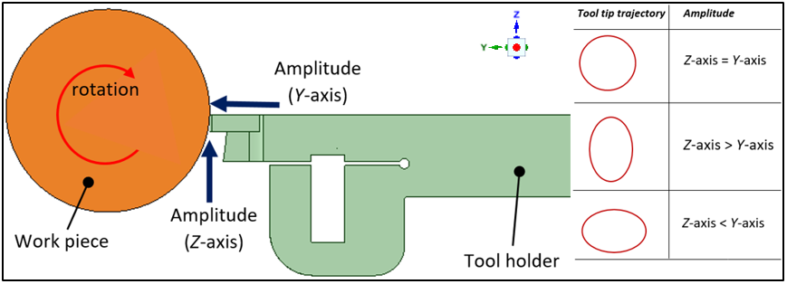
Fig. 1. Schematic of EVC Principle

The tool tip moves elliptically with high frequency (f) with large amplitude (a) and small amplitude (b) the direction of consumption. The movement that formed on the ellipse tool tip vibration. At the same time, there is the speed of the cut so that the relative motion of the V_{t} of tool orthogonal EVC can be described as follows [10]:

$x_{tool\left(t\right)}=a\cos\left(2πft\right)$ (1)
$y_{tool(t)}=b\sin{(2πft)}$ (2)
and relative motion of tooltip are:
$x_{\left(t\right)}=V_{t}+a\cos\left(2πft\right)$ (3)
$y_{(t)}=b\sin{(2πft)}$ (4)

a and b are the amplitudes tool tip tanks caused by a vibrating piezoelectric thrust in the direction of the x-axis and z axis-orthogonal basis.

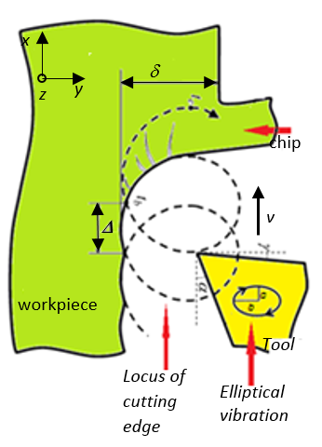
Fig. 2. Illustration of the EVC process [4]
3 Methodology
In this study developed tool holder designs will be used orthogonal two-dimensional ultrasonic vibration turning experiments. On the stem of tool holder added two piezoelectric used as vibration generator. To enlarge displacement on a tool tip, then created a design which is a flexure-hinges. Geometry and dimension of tool holder can be seen at Fig. 2 and 3 below. The first piezoelectric put perpendicular with the tool insert. The second is in the behind of tool insert, so force from piezoelectric can push directly, parallel with depth of cutting. Flexure hinges put in front of the first piezoelectric to strengthen piezoelectric block force.

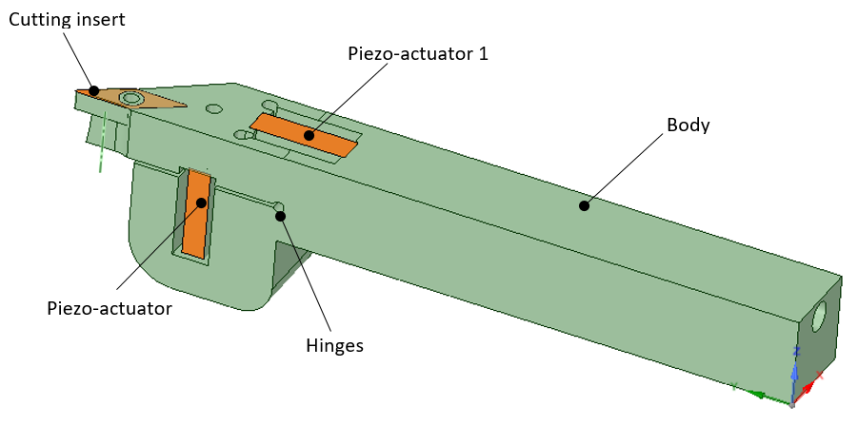
Fig. 3. Ultrasonic Vibratory Tool Holder in-3D

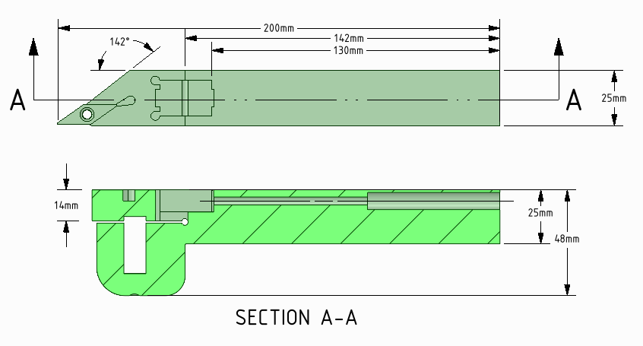
Fig. 4. Shape and dimension of tool holder design

The material used to make the tool holder is AISI 1045. AISI 1045 steel is appropriate weldability, machinability, high strength and impact properties in either the normalized or hot rolled condition and the tool insert use Carbide type VNMG 160408PM. AISI 1045 has ultimate strength 565 MPa, Yield Strength 310 MPa, Modulus of Elasticity 200 GPa, Poisson Ratio 0,290, density 7,87 g/cc. The simulation is performed a finite element modelling by using ANSYS Workbench. External force applied maximum block force of piezoelectric type PP 114 10 M from Cedrat (1000 N).
The Finite Element analysis and simulation method was used to determine the hidden characteristic of the tool holder. The analysis results were used to check the conformance of tool holder for design modification. To provide robust data, simulation was performed using ANSYS Workbench in 3D-Simulation including dynamic analysis, frequency response function analysis and static analysis.
The static analysis investigated the influence of load from block force piezo-actuator on tool tip when the tool holder is in static condition. Fix support placed in top and base and two of load put in the body of tool holder (see Figure 5). Tool tip displacement (in X and Y-axis) and equivalent stress criteria (Von Misses Criteria) will be analysis to determine stiffness of tool holder.
Dynamic load generated during a machining process directly affect the machining tool and influences the machining quality. Modal analysis was performed to investigated modes dynamic behaviour, mode shapes and natural frequencies of tool holder. The simulation assumed that the tool holder has linear behaviour, stable hardness and rigid-body motion, the load acting instead of time varying. Private frequency will depend on the degree of stiffness and mass of the material used [4]. The stiffness of the material is determined by the modulus of elasticity (Young Modulus).
The third simulation was performed harmonic response vibration analysis in frequency range between 15000Hz-25000Hz. To obtain high accuracy results of simulation then the mesh set in ‘fine’ level with 16311 nodes and 9190 elements.

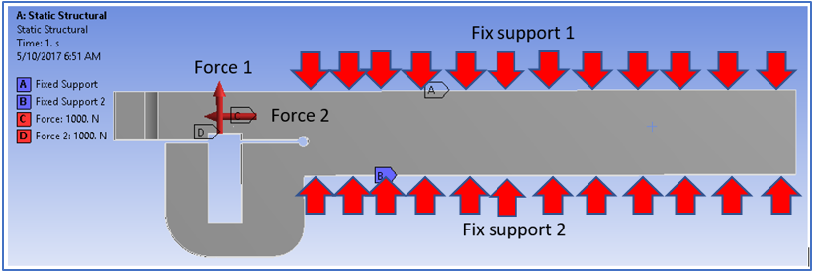
Fig. 5. Simulation Setting
5 Simulation Result
To analyse the static simulations results, the maximum displacement in Z-axis and Y-axis and equivalent tensile stress (von-Mises Criteria) have taken. Then dynamic analysis take several mode shape natural frequency and frequency response to check the tool holder behaviour when applied vibration from piezo-actuator.
5.1 Static structure analysis
According to the static simulation result, the equivalent tensile stress (von-Mises) is 244,5 MPa, that it located in left and right part of flexure hinges (see Fig. 6). Whereas the Yield Strength of the tool holder material is 300-450 MPa, so that it’s still under Yield Strength AISI 1045. This condition indicated that tool holder will not destruct when load applied.
Static analysis also produces displacement in tool tip in Z and Y-axis. The displacement should be measured in separate direction to check the direct influence of each piezo-actuator. According to the simulation, the displacement in the Z-axis (48,3 µm) is very larger than the displacement in Y-axis (2,63µm). That’s because the force from second piezo-actuator produce large moment and cause high deflection, so the ellipse-shape in tool tip will form as the third ellipse type. (Fig. 1, amplitude in Z-axis > Y-axis).

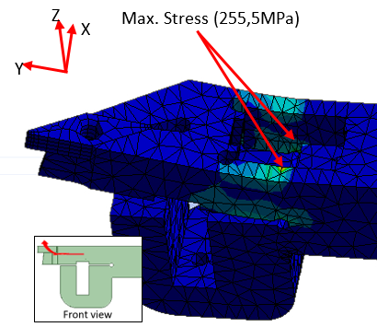
Fig. 6. Equivalent Tensile Stress (von-Mises)

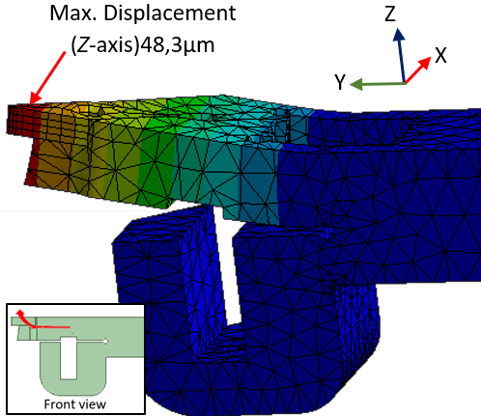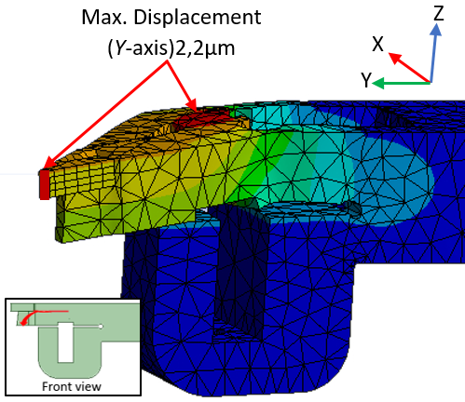
Fig. 6. Maximum displacement in static simulation
5.1 Dynamic analysis
Dynamic analysis is performed to find natural frequency and shape-mode of tool holder that must avoid when tool holder operated. The further understand to the natural frequency will affect machining performance and its very important for future analysis to predict the surface roughness including a frequency response function [12]. And, it was found from simulation the shapes of the modes of the tool holder: first mode at 2712 Hz (both of part: bending up-down), second mode at 2917 Hz (top part: bending up-down), third mode at 3082 Hz (top part : bending left-right) and fourth mode at 4535 Hz( bottom part : bending up-down). Based on the results of the simulation have been performed, critical vibration does not occur on areas of operation in ultrasonic vibration. Two-dimensional UVAT set the frequency between 20000 Hz - 23000 Hz. Figure 8 shows the captured image from the ANSYS Workbench for Modal and natural frequency simulation.

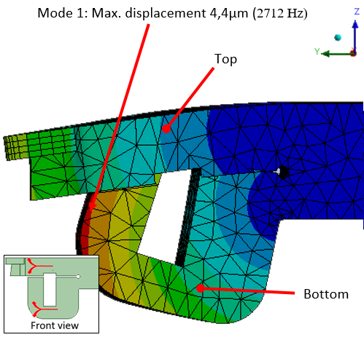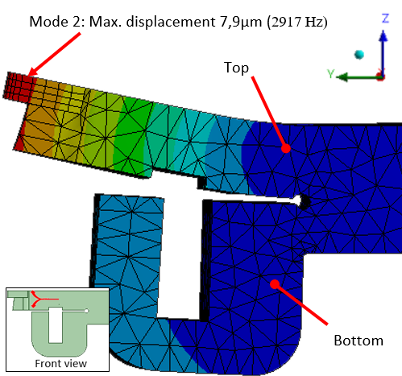
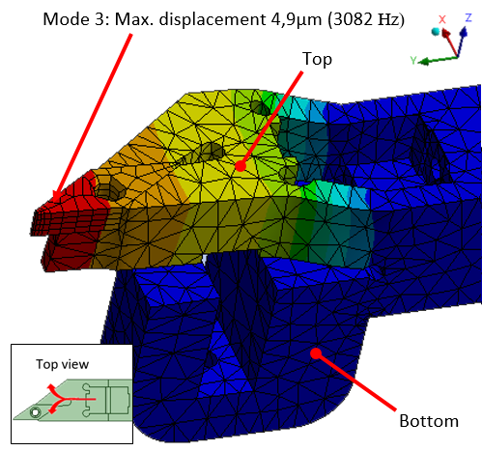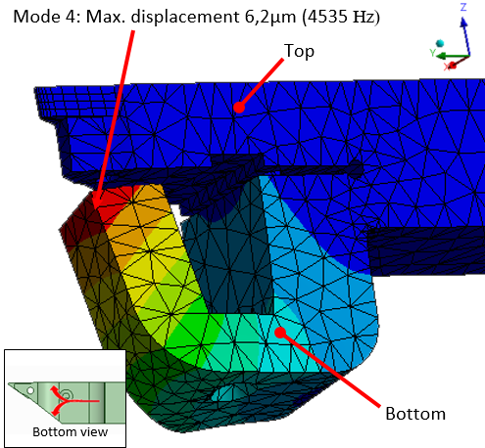
Fig. 8. Several modes natural frequency (rigid body displacement)
Then the next dynamic simulation is harmonic frequency response simulation test to obtain harmonic response of tool holder design when it influenced by external dynamic load. External load taken from the vibration produced by piezo-actuator (set between 0 – 23.000Hz) to analyse the critical frequency. Critical frequency must be avoided because the interference in critical frequency will correspond with machining process accuracy. From simulation was found that harmonic response occurs at frequency: 7.819Hz, 8223Hz, 11.322Hz, 13.012Hz, 14.346Hz, and 14.863Hz. The peak of frequency response deformation curve appears at 14.863Hz, while the amplitude of displacement is 69,8µm.

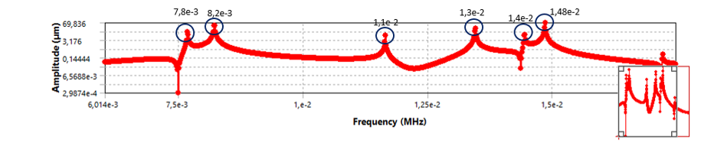
Fig. 7. Harmonic Response Analysis

6 Conclusion
Two-dimensional UVAT need to be performed at vibration that avoid natural frequency resonance of the tool holder. Finite element simulation shows both static and dynamic simulation presented: maximum equivalent tensile stress (Von-Mises criteria) below from yield strength of tool holder, its proof that design of tool holder has high stiffness. Design of tool holder also obtain trajectory tool tip in elliptical-shape with the Z-axis amplitude > than amplitude in Y-axis.
According to the dynamic simulation, the tool holder design has natural frequency and frequency response in the outer range of operating frequency in two-dimensional UVAT. It shows that tool holder design enable operate with vibration from piezo-actuator as external load.
For the future research can be simulate in conventional cutting process for obtain the comparison with the static and dynamic simulation. Tool holder design should produce perfect cutting chip in machining process. Second, the tool holder design be modified in flexure-hinge form for piezo-actuator in Y-axis, so that it can produce higher amplitude.

7 References
- Ahmed, N. (2013) ‘Ultrasonically assisted turning: Effects on surface roughness’, World Applied Sciences Journal, 27(2), pp. 201–206.
- Amini, S., Soleimanimehr, H., Nategh, M. J., Abudollah, A. and Sadeghi, M. H. (2008) ‘FEM analysis of ultrasonic-vibration-assisted turning and the vibratory tool’, Journal of Materials Processing Technology, 201(1–3), pp. 43–47.
- Asumi, K., Fukunaga, R., Fujimura, T. and Kurosawa, M. K. (2009) ‘Miniaturization of a V-shape transducer ultrasonic motor’, Japanese Journal of Applied Physics, 48(7 PART 2), pp. 1–5.
- Bai, W., Sun, R., Gao, Y. and Leopold, J. (2016) ‘Analysis and modeling of force in orthogonal elliptical vibration cutting’, International Journal of Advanced Manufacturing Technology, 83(5–8), pp. 1025–1036.
- Brehl, D. E. and Dow, T. A. (2008) ‘Review of vibration-assisted machining’, Precision Engineering, 32(3), pp. 153–172.
- Chern, G. L. and Lee, H. J. (2006) ‘Using workpiece vibration cutting for micro-drilling’, International Journal of Advanced Manufacturing Technology, 27(7–8), pp. 688–692.
- Kim, G. D. and Loh, B. G. (2007) ‘An ultrasonic elliptical vibration cutting device for micro V-groove machining: Kinematical analysis and micro V-groove machining characteristics’, Journal of Materials Processing Technology, 190(1–3), pp. 181–188.
- Li, K.-M., Hu, Y.-M., Yang, Z.-Y. and Chen, M.-Y. (2012) ‘Experimental Study on Vibration-Assisted Grinding’, Journal of Manufacturing Science and Engineering, 134(4), p. 41009.
- Lin, J., Lu, M. and Zhou, X. (2016) ‘Development of a Non-Resonant 3D Elliptical Vibration Cutting Apparatus for Diamond Turning’, Experimental Techniques, 40(1), pp. 173–183.
- Moriwaki, T. and Shamoto, E. (1995) ‘Ultrasonic Elliptical Vibration Cutting’, CIRP Annals - Manufacturing Technology, 44(1), pp. 31–34.
- Shen, X. H., Zhang, J., Xing, D. X. and Zhao, Y. (2012) ‘A study of surface roughness variation in ultrasonic vibration-assisted milling’, International Journal of Advanced Manufacturing Technology, 58(5–8), pp. 553–561.
- Ibrahim, R., Bateman, R., Cheng, K., Wang, C. and Au, J. (2011) ‘Design and analysis of a desktop micro-machine for vibration-assisted micromachining’, Proceedings of the Institution of Mechanical Engineers, Part B: Journal of Engineering Manufacture, 225(8), pp.
- I Rasidi, I., Rafai, N. H., Rahim, E. A., Kamaruddin, S. A., Ding, H. and Cheng, K. (2015) ‘An investigation of cutting mechanics in 2 dimensional ultrasonic vibration assisted milling toward chip thickness and chip formation’, IOP Conference Series: Materials Science and Engineering, 100, p. 12057.
- Ibrahim, M. R., Rahim, Z., Rahim, E., Tobi, L., Cheng, K. and Ding, H. (2017) ‘An Experimental Investigation of Cutting Temperature and Tool Wear in 2 Dimensional Ultrasonic Vibrations Assisted Micro-Milling’, MATEC Web of Conferences, 95, p. 7005.

