Modelling of Rigid Walled Enclosure Couple to a Flexible Wall using Matlab and Ansys APDL
I Zaman^{1,2,a}, S A M Rozlan², N A Azmir², M Ismon², M A Madlan², M N Yahya², M H Zainulabidin², M S M Sani³, M F M Noh⁴
¹Mechanical Failure Prevention and Reliability Research Centre, Universiti Tun Hussein Onn Malaysia, 86400 Batu Pahat, Johor, Malaysia
²Noise and Vibration Analysis Research Group, Faculty of Mechanical and Manufacturing Engineering, Universiti Tun Hussein Onn Malaysia, Johor, Malaysia
³Automotive Engineering Centre, Universiti Malaysia Pahang, 26600 Pekan, Pahang, Malaysia
⁴Kolej Kemahiran Tinggi MARA Kuantan, KM8 Jalan Gambang, 25150 Kuantan Pahang, Malaysia
E-mail: izzuddin@uthm.edu.my

Abstract. Generally, solutions to improve the noise problems in enclosure are to redesign or modifying the system such as increasing the thickness of the wall panels, enhancing the elasticity of the structure, and increase the damping mechanism of the wall structure. In this paper, the application of vibroacoustic modelling of enclosure coupled to a flexible wall was presented. The sound pressure characteristics of rigid walled enclosure, such as natural frequency and mode shape were determined using two approaches which are finite element simulation of Ansys® and mathematical model. The mathematical equations derived in Matlab® such as rigid walled enclosure and rigid walled enclosure coupled to flexible wall were used to validate finite element analysis (FEA). The result indicates that the theory and FEA display in a good agreement. Thus, proved that the FE model was accurate and can be applied in further research such as sound pressure and noise attenuation in enclosure.

Keywords: Sound, Plate, Vibration, Simulation, Mathematical Model
1. Introduction

These days, noise and vibration has turned into a vital issue for modern society to find a better life satisfaction. This in turn makes vibration and acoustic characteristics as the critical criteria to be examined and considered in many engineering design issues. For instance, in the car and aviation industries, the level of vibration and noise has become an important asset in manufacturing because of its impact on passenger comfort [1].
Theoretically, noise in real applications mostly involves structural vibration generating sound waves. This combination is known as vibroacoustic. Vibroacoustic study shows that when an elastic structure is in contact with the liquid, the structural vibration and acoustic pressure in the fluid are influenced by the mutual vibroacoustic coupling interaction [2]. Despite the fact that these issues have been known from time to time [2-4], there is an absence of studies in the field of vibroacoustic especially when it comes to modeling analysis.
Lately, vibroacoustic is observed to be a major contributor to health disorders. These disorders are basically due to the vibration and noise occurring simultaneously. The effect of vibration can cause sleeping deprivation, exhaustion and headache soon after or during exposure [5]. The symptoms are the same as many people experience after a long boat or car trip. After consistent exposure every day for several years, whole body vibration can affect the entire body and cause several health disorders. For example, sitting in the ship or sea vehicles can cause motion sickness when vibration exposure happens in the frequency range of 0.1-0.6 Hz [5]. Studies of bus drivers have discovered that exposure to whole body vibration may contribute to muscle and circulatory problems, breathing and back pain. The joined effects of body posture, postural fatigue, dietary habits and whole-body vibration are the possible reasons for these problems.
Research shows that whole body vibration can increase oxygen uptake, heart rate, respiratory rate, which in turn, can prompt changes in blood and urine [6]. For some other cases, the effect of noise affects the hearing organs (cochlea) in the inner ear. That is why noise-induced hearing loss is indeed sensory neural type of hearing loss. The workers in noisy environments who are also exposed to vibration (for example, a person operating a jack hammer) may experience hearing loss greater than those exposed to a similar level of noise but not to vibration [7].
Therefore, this paper expects to preseent the problem solving of vibroacoustic system of rigid walled enclosure coupled to a flexible wall by using analytical approach plotted in Matlab and finite element analysis of Ansys. Similir to our previous analytical modelling study [8-10], the result of this review will give a supportive reference to future analysts who adapt an approach to minimize the sound pressure level of rigid walled enclosure attached to a flexible wall.

2. Modelling

This section describes the parametric study of rigid walled enclosure with a flexible wall and determination of a mathematical model which permits the estimation of sound pressure in enclosure attached to a flexible wall.

2.1 Parametric Study

Figure 1 shows the schematic diagram of rigid walled enclosure with attached a flexible wall. Force is applied on the flexible wall at the coordinate (1, 0.1, 0.1) m, while sound pressure, P is measured at the coordinate (0, 0.5, 0) m. The parameters of enclosure, air and flexible wall used in this analysis are shown in Tables 1.

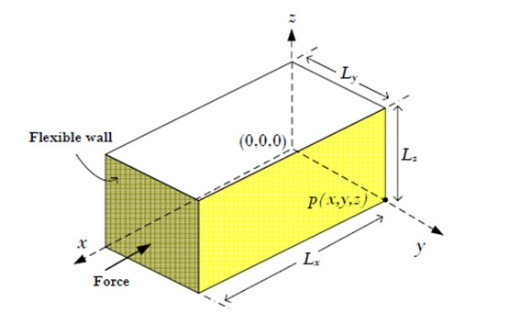
Figure1. Schematic diagram of rigid walled enclosure with a flexible wall

Table 1. Parameters applied in the analysis of an enclosure with a flexible wall
Medium | Parameters | Description | Value | Units
Enclosure | L_{x} | Length | 1.0 | m
Enclosure | L_{y} | Width | 0.5 | m
Enclosure | L_{z} | Height | 0.3 | m
Air | ρ_{a} | Density | 1.21 | kg/m³
Air | c | Speed of sound | 344 | m/s
Flexible wall | B | Width | 0.2 | m
Flexible wall | h | Thickness | 1.0 x 10⁻² | m
Flexible wall | E | Young’s modulus | 2.1 x 10¹¹ | GPa
Flexible wall | v | Poisson ratio | 0.3 | -
Flexible wall | ρ | Density | 7.85 x 10³ | kg/m³
Flexible wall | ζ | Damping ratio | 1 | %

2.2 Mathematical Derivation

The acoustic pressure, p at x inside the enclosure and the structural vibration velocity, u at y are given by [11,12]:
$p(x)=\sum_{n}{a_{n}(ω)ψ_{n}(x)}$ (1)
$u(y)=\sum_{m}{b_{m}(ω)ψ_{m}(y)}$ (2)

where Ψ_{n}(x) and a_{n}(ω) are the amplitude of uncoupled acoustic mode shape function and acoustic pressure and, respectively. Similarly, Ψ_{m}(y) and b_{m}(ω) are the respective complex amplitude of uncoupled vibration mode shape function and vibration velocity

The amplitude of the n^{th} acoustic mode is shown as in Eqn. (3) [11,12].
$a_{n}(ω)=\frac{j{\text{ωρ}}_{a}c^{2}}{Λ_{n}(ω_{n}^{2}−ω^{2}+2{jξ}_{n}ω_{n}ω)}×\left[\int{q_{\text{vol}}ψ_{n}\text{dV}−}\int{u_{n}ψ_{n}\text{dS}}\right]$ (3)

where $Λ_{n}=\int{ψ_{n}^{2}(x)\text{dV}}$, ω_{n} and ξ_{n} are the natural frequency and damping ratio of the n^{th} acoustical mode Ψ_{n}, respectively, ρ_{a} is the fluid density, c is the speed of sound in fluid, q_{vol} is the volume velocity of sound source and u_{n} is the vibration velocity of structure.

In this case, the damping ratio of enclosure is neglected and the volume speed of sound source is not considered for this study. Thus, Eqn. (3) can be further improved as given by:
$a_{n}(ω)=\frac{j{\text{ωρ}}_{a}c^{2}\int{u_{n}ψ_{n}\text{dS}}}{Λ_{n}(ω_{n}^{2}−ω^{2})}$ (4)

Meanwhile, the amplitude of the m^{th} structural mode is given by [12,13]:

$b_{m}(ω)=\frac{jω}{M_{m}(ω_{m}^{2}−ω^{2}+2{jζ}_{m}ω_{m}ω)}×\left[\int{p_{m}ψ_{m}\text{dS}−}\int{F_{m}ψ_{m}\text{dS}}\right]$ (5)

where $M_{m}=\int{ψ_{n}^{2}\text{dS}}$, ω_{m} and ζ_{m} are the natural frequency and damping ratio of the m^{th} simply-supported wall mode Ψ_{m}, respectively, p_{m} is the pressure on the surface of the flexible wall and F_{m} is the external force imposed on the flexible wall.

By employing mode summation method, the amplitude of the n^{th} acoustic mode can be written as [11]:

$a_{n}(ω)=\frac{j{\text{ωρ}}_{a}c^{2}}{Λ_{n}(ω_{n}^{2}−ω^{2})}\left[−\sum_{m=1}^{∞}{b_{m}(ω)C_{\text{mn}}}\right]$ (6)

Likewise, by employing mode summation method, the complex amplitude of the m^{th} structural mode is simplified as [13]:

$b_{m}(ω)=\frac{jω}{M_{m}(ω_{m}^{2}−ω^{2}+2{jζ}_{m}ω_{m}ω)}×\left[\sum_{n=0}^{∞}{a_{n}(ω)C_{\text{mn}}−\sum_{m=1}^{∞}{F_{m}ψ_{m}}}\right]$ (7)

where C_{mn} is defined in Eqn. (8) as the modal coupling between the the structural mode and acoustic mode [13]:
$C_{\text{mn}}=\int{ψ_{n}ψ_{m}\text{dS}}$ (8)

The analytical solution for the modal coupling between acoustic mode and the structural mode has been derived by [13], and it is given as follows:

$C_{\text{mn}}=2(−1)^{n_{3}}S\sqrt{ε_{n_{1}}ε_{n_{2}}ε_{n_{3}}}\left\{\frac{m_{1}}{n_{1}^{2}−m_{1}^{2}}\right\}\left\{\frac{m_{2}}{n_{2}^{2}−m_{2}^{2}}\right\}\left\{\frac{−1^{n_{1}+m_{1}}−1}{π}\right\}\left\{\frac{−1^{n_{2}+m_{2}}−1}{π}\right\}$ (9)

where n₁,n₂ and n₃ defines cavity modal integers, m₁ and m₃ are the structural modal integers and ε_{n1}, ε_{n2} and ε_{n3} are the normalization factors. By solving equation above, the sound pressure inside the enclosure with attached flexible wall can be determined.

3. Result and Discussion

In this study, the analytical equation shown before was plotted using Matlab® and later was validated with numerical analysis of Ansys®. Figure 2 displays the results of sound pressure level in an enclosure with attached a flexible wall when the wall is imposed by a point force, at different discrete frequencies varied from 0 to 500 Hz with 1 Hz step size. There are 400 structural modes and 1000 acoustic modes were applied in the mode superposition method in Matlab® in order to get an accurate outcomes. Once more, for this analysis, it is discovered that Matlab® and Ansys® results accomplishes a better agreement when the finite element model of the enclosure was discretised into an adequate number of elements and substeps. The frequency modes are identified in the frequency range of 0 to 500 Hz which represented by the total number of the peaks [14].
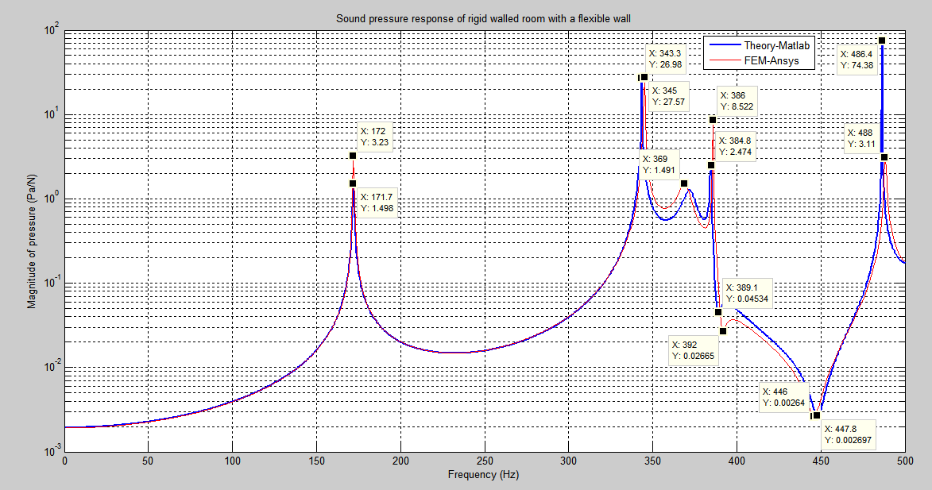
Figure 2. Magnitude of sound pressure response in a rigid walled cavity with flexible wall

Table 2 indicates the mode frequency values of rigid walled enclosure with a flexible wall obtained from theoretical model and numerical Ansys®. The outcome shows that the percentage error between theoretical model and numerical Ansys® is too small which less than 10%, thus can be negligible. Meanwhile, Figure 3 shows the characteristics mode shape of rigid walled enclosure with a flexible panel that obtained from the modal analysis of Ansys®.

Table 2. Errors of rigid walled enclosure with a flexible wall between theory and FEM
Mode n^{th} | Ansys® | Matlab® | Error (%)
1 | 172 | 171.7 | 0.17
2 | 345 | 343.3 | 0.49
3 | 369 | 372 | 0.81
4 | 386 | 384.8 | 0.31
5 | 392 | 389.1 | 0.73
6 | 446 | 447.8 | 0.40
7 | 488 | 486.4 | 0.33

Figure 3. Mode shape of enclosure with a flexible wall

5. Conclusion

This paper attempted to predict the sound pressure of a rigid walled enclosure with a flexible wall by deriving the mathematical model. Matlab® was used for plotting the analytical analysis while Ansys® for numerical analysis. The result shows that the error difference between both methods are below 1% which can be neglected. Thus, this prove the theoretical as well as numerical model prediction can be used for the other research related.

Acknowledgements
The authors wish to acknowledge Ministry of Higher Education Malaysia and Research, Innovation, Commercialization and Consultancy Management, Universiti Tun Hussein Onn Malaysia for the partial support under Fundamental Research Grant Scheme (FRGS) vote 1546.

References

[1] Jang H-K and Griffin M 2000 Effect of phase, frequency, magnitude and posture on discomfort associated with differential vertical vibration at the seat and feet. Journal of Sound and Vibration 229 273-286
[2] Zhou Q and Wang D 2015 Vibro-acoustic coupling dynamics of a finite cylindrical shell under a rotor-bearing-foundation system׳ s nonlinear vibration excitation. Journal of Sound and Vibration 347 150-168
[3] Li Y, Wang X, Huang R and Qiu Z 2015 Active vibration and noise control of vibro-acoustic system by using PID controller. Journal of Sound and Vibration 348 57-70
[4] Conlon S C, Fahnline J B and Semperlotti F 2015 Numerical analysis of the vibroacoustic properties of plates with embedded grids of acoustic black holes. The Journal of the Acoustical Society of America 137 447-457
[5] Burdzik R and Konieczny Ł, Application of vibroacoustic methods for monitoring and control of comfort and safety of passenger cars. in Proceedings of the Solid State Phenomena, 2014, p. 20-25.
[6] Nassiri P, Ebrahimi H, Monazzam M, Rahimi A and Shalkouhi P J 2014 Passenger noise and whole-body vibration exposure—a comparative field study of commercial buses. Journal of Low Frequency Noise, Vibration and Active Control 33 207-220
[7] Stansfeld S, Brown B and Haines M 2000 Noise and health in the urban environment. Reviews on environmental health 15 43-82
[8] Zaman I, Rozlan S A M, Yusoff A, Madlan M A and Chan S W 2017 Theoretical modelling of sound radiation from plate. IOP Conference Series: Materials Science and Engineering 166 012023
[9] Rozlan S A M, Zaman I, Manshoor B, Khalid A, Chan S W and Sani M S M 2016 Theoretical modelling of a beam with attached spring-mass-damper system MATEC Web of Conferences 90 01030
[10] Salleh M M and Zaman I 2016 Finite element modelling of fixed-fixed end plate attached with vibration absorber. ARPN Journal of Engineering and Applied Sciences 11 2336-2339
[11] Fahy F J and Gardonio P 2012 Sound and structural vibration: radiation, transmission and response (UK: Academic press)
[12] Hansen C, Snyder S, Qiu X, Brooks L and Moreau D 2012 Active control of noise and vibration (CRC Press)
[13] Fahy F J 2000 Foundations of engineering acoustics (Academic press)
[14] Zaman I, Salleh M M, Ismon M, Manshoor B, Khalid A, Sani M S M and Araby S 2014 Study of passive vibration absorbers attached on beam structure. Applied Mechanics and Materials 660 511-515

