A study on tensile deformation at room temperature and 650 ºC in the directional solidified Ni-base superalloy GTD-111
AA Pauzi¹, MH Abdul Ghaffar², SY Chang³, GP Ng⁴, S Husin⁵
^{1,2,4,5} Materials Engineering Group, TNB Research Sdn Bhd, Kawasan Institusi Penyelidikan dan Latihan Bangi, 4300 Kajang, Selangor, Malaysia.
³ Korea Electric Power Research Institute (KEPRI), 105 Munji-Ro, Yuseong-gu, Daejeon, 34056, South Korea.
E-mails:afiqpauzi@tnb.com.my¹, hafiz.ghaffar@tnb.com.my², sychang@kepco.co.kr³, guatpeng@tnb.com.my⁴, shuib.husin@tnb.com.my⁵
Abstract. GTD-111 DS generally used for gas turbine blades is a high performance Ni-base superalloy. This alloy, with high volume of γ’ phase, has excellent tensile properties at high temperature. The effect of temperature on the tensile deformation of GTD-111 DS was investigated by using tensile test and microstructure evaluation of the fractured specimens. The tensile behaviour of GTD-111 DS was studied in the room temperature (RT) and 650 °C. From the yield strength results, the yield strength decreases from the average of 702.72 MPa to the average of 645.62 MPa with the increase of temperature from RT to 650 °C. The scanning electron microscope (SEM) results on fractured specimens confirmed that the tensile behaviour affected by deformation of the surface at 650 ºC compared to fractured surface at RT. Based on the laboratory testing results, the correlation between tensile deformation of fractured surface and yield strength were discussed.
- Introduction
Nickel base superalloys are widely used as the materials of gas turbine blades. These materials are selected for this application because of their excellent properties at elevated temperature. Directional solidified (DS) Ni-base GTD-111 was selected for this study. GTD-111 DS has a multi-phase microstructure containing of γ matrices, γ’ precipitates, γ-γ’ eutectics and a small amount of phases and carbides [1]. The fine shape of γ’ that provides this directional solidified GTD-111with excellent high temperature properties in comparison with other Ni-base alloys. The total amount of γ’ in GTD-111 DS is 60 – 70%. For this reason, the behavior of this alloy at high temperature depends on the amount γ’. With the increase of firing temperature for future advanced gas turbines, it is important to investigate and understand the behavior of GTD-111 DS as the superalloy mainly operates all of its lifetime at high temperatures during the operation [2]. Other than its capability to maintain excellent resistance at high temperature, this superalloy also has good oxidation resistance. These characteristics are the main reason for using this superalloy in severe and harsh operating condition of hot section gas turbine [3].
There are numerous studies have been carried out to investigate the deformation of GTD-111 at high temperatures. For materials researchers, it is important to study the mechanical properties of this alloy for high temperature gas turbine applications. One of the main laboratory life assessments of this alloy is by performing tensile test to investigate the strength of the materials at high temperature [4].
Previous work carried out by Sajjadi et al. [5] revealed that the behavior of this Ni-base superalloy is mainly depended by phase of γ’. The study also found that the yield strength decreased rapidly with the increase of temperature. In a study conducted by Yoon et al. [6], it showed that the yield strength increased with the increase of temperature up to 800 ºC. The yield strength then dropped with the increase of temperature more than 800 ºC. Lipski and Mrozinski [7] revealed that the value of yield strength normally decreases for high temperature, but the yield strength indicated different value in different temperature ranges. Another study on the temperature dependence of Ni-based alloys conducted by Zhang et al. [8], it stated the yield strength and elongation of this alloy attribute the variation to different deformation mechanisms at different elevated temperature.
The aim of this study was to investigate the temperature dependence of tensile properties of directional solidified Ni-based GTD 111at temperature 650 ºC. While previous literatures mainly focused on the temperature 800 ºC and more, this study has been focusing on strength of this material at the region between 25 ºC and 650 ºC. It is important to investigate the correlation between yield strength and tensile deformation structures at these temperatures. For this study, the room temperature at 25 ºC has been used as a reference.
- Experimental procedures
The elemental composition of the Ni-base superalloy was verified by using X-ray fluorescent. The chemical composition of the directional-solidified Ni-base superalloy is listed in Table 1.

Table 1: Chemical composition of GTD 111 (in wt %)
Ni | Cr | Co | Mo | Fe | W | Ta | Ti | Hf
60.65 | 14.60 | 9.93 | 1.78 | 0.78 | 4.48 | 2.77 | 4.37 | 0.20

The test specimens were fabricated from a rod according to ASTM E21. Tensile test were performed at two different temperatures, 25 ºC and 650 ºC at a constant strain rate of 10⁻⁴s⁻¹. At least five samples were tested at each temperature to obtain precise results. Microstructures of the tested samples were examined in a scanning electron microscope to analyse the degraded microstructure and investigate the deformation mechanisms.
- Results and discussion
The fractured surfaces of the GTD-111 DS superalloy from the tensile test were analysed to investigate the damage characteristics.
  - Variation of yield strength (YS) with temperature
Tensile test results for both temperatures are shown in Figure 1. For comparison, the yield strength of the alloys GTD-111 at room temperature (RT) and 650 °C are included. From the results, the yield strength decreases from the average of 702.72 MPa to the average of 645.62 MPa with the increase of temperature from RT to 650 °C. According to the previous works conducted by Sajjadi et al. [9] and Zhang et al. [8], the yield strength of directional solidified GTD-111 at RT should be higher than the yield strength at 650 °C. The detail explanations of this situation will be discussed in the next sections.

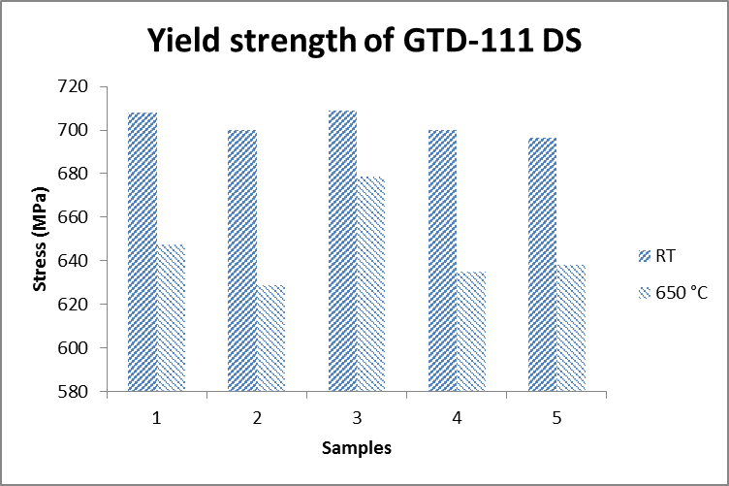

Figure 1: Yield strength of GTD-111 DS at RT and 650 °C
  - Tensile deformation
    - At low temperature. Figure 2 shows the fractured surface of one of the tensile samples at RT. The microstructure of the fractured sample is shown in Figure 3. From the micrograph image, the γ’ phase appeared in cuboidal shape. The shapes were uniform and the average size of the γ’ phase is between 0.5 µm to 1 µm. The γ’ phase shapes in the micrograph image exhibit similar deformation pattern at RT. In a study by Sajjadi et al. [5], there was no evidence of voids on the fractured surface. The author concluded that the cracks on the fractured surface are due to the brittleness of grain boundary. With the proof of no voids on the fractured surface, it also concluded that the cracks are not due to the void growth on the surface.

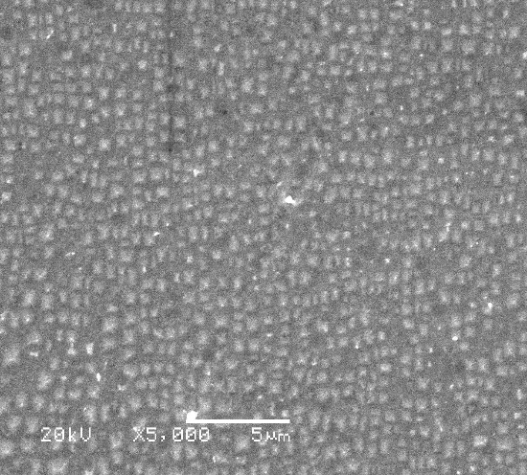
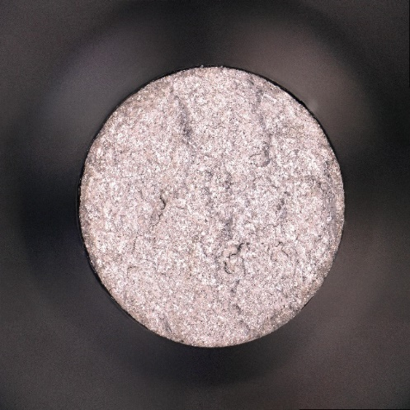
γ '

Figure 2: Fractured surface of tensile specimen Figure 3: Micrograph image of tensile specimen
at RT. at RT (X5000 magnification).
    - At high temperature. Figure 4 shows the fractured surface of one of the tensile samples at 650 °C. The microstructure of the fractured sample is shown in Figure 5. From the micrograph image, the γ’ phase appeared in elliptical shape. The γ’ began to degrade with the increase of temperature. The average size of γ’ at 650 °C increased between 1.5 µm to 3 µm. The cuboidal shape of γ’ that has been shown at RT totally elongated and showed non-uniform elliptical shape. Several previous studies by Sajjadi and Nategh[10] stated that, when γ’ began to degrade due to the exposure at high temperature, the size of γ’ increased, the γ’ began to elongate and changes the shape from cuboidal to elliptical or spherical.

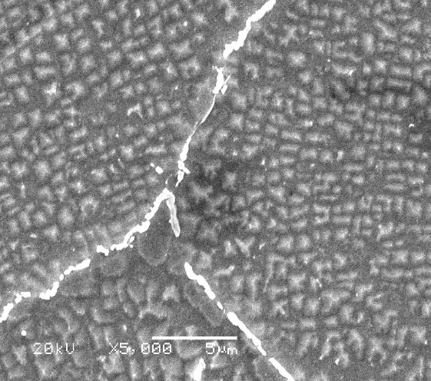
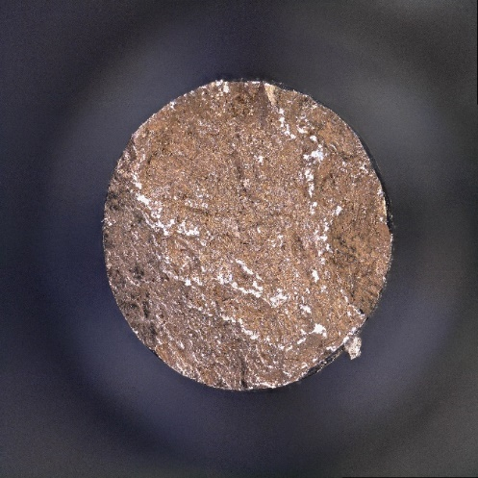
γ '

Fractured surface

Figure 4: Fractured surface of tensile specimen Figure 5: Micrograph image of tensile specimen
at 650 °C. at 650 °C (X5000 magnification).
  - Correlation between yield strength and tensile deformation structures
From the previous study undertaken by Wang et al., it is stated that the finer shape and higher volume of γ’, the higher the strength of this superalloy at high temperature. At the high temperature of 650 °C, it was found that the yield strength decreased from RT. At this temperature region, the γ’ has shown finer shape with huge volume of γ’, and this resulted in high yield strength of the specimen. When the test carried out at 650 °C, the γ’ precipitates began to expand their sizes due to exposure at high temperature, and this resulted in reduction of yield strength. This degradation process could also be classified as sphericalisation or coarsening of γ’phase. The tensile properties of GTD-111 DS depend on the condition of γ’ during the exposure at high temperature [11, 12]. From the decrement of yield strength less than 10% from RT to 650 °C, it showed that the GTD-111 DS superalloy could maintain its excellent tensile properties (strength) in high temperature environment for a certain period.
- Conclusions

- The SEM investigations revealed that the fractured tensile specimens indicated different deformations at RT and 650 ºC. The occurrence of different tensile deformation depends on the test temperature.
- The decrement of 10% yield strength from RT and 650 °C confirmed that GTD-111 DS alloys has excellent mechanical properties (strength) at high temperature.
- The effect of temperature on tensile deformation for GTD-111 DS superalloys could be investigated after yielding in the certain temperature range that was determined before carried out tensile test.
References

[1] S.A Sajjadi, S.M Zebarjad, “Effect of temperature on tensile fracture mechanisms of Ni-base
superlloy”, in International Scientific Journal (2007), Vol.28, Issue 1, pp 34-40.
Arman Dadkhah, Ahmad Keranpur, “On the precipitation hardening of the directionally solidified

[2] GTD-111 Ni base superalloy: Microstructures and mechanical properties”, in Materials Science
and Engineering (2017), Vol.685, pp.79-86.

[3] Baig Gyu Choi, In Soo Kim, Doo Hyun Kim, Chang Yong, “Temperature dependence of MC
decomposition behavior in Ni-base superalloy GTD 111”, in Materials Science and Engineering
(2007) ,Vol. 478, pp. 329-335.

[4] Z.J. Zhou, L. Wang, D. Wang, L.H. Lou, J. Zhang, “Effect of secondary orientation on room
temperature tensile behaviors of Ni-base single crystal superalloys”, in Materials Science and
Engineering (2006), Vol. 659, pp.130-145.

[5] Seyed Abdolkarim Sajjadi, Said Nategh, Mihaiela Isac, Seyed Motjaba Zebarjad, “Tensile
deformation mechanisms at different temperatures in the Ni-base superalloy GTD-111” in Journal
of Materials Processing Technology, Vol. 155-156.

[6] Kee Bong Yoon, Tae Gyu Park, and Ashok Saxena, “Elevated Temperature Fatigue Crack
Growth Model for DS-GTD-111”

[7] Adam Lipski, Stanisław Mroziński, “The Effects of Temperature On The Strength Properties Of
Aluminium Alloy 2024-T3” (2013).

[8] ASTM E21, “Standard Test Methods for Elevated Temperature Tension Tests of Metallic
Materials”, (2006).

[9] Seyed Abdolkarim Sajjadi, Said Nategh, Roderick I.L. Guthrie, “Study of microstructure and
mechanical properties of high performance Ni-base superalloy GTD-111” in Materials Science and
Engineering(2002) , Vol. 325, pp. 484-489

[10] S.A. Sajjadi, S. Nategh. “A high temperature deformation mechanism map for the high
performance Ni-base superalloy GTD-111”, in Materials Science and Engineering, Vol.307, pp.
158-164.

[11] S.A. Sajjadi, S.M Zeberjad, “Study of fracture mechanisms of a Ni-Base superalloy at different
Temperature” in Journal of Achievements in Materials and Manufacturing Engineering (2006),
Vol.18, pp.1-2.

[12] Leonid B. Getsov, Artem S. Semenov, Elena A. Tikhomirova, Alexander I. Rybnikov,
“Thermocyclic- And Static-Failure Criteria For Single-Crystal Superalloys Of Gas-Turbine
Blades” in Original scientific article (2014), Vol.48, pp. 255.

[13] A.R. Ibanez, V.S. Srinivasan, Ashok Saxena, “Creep deformation and rupture behaviour of
directionally solidified GTD 111 superalloy” in Fatigue & Fracture of Engineering Materials &
Structures (2006), Vol.29, Issue 12,

[14] Gas Turbine Blade Materials Handbook Property by EPRI.

[15] Majid RezazadehReyhani, MohammadAlizade, AlirezaFathic, Hiwa Khaledid, “Turbine blade
temperature calculation and life estimation –a sensitivity analysis” in Propulsion and Power
Research (2013), Vol.2, pp. 148-161.

