INFLUENCE OF ALKALI RESISTANT (AR) FIBREGLASS IN PORCELAIN CLAY FOR MANUFACTURING VITRIFIED CLAY PIPES
MUHAMMAD IKHMAL HANAPI¹, SUFIZAR AHMAD¹, and HARIATI TAIB¹
¹Faculty of Mechanical and Manufacturing Engineering, Universiti Tun Hussein Onn Malaysia, 86400 Parit Raja, Batu Pahat, Johor
*sufizar@uthm.edu.my
Abstract. The aim of this work is to determine the characteristics of porcelain ceramic with influence of milled Alkali Resistant (AR) fiberglass for manufacturing vitrified clay pipes. In this study, raw materials consist of porcelain clay and AR fiberglass were refined into powders less than 90µm. Subsequently, these samples were compacted into cylindrical pellet for chemical analysis using X-Ray Fluorescence (XRF). The ceramic sample was produced by mixing different weight percentage of AR glass to porcelain ceramic with 3 wt%, 6 wt%, 9 wt% and 12 wt%. Subsequently, the sample was compacted with 3 ton of pressure load and sintered at 900 °C, 1000 °C, 1100 °C and 1200 °C. The phase identification by using X-Ray Diffraction (XRD) and microstructural analysis were performed for the sintered sample. Chemical analysis revealed that the significant element for all raw material are SiO₂, Al₂O₃, Na₂O and K₂O. Phase identification analysis shown that sample sintered at 1000 °C produces quartz (SiO₂), berlinite (AlPO₄), albite (NaAlSi₃O₈) and calcium-magnesium-aluminum-silicate (CaMgAlSiO). The formation of primary mullite was observed in sample sintered at 1100 °C. The image of microstructural morphology denoted that the formation of glassy phase with decreasing amount of void when sintering temperature and addition of AR glass were increased, which correspond well to phase identification analysis.
- Introduction
Ceramic is essential for advanced application because of its properties towards thermal and high strength. The coalition of three materials that consists of silica, clay, and feldspar, form a main component in structure of traditional ceramic. Silica function as filler whereas clay provide plasticity in ceramic body. As for fluxing agent in ceramic material, feldspar was significant and commonly used in formulation of ceramic material [1]. It is previously acknowledged that the fluxing agent were included in ceramic material to assist the adherence of different particle and has the tendency to affect the formation of glassy form at lower melting temperature to ceramic bodies. Therefore, nowadays there are more endeavours has been put into increasing the fluxing agent in ceramic material [2]. Notably, ceramic has been commonly used in manufacturing pipes for sewage application such as vitrified clay pipes. The purpose of this work is to identify the suitability of porcelain ceramic in manufacturing of vitrified clay pipes. This is crucial as the conventional ceramic powder formulation is not feasible for mixing the main components together, namely clay, feldspar, and grog. Therefore, porcelain has been chosen in this study due to the fact that the tri-axial ceramic material comprises in porcelain produced highly glassy finish which make up 70% of glass and 30% crystalline after sintering process [3].
Consequently, ceramic was a dubious metal and polymeric materials with high plastic deformation properties. Thus, the main drawback of ceramic material there is a tendency for sudden or catastrophic failure when thermal or mechanical loading were subjected due to restricted displacement of stress induced crack propagation. To resolve this, a small fraction of short fibre is commonly added into the ceramic body to feasibly govern the crack growth and to reduce impact of early shrinkage, in which result in dimensional control [4]. Moreover, low porosity of ceramic material can be achieved by high fluidity of glass forming throughout the sintering process by constructing ceramic composite with glass ceramic system such as Alkaline Resistant (AR) fiberglass material. The complex matrix reinforcement interaction can also resulted in absorbing fracture energy due to crack deviating [5].
Sintering process is another crucial factor in manufacturing of ceramic product because it involves physicochemical reactions that significantly affect the final properties of ceramic material. Besides that, it is important to properly contemplate the choice of raw material preparation, drying condition, and sintering cycle to develop a better phase and microstructure intricacy in producing quality product. Thus, time consuming and high energy consumption can be made optimal by examining the preliminary properties [6]. In this study, Alkali Resistant (AR) fiberglass was incorporated in porcelain material via simple planetary ball milling method. AR fiberglass is expected to enhance the properties of porcelain material with optimum sintering temperature. AR fiberglass was added at the ratio of 0-12 wt.% into porcelain. The samples were sintered at various sintering temperatures of 900-1200 °C. The phase formation and microstructure of sintered samples were investigated.
- Experimental Methods
The raw material consists of porcelain clay and Alkali Resistant (AR) Fiberglass (18mm in length) was milled into powder with the average particle size of 90 µm. These powders were later milled in different weight percentage of 3 wt%, 6 wt%, 9 wt% and 12 wt% via planetary ball milling at 150 rpm as shown in Figure 1.

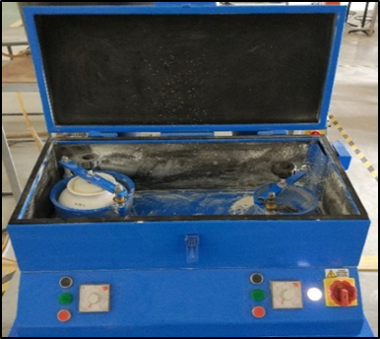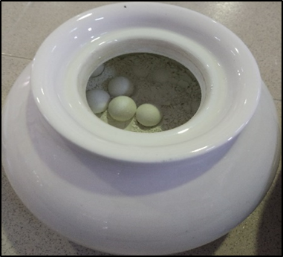
Figure 1. Planetary ball milling

The chemical analysis was performed via X-Ray Fluorescence spectrometry (Xsupreme8000, Oxford Instrument, United Kingdom). The sample is pressed to bar shape at 3 tons and sintered at various temperatures at 900 °C, 1000 °C, 1100°C and 1200 °C for 2 h in air. The sintering rate was controlled at 5°C/min. The phase identification analysis was conducted using X-Ray Diffraction (D8 Advance, Bruker, England). The microstructural analysis was performed for sintered sample using Scanning Electron Microscope (Hitachi, Japan). The magnification of 1000X were selected at an accelerating voltage of 15kV.
- Results and Discussions

Chemical analysis
It is fundamental to identify chemical composition of all ceramic material as it provides the result of weighing oxides required to determine the better formulation for final properties of ceramic product. Table 1 shows the chemical composition analysis of porcelain ceramic, AR glass and mixture of porcelain and AR glass.

Table 1. The chemical composition of the porcelain powder and mixture by using XRF

Element | Raw Material |  | Mixture (Porcelain + AR Glass (%))
Element | Porcelain | AR Glass | 3 wt% | 6 wt% | 9 wt% | 12 wt%
SiO₂ | 70.9290 | 59.4350 | 70.351 | 70.055 | 69.997 | 69.841
Al₂O₃ | 24.319 | 6.1370 | 24.206 | 23.597 | 23.046 | 22.540
Na₂O | 1.7500 | 24.4780 | 2.251 | 2.954 | 3.339 | 3.864
K₂O | 1.5680 | 1.2180 | 1.529 | 1.497 | 1.526 | 1.487
Fe₂O₃ | 0.4450 | 0.1240 | 0.428 | 0.405 | 0.396 | 0.387
MgO | 0.3580 | 0.2090 | 0.365 | 0.368 | 0.345 | 0.308
CaO | 0.2260 | 1.8780 | 0.286 | 0.339 | 0.407 | 0.469
SO₃ | 0.1780 | 0.1220 | 0.165 | 0.159 | 0.150 | 0.150
TiO₂ | 0.1170 | 1.6380 | 0.183 | 0.237 | 0.296 | 0.359
P₂O₅ | 0.0870 | 4.7140 | 0.215 | 0.365 | 0.478 | 0.575
Mn₂O₃ | 0.0152 | 0.0019 | 0.0141 | 0.0132 | 0.0116 | 0.0112
CI | 0.0054 | 0.0384 | 0.0057 | 0.0058 | 0.0064 | 0.0049
ZnO | 0.0029 | 0.0000 | 0.0025 | 0.0026 | 0.0021 | 0.0021
Cr₂O₃ | 0.0000 | 0.0056 | 0.0000 | 0.0016 | 0.0019 | 0.0019
SrO | 0.0000 | 0.0000 | 0.0000 | 0.0000 | 0.0000 | 0.0000

Based on the XRF result in Table 1, silica (SiO₂), alumina (Al₂O₃), sodium oxide (Na₂O) and potassium oxides (K₂O) produced higher concentration and can be indicated as major element in producing ceramic product. Silica produced the highest concentration among all elements, which is more than 59% for all material. Silica is essential to the final properties of ceramic as it function as quartz and affect the major crystalline phase of ceramic body. Whereas, the concentrations of alumina (Al₂O₃) was higher for porcelain and all mixture, that is significant for finer mechanical properties of ceramic. This is due to its function in increasing the viscosity of glassy phase to produce primary mullite and reducing recrystallization to form secondary mullite [7].
Simultaneously, Sodium Oxide (Na₂O) manifested an outstanding concentration percentage in AR glass yet yielded in small amount in porcelain and all mixture. Sodium is commonly favorable in the mixture of ceramic material as it gave the strongest flux in sintering process and slightly stiffer than potassium. [8]. Sodium and potassium is vital to aid different particle because it will ensure high fluidity of glassy phase to form eutectics at low melting temperature causing the network structure of ceramic particle breakdown during sintering process. [9]. Thus, the addition of AR glass to porcelain has slightly decreased the concentration of alumina and slightly increase the sodium oxides concentration for all mixtures depending on the elevation of AR glass addition.
3.2 Phase identification analysis
Phase identification was conducted to identify the crystalline structure formed in ceramic material after the sintering process. The crystalline structure can be correlated with the amount of glassy phase formation. Figure 2 and Figure 3 display the of X-Ray Diffraction patterns for sample sintered at 1000°C and 1100°C, respectively.

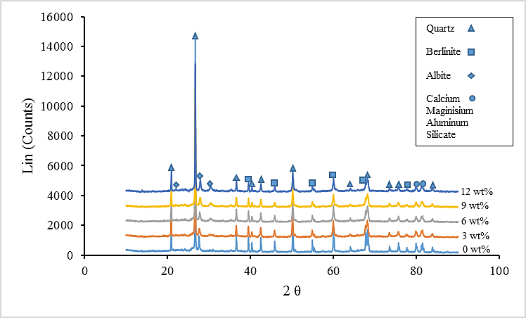
Figure 2. X- Ray Diffraction pattern for sample sintered at 1000°C

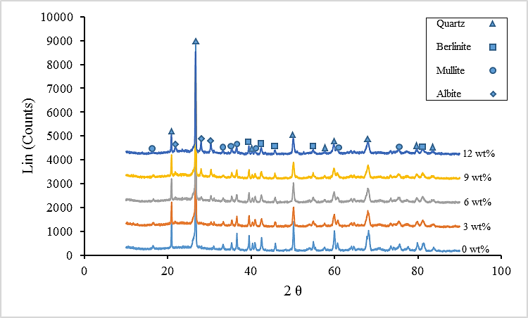
Figure 3. X- Ray Diffraction pattern for sample sintered at 1100°C

Figure 2 reveals that the formation of crystalline structures such as quartz, berlinite, calcium magnesium aluminum silicate and albite have been identified for sample sintered at 1000°C. Quartz was found to be the major crystalline phase based on the peaks produced. This can be attributed to the highest content of silica, which is in good agreement with the XRF results in Table 1. Quartz possesses refractory property and commonly maintained its shape in which imparts rigidity to ceramic bodies [10]. The formation of berlinite occurs due to the equivalent size of aluminum and phosphorus ions in comparison to silicon. Moreover, quartz is isostructural with berlinite that has different mineral chemistries with although with the same crystal structure [11]. The small intensity for albite (NaAlSi₃O₈) and calcium-magnesium-aluminum-silicate (CaMgAlSiO) shift produces is shown in Figure 2. The formation of albite has proven the process of particle consolidation where liquid phase takes place while it is to known that calcium magnesium aluminum silicate visible as sealing and wetting material [12].
Despite that, Figure 3 displays almost comparable results with Figure 2. However, the formation of mullite starts to appear at 1100°C based on the shift produce. Other than that, the formation of berlinite was reduced and no constituent of CaMgAlSiO was detected. The formation of albite and mullite proved the formation of a much glassy phase that adhere with quartz. Mullite appear at 1100°C due to the formation of liquid phase that infiltrated the interconnected pores, which had derived from breaking reaction of sodium and potassium [13]. The evidence of mullite crystal is vital because it provide high tenacity and better mechanical properties to ceramic material [14]. By looking at the overall result, the degree of crystallinity obtained was the same and the elevation of temperature lowering the peak intensity.
3.2 Microstructural morphology
Microstructural studies were conducted to observe quartz relict, void formation, and glassy phase formation that were correlated with previous result such as phase identification analysis. Figure 4 and Figure 5 display the SEM microstructure for sample sintered at for sample sintered at 900°C and 1200°C.

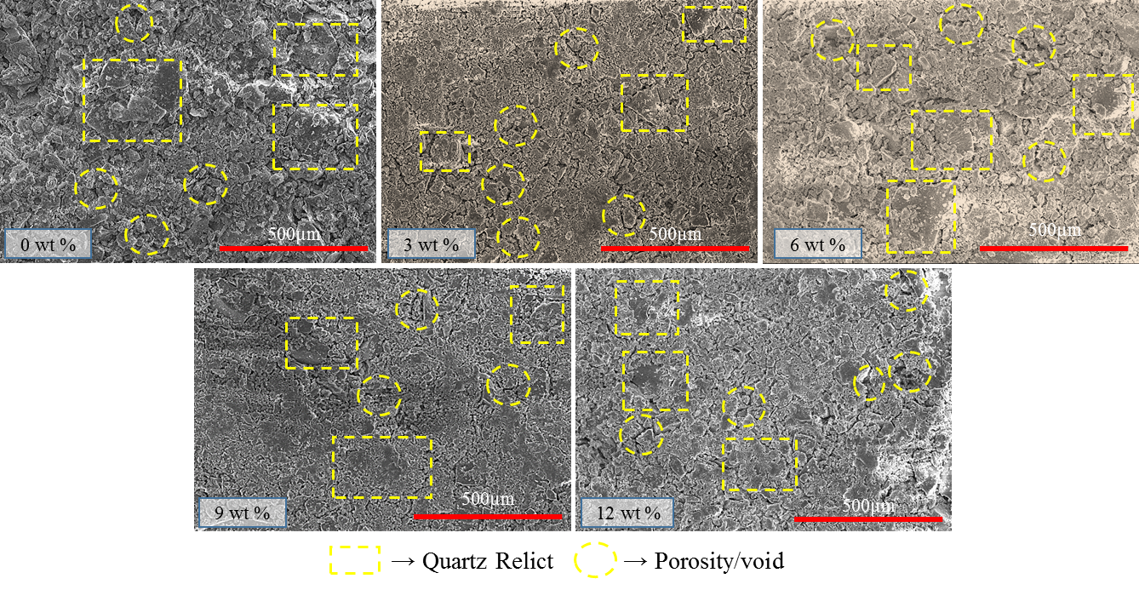
Figure 4: SEM images of sample sintered at 900°C

By looking at Figures 4, scatter formation of quartz and the incomplete grain growth can be observed which consequently resulting in large void formation and uncountable porosity. Moreover, the sample shows less dense where lack of glassy phase produce to the sample sintered at 900 °C. Referring to M. Salehi & A. Salem (2010) [15], a low sintering temperature will construct separation gap between particle due to the reduction of particle interaction. This result corresponded well with XRD results in Figure 2, whereby no formation of mullite or less glassy phase and high formation of quartz were found at low temperature of 900 °C, which possibly produced a less dense ceramic body.

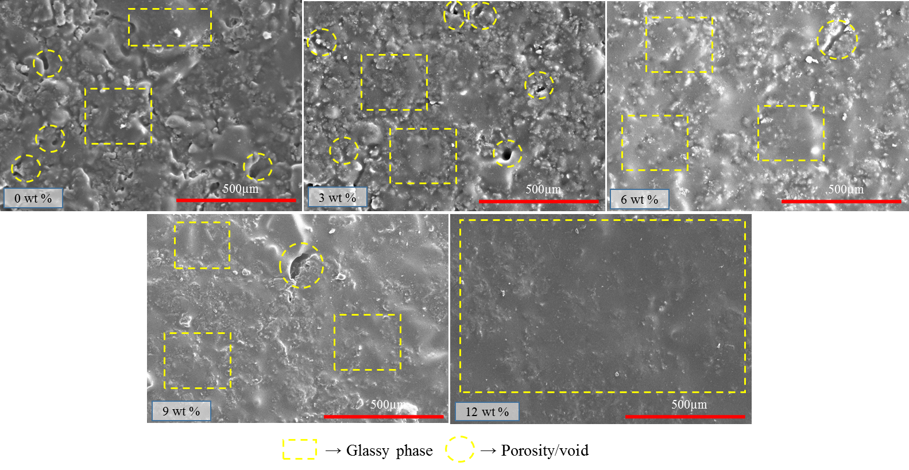Figure 5: Microstructure image at sintering temperature of 1200°C

The image of microstructure morphology shown in Figure 5 revealed that the dense sample was produce with increasing temperature and addition of AR glass. It can be seen that the formation of void or porosity is eliminated due to the formation of mullite (glassy phase) that has covered and filled pores within the quartz. In addition, the presence of the mullite as glassy phase was also coherent with the result shown in Figure 3. Based on C.M. F. Viera & S. N. Monteiro, (2007) [16], it is stated that the liquid phase from AR will intensify as the sintering temperature is increasing, whereby the inclusion of fluxes aids the particle diffusion, thus producing a dense solid ceramic body. Therefore, the microstructure produced at the highest AR glass content of 12 wt.% manifest a more densify body with the least occurrence of porosity as compared to the rest of the samples.
- Conclusions
In this study, the effects of sintering temperature and addition of AR glass into porcelain were investigated on porcelain ceramic. A formation of mullite as glassy phase is important for development of a dense ceramic body. A sintering temperature of 900 °C demonstrated absence of mullite phase on the phase analysis results, which will possibly lead to the formation of more voids and lesser dense ceramic structure regardless of AR glass content. A sintering temperature of 1100 °C coupled with the addition of AR glass were favourable to induce the formation of primary mullite, as observed on XRD analysis. Moreover, the microstructural analysis also demonstrated a denser and lesser void ceramic body at sintering temperature of 1200 °C, as compared to 900 °C and 1100 °C. Therefore, the elevation of sintering temperature and addition of AR glass are crucial factors that can enhance the properties of porcelain ceramic for vitrified clay pipes application. Further studies regarding the mechanical properties with respected to AR glass content and sintering temperature will be deliberated for future research.
- Acknowledgement
The authors gratefully acknowledge Universiti Tun Hussein Onn Malaysia (UTHM) for funding this research under Geran Kontrak UTHM (Vot-U553).
References
[1] R. D. Rawlings, J. P. Wu, and A. R. Boccaccini, “Glass-ceramics: Their production from wastes-A Review,” J. Mater. Sci., vol. 41, no. 3, pp. 733–761, 2006.
[2] Y. N. El-shimy, S. K. Amin, S. A. El-sherbiny, and M. F. Abadir, “The use of cullet in the manufacture of vitrified clay pipes,” Constr. Build. Mater., vol. 73, pp. 452–457, 2014.
[3] F. Keith and D. Y. Goswani, The CRC HANDBOOK of Mechanical Engineering, 2nd ed. CRC Press LLC, 2005.
[4] G. Barluenga and F. Hernández-olivares, “Cracking control of concretes modified with short AR-glass fibers at early age. Experimental results on standard concrete and SCC,” vol. 37, pp. 1624–1638, 2007.
[5] A. V. Gorokhovsky, J. I. Escalante-Garcia, E. Sanchez-Valdes, I. N. Burmistrov, and D. V. Kuznetsov, “Synthesis and characterization of high-strength ceramic composites in the system of potassium titanate – Metallurgical slag,” Ceram. Int., vol. 41, no. 10, pp. 13294–13303, 2015.
[6] S. R. Bragança and C. P. Bergmann, “Traditional and glass powder porcelain: Technical and microstructure analysis,” J. Eur. Ceram. Soc., vol. 24, no. 8, pp. 2383–2388, 2004.
[7] C. . Prasad, K. . Maiti, and R. Venugopal, “Effect of rice husk ash in whiteware compositions,” Ceram. Int., vol. 27, no. 6, pp. 629–635, 2001.
[8] T. Hansen, “Na₂O (Sodium Oxide, Soda),” Digitalfire References Database, 2015. [Online]. Retrieved from: https://digitalfire.com/4sight/oxide/na2o.html. at July 2016
[9] D. Askeland, P. Fulay, and W. Wright, The Science and Engineering of Materials, 6th ed. Cengage Learning, Inc, 2010.
[10] M. S. Spiller and M. Jameson, “Dental Ceramics,” Academy of Dental Learning and OSHA Training 2015.
[11] G. Dhanaraj, K. Byrappa, V. Prasad, and M. Dudley, Springer Handbook of Crystal Growth. Springer Berlin Heidelberg, 2010.
[12] A. Amarnath, A. Goel, D. U. Tulyaganov, S. Kapoor, K. Pradeesh, M. J. Pascual, and J. M. F. Ferreira, “Study of calcium magnesium aluminum silicate (CMAS) glass and glass-ceramic sealant for solid oxide fuel cells,” J. Power Sources, vol. 231, pp. 203–212, 2013.
[13] M.-M. Jorge, J. M. Rincón, and M. Romero, “Mullite development on firing in porcelain stoneware bodies,” J. Eur. Ceram. Soc., vol. 30, no. 7, p. 1599, 2010.
[14] T. Manfredini and M. Hanuskova, “Natural Raw Materials in ‘ Traditional ’ Ceramic Manufacturing,” J. Univ. Chem. Technol. Metall., vol. 47, no. 4, pp. 465–470, 2012.
[15] M. Salehi and A. Salem, “Porosity-strength correlations in ceramic Raschig ring: Effects of sintering temperature and water content,” Int. J. Appl. Ceram. Technol., vol. 7, no. 6, pp. 918–924, 2010.
[16] C. M. F. Vieira and S. N. Monteiro, “Evaluation of a plastic clay from the state of Rio de Janeiro as a component of porcelain tile body,” Matéria (Rio Janeiro), vol. 12, no. 1, pp. 1–7, 2007.

