Effect of welding speed on microstructure and mechanical properties due to the deposition of reinforcements on friction stir welded dissimilar aluminium alloys

Ravinder Reddy Baridula^{1*}, Che Ku Mohammad Faizal Bin Yahya¹, Ramgopal Varma Ramaraju² and Abdullah Bin Ibrahim¹
¹Faculty of Engineering Technology, Department of Manufacturing Engineering Technology, University Malaysia Pahang, Gambang, Malaysia ²Faculty of Technology, Department of Mechanical Engineering, Stanford International College of Business and Technology, Toronto, Canada.

Abstract The strength of the welded joint obtained by solid state stir welding process was found to be improved as compared to fusion welding process. The deposition of reinforcements during friction stir welding process can further enhance the strength of the welded joint by locking the movement of grain boundaries. In the present study, the aluminium alloys AA2024 and AA7075 were welded effectively by depositing the multi-walled carbon nanotubes in to the stir zone. The mechanical properties and microstructures were studied by varying the traverse speed at constant rotational speed. The results show that rotating tool pin stirring action and heat input play an important role in controlling the grain size. The carbon nanotubes were found to be distributed uniformly at a welding speed (traverse speed) of 80mm/min. This enhanced the mechanical properties of the welded joint. The microstructure and Electron dispersive X-ray analysis (EDX) studies indicate that the deposition of carbon nanotubes in the stir zone was influenced by the traverse speed.
Keywords: AA2024, AA7075, Carbon nanotubes (CNT), Dissimilar Aluminium alloys, Mechanical Properties
1. Introduction
Friction Stir Welding (FSW) is an efficient method for joining nonferrous metals which was invented by The Welding Institute (TWI), in the year 1991 [1]. Since, FSW utilizes a non consumable specially shaped tool, the absence of filler material is observed, which leads to less distortion tool. The tool includes a profiled pin (or probe) and a cylindrical shoulder. The probe helps to increase the frictional force between the work piece and the pin, and stirs the plastically deformed work piece material, resulting in a porosity free weld. The joining takes place at much low temperatures, in which the metal is in plastic zone. Though this method was initially applied to weld wrought aluminum alloys and later this technique applied on variety of materials with variety of joint scenarios of which metals and polymers were also included. FSW has proven to be an alternative joining technique in which less distortion, less plastic deformation and low residual stresses resulted when compared with other conventional joining methods [2]. Therefore, the weld defects in FSW are less than defects in fusion welding process. The quality of the welds depends mainly on the process parameters like tool rotational speed (rpm), axial force (KN), and tool traverse speed (mm/s). The weld joints produced between pure aluminium and interstitial free steel, the positioning of the tool pin center towards the soft material which was placed on retreating side yielded good quality welds [3].
In recent years the concept of FSW was utilized to produce the surface composites by depositing different types of reinforcements (macro, micro and nano) during friction stir processing [4, 5]. The impact of particle distribution during number of pass was investigated by various researchers. It was found that the particle distribution was improved by the increasing the passes and the process parameters [6-10]. Jafari et al.[11] studied the outcome of CNT on 6mm Cu plates fabricated by friction stir processing by taking the groove size 0.3mm depth and 1.5mm width, and found that there is an enhancement of mechanical properties of the welded joint. Lim et al.[12] reported the synthesis of multi-walled CNT reinforced aluminium alloy composite with a groove of 0.3depth and 2.3mm width by friction stir processing, in which the hardness of the joint was improved. Izadi et al. [13] studied the multi-pass FSP of AA5059 alloy by inserting the carbon nanotubes of mean diameter 30-50nm in to the groove of size 2.5mm in width and 1.8mm in depth. After three passes the reinforcements were distributed uniformly in the stir zone of the nanocomposite which restricted the grain size and yielded higher microhardness. Morisada et al. [14] studied the AZ31 surface composites by dispersing Multi-walled carbon nanotubes of outer diameter 20-50nm in a groove of 1 mm × 2 mm using friction stir processing. It has been
_______________________________
*Corresponding author: baridula@gmail.com
reported that the microhardness of the composite was increased due to grain refinement and reinforcement of cabon nanotubes. Morisada et al. [15] reported AA5083 composites fabricated by fullerene powder of mean grain size 25.4 µm in to a groove of 1 mm× 2 mm during friction stir processing. Sun et al. [16] reported the deposition of SiC particles in to copper plates of 2mm thickness by friction stir welding which improved the mechanical properties of the welded joint. Abnar et al. [17] investigated the friction stir welding of AA3003-H18 aluminium alloy by depositing the reinforcements in the stir zone. He reported that Cu and premixed Al-Cu powder were inserted between the two metals without making groove. The mechanical properties found to be improved more for premixed Al-Cu powder, when compared to Cu powder. Ravinder et al. [18] studied the deposition of copper nanoparticles during friction stir welding of dissimilar aluminium alloys and found that the mechanical properties of the welded joint improved in all the samples.
Thus the above literature review show that different researchers have successfully produced the surface composites by depositing the reinforcements in the stir zone. Hence, the present study focuses on the effect of traverse speed on microstructure and mechanical properties due to the deposition of multi-walled carbon nanotubes on fricton stir welded dissimilar aluminium alloys AA2024-T3 and AA7075-T6.

2.Experimental Details
In the present study the dissimilar aluminium alloys selected as base metals are AA2024-T3 and AA7075-T6 with dimensions of 100 mm× 50 mm× 4.85mm . The chemical composition and mechanical properties of the base metals are shown in Table1 and Table2. Fig. 1 shows the as received multi-walled carbon nanotubes having purity more than 90% with a nominal diameter of 10 to 20nm. The reinforcements were inserted in to the groove of 1mm in width and 2mm in depth which is being cut precisely by a wire cut machine i.e 0.5mm width and 2mm depth in each base metal. The welding is performed by a 5T NC FSW machine and the welding tool used is made of tool steel (W-Co) with dimensions- shoulder diameter of 18mm, pin height 4.65mm and cylindrical pin diameter of 5mm. The welded joints were fabricated by a double pass friction stir welding process. Initially a rotating tool with out pin is passed gently over the groove with carbon nanoparticles to compress and avoid the sputtering of nanoparticles during welding process, then the welded joints were fabricated by using a rotating tool with pin. The process parameters selected are at a contant rotational speed of 1400 rpm and axial load of 1 kN, the welding speed (traverse speed) was varied as 70,80,90mm/min. In the experimentation a total of 4 welded joints were fabricated in which thee joints are with nanoparticles and one joint with out nanoparticles. The process parameter selected for the welded joint without nanoparticles are 1400 rpm, 80 mm/min and 1kN, since with the same process parameters the strength of the welded joint with nanoparticles was found to be maximum. The tensile test specimens (ASTM-E8) were cut by using EDM wire cut machine and the tensile test was carried out on 12 samples by INSTRON universal testing machine of 30 kN. The microhardness of the samples was carried out by Wilson vickers hardness tester. The samples were prepared for microstructure examination and etched with keller’s reagent. The stir zone microstructures were obtained by optical microscope and elemental identification was done by FESEM.

Table 1. The chemical composition of the alloys in this work (%wt)
Alloy Material | Cu | Mg | Mn | Zn | Si | Fe | Cr | Al
AA2024-T3 | 4.46 | 1.42 | 0.63 | 0.05 | 0.04 | 0.11 | 0.001 | Balance
AA7075-T6 | 1.7 | 2.43 | 0.08 | 6.93 | 0.05 | 0.12 | 0.001 | Balance

Table 2. Mechanical Properties
Base Material | Yield Strength | Tensile Strength | Elongation | Hardness (Vickers)
AA2024-T3 | 376Mpa | 446Mpa | 17% | 144
AA7075-T6 | 489Mpa | 573Mpa | 13% | 172

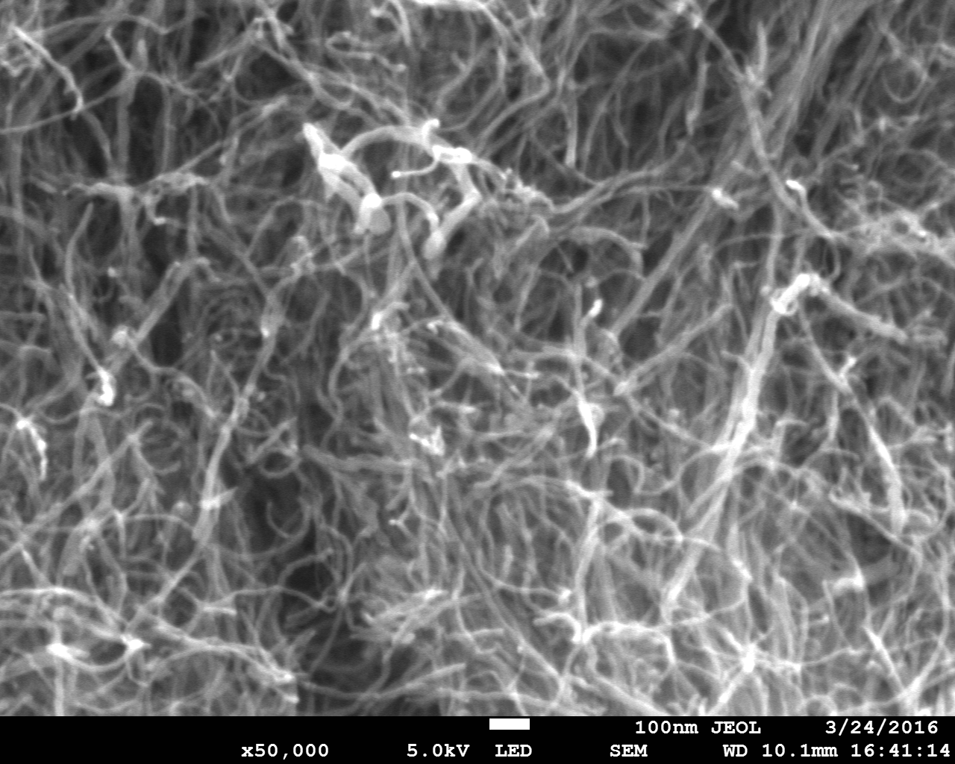
Fig. 1. FESEM image of Carbon nanotubes
3.Results and Discussion
The weld quality and weld pool geometry are observed to be effected by process parameters during friction stir welding process. During FSW, defects may be formed due to variation in the velocity field around the rotating tool. Defects may also be formed due to the material flow at high or low rotational speeds. The flow lines within the stir zone are observed to be formed at different positions of the weld as the material layers undergo different levels of plastic deformation. It has been observed that by the change in traverse speed the strength of the welded joints has changed, with nano-particles. This may be due to change in the distribution and amount of reinforcements present in the microstructure.

3.1 Microstructure
Fig. 1 and Fig. 2 show the microstructures of the welded joint at varying traverse speed. During FSW process the fine grains are formed in the material due to intense plastic deformation at high temperatures, which is referred as dynamic recrystallization[14]. Heat input is the controlling factor which determines the grain size during the FSW process, where as the conditions change due to the addition of reinforcements in to the metal matrix[6]. Also it has been reported by Humphrey et al.[19] that the migration of grain boundaries takes place at higher temperatures. Thus by increasing the rotational speed or decreasing the welding speed promotes higher temperatures in the weld zone which leads to coarse grain size [20]. The migration of grain boundaries can be controlled by the reinforcements addition which breaks the initial grains and impedes the grain growth [21]. The addition of reinforcements in to the metal matrix creates more number of misoriented low angle grain boundaries during the plastic deformation, which results more nucleating sites in the stir zone. Thus the low angle grain boundaries are transformed in to high angle grain boundaries and new grains are nucleated at favourable sites, which yielded fine grain microstructure [4]. The stir zone microstructure with carbon nanotubes at a traverse speed of 70mm/min and 80mm/min are shown in Fig. 1. The material flow in the stir zone was found to be optimum at a traverse speed of 80mm/min which improved the distribution of nanoparticles and yeilded fine grains in the microstructure as shown in Fig. 1(b). At a traverse speed of 70mm/min the distribution of carbon nanoparticles were not even which yeilded combination of coarse and fine grains as shown in Fig. 1(a). Similarly as the traverse speed was increased to 90mm/min the heat input decreased which influenced the material flow and the nanoparticles are distributed randomly in the microstructure as shown in the Fig. 2(a). Due to more heat input the microstructure of the welded joint without nanoparticles yeided coarse grains as shown in Fig. 2(b).

Fig. 1.Microstructure of Stir zone at (a) 70 mm/min (b) 80 mm/min
Fig. 2. Microstructure of Stir zone at (a) 90 mm/min (b) 80 mm/min without nanoparticles
3.2 EDX RESULTS
Elemental identification was obtained by Electron dispersive X-ray analysis (EDX) as the optical microscopy does not show the amount of distribution of the elements in the stir zone. The EDX patterns of the stir zone for different traverse speeds are shown in the Fig. 3 and Fig. 4. The results show that the carbon nanotubes were deposited in all the samples, but there is a slight variation in the deposition of the reinforcements in the stir zone. This is due to the difference in material flow under various traverse speed. Thus the process parameters of 1400 rpm, 80 mm/min and 1kN are found to be optimum where the heat input is sufficient for the material flow to distribute the carbon nanotubes uniformly and maximum amount in the stir zone as shown in the Fig. 3(b). If the heat input is higher or lower than the material flow may not be proper and which influences the distribution of nanoparticles in the stir zone. Fig. 4(b) shows the EDX results for the sample without nanoparticles at a traverse speed of 80 mm/min. As the heat input was optimum at a traverse speed of 80 mm/min exhibited the maximum carbon nanotube reinforcements of 16.49 wt% and minimum amount of 12 .47 wt% at a traverse speed of 90 mm/min.
Fig. 3. EDX results of Stir zone with nanoparticles at (a) 70 mm/min (b) 80 mm/min
Fig. 4. EDX results of Stir zone with nanoparticles at (a) 90 mm/min (b) 80 mm/min without nanoparticles

3.3 Tensile strength
Tensile tests are carried out to find the effect of traverse speed on the strength of the friction stir welded joints with and without nanoparticles. The factors which influence the mechanical properties are grain size, the interaction between the reinforcements and base metals and dislocation density[4]. The generation of dislocation density was higher at the interface due to large thermal mismatch between the carbon nanotubes and aluminium matrix, which enhances the strengthening of the matrix by work hardening[22]. And the dislocations movement will be hindered by the nanosized carbon nanotubes which were distributed in the matrix. The tensile strength and microhardness of the friction stir welded joints are shown in the Table 3. Fig. 5(a) shows the effect of traverse speed on the tensile strength of welded joints. It has been observed that the strength of the welded joint was maximum at a traverse speed of 80 mm/min. This is due to the uniform distribution of carbon nanotubes in the stir zone which restricted the movement of grain boundaries and pins the movement of dislocations during elongation[14,17,18]. At 70 mm/min the heat input is more than the earlier case but the plasticity of the material is more and distribute the nanoparticles randomly and thus the strength decreases. As the welding speed is increased the heat input decreases and the material flow around the rotating tool pin influences the distribution of nanoparticles and yeilded the second heighest tensile strength of 443.2 MPa. Thus due to optimum heat input the maximum tensile strength of 449.71 Mpa was obtained for the process parameters of 1400 rpm, 80 mm/min and 1 kN. The strength of the welded joint was improved by 8.8% when compared to the welded joint without nanoparticles .

Table 3. Mechanical Properties of Friction Stir Welded Joints
Traverse Speed(mm/min) | 70 | 80 | 90 | 80(without nanoparticles
Tensile Strength(MPa) | 436.2 | 449.71 | 443.2 | 410.3
Microhardness(Hv) | 173.5 | 189.3 | 179.7 | 145.2

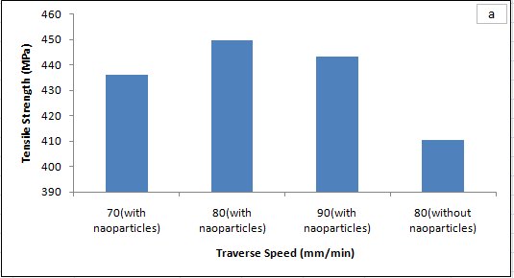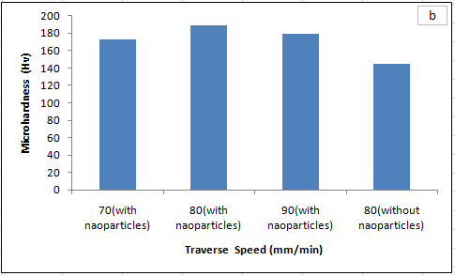

Fig. 5. Mechanical Properties of the welded joint (a) Tensile Strength (b) Microhardness

3.4 Microhardness
The important factors which influence the microhardness of the composites are amount of reinforcement distribution, heat input, grain size and dislocation density. It has been reported that the fine grains yeild higher microhardness as per the Hall-Petch equation [8]. Since the reinforcing phase and the matrix have different coefficient of thermal expansion which generates the dislocations and yeilds high hardness [23]. The average microhardness of the stir zone is shown in the Table 3 for all welded joints. It has been observed that the microhardness of the welded joints with nanoparticles was higher than the welded joint without nanoparticles, due to the distribution of reinforcing particles in the stir zone. But the distribution is found to be varying due to change in the process parameters [16,17,18]. Fig. 5(b) shows the effect of traverse speed on the microhardness of welded joints. The maximum hardness was achieved for the welded joint fabricated at a traverse speed of 80 mm/min and minimum hardness at 70 mm/min. Even though heat input was higher at lower traverse speed the pin stirring action was found to be better at traverse speed of 80 mm/min and uniform distribution of nanoparticles was achieved. This enhanced the microhardness as fine grains are formed. As the traverse speed is increased the heat input decreases and non uniform distribution of particles takes place, due to change in material flow behaviour around the tool rotating pin. The microhardness of the welded joint was improved by 23.3% when compared to the welded joint without nanoparticles .

4. Conclusions
The dissimilar aluminium alloys were fabricated effectively by depositing the muti-walled carbon nanotubes during friction stir welding process. The nanoparticles were deposited in all the welded joints irrespective of process parameters and enhanced the mechanical properties. Heat input and stirring action of the tool pin are the important factors which enhances the uniform distribution of nanoparticles in the stir zone. The process parameters combination play an important role in distribution of nanoparticles in the stir zone, which enhances the mechanical properties of the welded joint. Microhardness and tensile strength were observed to be maximum at a traverse speed of 80 mm/min when compared to the welded joint obtained at 70 mm/min and 90 mm/min. The heat input was found to be optimum at 80 mm/min and uniform distribution of nanoparticles was achieved due to better stirring action of pin. Thus, the fine grain size were observed in the microstructures due to the dispersion of nanoparticles, locks the dislocations movement and enhances the strength of the welded joint. The tensile strength and microhardness of the welded joint was improved by 8.8% and 23.3% when compared to the welded joint without nanoparticles.

Acknowledgements
The authors are thankful to Universiti Malaysia Pahang for its constant encouragement during the course of this work. The authors are also thankful to Ministry of Higher Education, Malaysia for granting FRGS under RDU130103. The first author would like to thank University Malaysia Pahang, for awarding Doctoral Scholar Ship Scheme.
References

- W.M.Thomas,E.D. Nicholas,J.C. Needham,M.G. Murch,P. Templesmith,C.J. Dawes, GB Patent Application No. 9125978.8, (1991).
- M.W. Mahoney, C.G. Rhodes, J.G. Flintoff, R.A. Spurling, W.H. Bingel, Metal Mater Trans. A 29, 1955–64 (1998)
- S. Kundu, D. Roy, R. Bhola, D. Bhatacharjee, B. Mishra, S. Chatarjee, Materials and Design 50,370–375 (2013)
- M. Barmouz, P. Asadi, M.K. BesharatiGivi, M. Taherishargh, Mater Sci Eng. A 528, 1740–9 (2011)
- S.A.Alidokht, A.Abdollah-zadeh, S.Soleymani, H.Assadi, Materials and Design 32, 2727-2733 (2011)
- G.Faraji, P.Asadi, Materials Science and Engineering A 527, 2320–30 (2011)
- A.Shamsipur, S.F.Kashani-Bozorg, A.Zarei-Hanzaki, Surf Coat Technol. 206, 1372–81 (2011)
- M. Sharifitabar, A.Sarani, S.Khorshahian, M.Shafiee Afarani, Mater Des. 32, 4164–72 (2011)
- M. Barmouz, M.K. Besharati Givi, Composites: Part A 42,1445–53 (2011)
- D. Khayyamin, A. Mostafapour, A. Keshmiri, Materials Science and Engineering A 559,217–21 (2013)
- J.Jafari,M.K.B. Givi,M. Barmouz, Int J Adv Manuf Technol. 78,199–209 (2015)
- D.K.Lim,T. Shibayanagi,A.P. Gerlich, Materials Science and Engineering A, 507(1-2), 194-199 (2009)
- H. Izadi, A. P. Gerlich, Carbon 50, 4744-4749 (2012).
- Y.Morisada, H. Fujii, T.Nagaoka, M.Fukusumi, Materials Science and Engineering A 419, 344–348 (2006)
- Y.Morisada,H.Fujii,T.Nagaoka,K.Nogib,M.Fukusumi,Composites Part A: Applied Science and Manufacturing 38, (10) 2097–2101 (2007)
- Y.F.Sun,H. Fujii, Materials Science and Engineering A. 528 ,5470−5475 (2011)
- B. Abnar, M. Kazeminezhad, A. H. Kokabi, Journal of Materials Engineering and Performance 24(2) 1086-1093, (2015)
- R. B. Ravinder, R.V. Ramaraju, A.B. Ibrahim, M.F.B. Cheku, Trans Indian Inst Met. 70(4),1005-1017 (2017)
- F. J. Humphreys, M. Hatherly, UK, Elsevier Ltd., University of Manchester, Institute of Science
and Technology ( 2004)
- M.Azizieh, A.H.Kokabi, P.Abachi, Mater Des. 32, (4) 2034–41 (2011)
- M. El-Rayes Magdy, A. El-Danaf Ehab, J Mater Process Technol. 212,1157–68 (2012)
- R.George, K.T. Kashyap, R. Rahul, S. Yamdagni , Scr Mater 53, 1159 (2005)
- A.Dolatkhah, P. Golbabaei, M. K. Besharati Givi, F. Molaiekiya, Materials and Design 37, 458–464 (2012)

