The dispositional attribution of customer satisfaction through the juxtaposition of QFD and ServQual in service industry design

Fevi Syaifoelida^{1*}, Khairul Salleh Mohamed Sahari¹,Hasril Hasini¹, ,A.M Megat Hamdan^{2,} and A.Z Syahmi¹
¹ Department of Mechanical Engineering, Universiti Tenaga Nasional, (UNITEN)
² Department of Mechanical Engineering, Universiti Pertahanan Nasional Malaysia (UPNM)

Abstract. This study has been carried out to analyze the dispositional source of satisfaction through the juxtaposition of Quality Function Deployment (QFD) and Service Quality (ServQual) in the service industry. ServQual is one of the famous tools to measure the customer satisfaction. The customer satisfaction is measure through five dimensions, which are reliability, assurance, tangible, empathy and responsiveness. QFD is one of the mathematical approach to transform the customer needs into technical requirements. The difference between these two models is, ServQual evaluates the priorities of the basic customer needs, which within these five dimensions, which one is the most important and which one is the least important, according to responds obtained from the customer. Meanwhile, for QFD evaluate the priorities of technical requirement of service that will be able to satisfy the customer. The study has been carried out at one customer service centre in Bangi. The study applies ServQual methodology to measure the customer satisfaction after the service has been delivered through its five dimensions. The QFD methodology is used as one of the mathematical approach to transform the customer needs into technical requirement and evaluate the priorities of technical requirement of service that will be able to satisfy the customer. The results show ServQual and QFD ought to be consolidated to get alternate points of view regarding the behavior of the customers. Acted as variables to quantify in terms of the contentment felt by the customers in the service quality. Besides, it has a distinctive methodology to help service industry being able to gauge the satisfaction of customers. Together they give an intense instrument that is not exclusively will reveal whether the customer satisfaction is fulfilled or not, but rather additionally how great the distinction of the service is as well as the level of competence the organization functions. In addition to that, it will let the companies in the service industries know that they should take action in order to enhance the service quality and along these lines to make the customers satisfied. Through the theoretical base questionnaires, as both of the juxtaposition approaches' analysis, the main priorities need to be taken into consideration is ‘facilities’ in service centre. The service centre needs to ease the customer in whatever their purpose to come to the service centre and make them comfortable enough. While, the factor ‘Ease of contact’ is become the vital consideration in ServQual before integrating towards QFD. These elements are the improvement needed by the service centre to look into details in order to increase and grab more attention towards customer satisfaction.

1 Introduction

Disposition has been defined in many different ways. Some of them are the state of mind regarding something, mood and feelings. In this manufacturing service case study, the dispositional source of satisfaction is defined as the tendency of individual to react or respond to the situation. There are two traits to express the tendency, which are to view things in either positive or negative way. In service industry as well, the dispositional is relate to the job satisfaction. Equally, important, dispositional approach indicates that individuals differ in their propensity to be enthusiastic about their job or task, the degree of individual trait in the job fulfillment [1]. The dispositional of job satisfaction give impact to the emotions and actions of individual and most of them happen unconsciously. Past analysis has shown there is a connection between dispositional effect, psychology and science.

*Corresponding author:Fevilia@uniten.edu.my
The connection such as the character or behavior, lifestyle, decision making of a person is very important in most organizations or association in order to achieve stability and success especially in socioeconomic impact that will lead to others such as customer.
Nowadays, service organizations are all related to human whether the service provider or the service receiver. For the service organizations to succeed it is important for them to give high quality of service and fulfilling or meet the customer needed. The fulfillment of customer expectation plays a very significant role in service industries as it controls the up and down in sales and profits. A good quality service provided bring the customer loyalty and increase the organization’s efficiency [2]. Thus, the level of getting the customer’s loyalty and loyal customers depends on how the organizations work to meet the customer’s needs and expectations. This study is carry out to classify and investigate the service industry’s customer satisfaction by collecting data and information.
Consequently, the customer chooses the service provider and not the other way around [3]. The service organizations must realize the importance of the customers and the service quality in managing their organizations. Second, in current global economy service industry is a very competitive and rough sector. The service providers need to set their goals for customers and just by fulfilled their needs are not enough nowadays. Service providers need to put the customers as their top priority. They need to move beyond to meet customer’s needs such as providing opportunities for additional profit in order to survive and thrive in this industry.
Thus, other than just to meet the customer’s expectations, service providers need to improve their service quality to ensure better effectiveness and efficiency [4]. Understanding their customer is a matter of concern but how to understand them is another major concern in this industry. Third, detail understanding of the customer’s situation, issues and concerns will help organizations to find solution for customer’s problems in meeting their expectations and perspectives [5]. This will also improve the organization opportunities and knowledge in delivering their service quality in the future. Based on those reasons, the study is carry out by highlighting the implication of juxtaposition between ServQual method and Quality Function Deployment (QFD) method in measuring dispositional source of satisfaction in service provided. The juxtaposition of these two methods will lead to dispositional attribution of customer satisfaction in service industry design.

2 Theoretical Approach

2.1 Customer Satisfaction

Customer’s satisfaction has been define in many ways nowadays. Customer satisfaction is view as something that is pleasurable to fulfil [6]. While Kotler [7] defined it when the pre-consumption expectations of customer has been given the customer, satisfaction is including of post consumption assessment about the goods or service quality. In different perception, customer satisfaction is describe as the consumer’s assessment that products or services meet or fall to meet customer’s expectation [8][9]. There are two types of customer in service industry, which are external customer and internal customer. An external customer is the individual who does not involve in the organization directly while the internal customer is surely the one who does involve directly in the organization such as the employees, stakeholders and shareholders.
More than that, matter such as salesperson, service provider, experience and decision-making can affect the customer satisfaction towards organization. Customer satisfaction is an extremely private evaluation that is affect by the individual expectations. Without customer information and feedback, there will be no clue to design product or delivering service according to customer expectation, thus decreasing the organization effectiveness and losing of customers. The simplest way, which is customer feedback survey, really helps and gives insight about customer expectation and perception but it also has their pros and cons. Dispositional satisfaction of customer satisfaction is all about how the perceptions, views and personality traits regarding the product or service and their reaction. This is often see in situations after consuming or purchasing the product or service by getting feedbacks whether they are satisfied or dissatisfied. Thus, resulting in their action and emotion such as whether they dislike the organization and want to unsubscribe or satisfied enough and resulting loyalty, returns and increasing of customer.

2.2 ServQual

Service quality (ServQual) is an evaluation of how well a provided product or service is in accordance to the customer’s objectives. Service industry organization often look at the service quality offered to their customers in order to enhance their service, to recognize problems at a fast rate as well as for better evaluation of customer service. Service quality is an approach to manage business for ensuring fulfilment of customer satisfaction and quality of service delivered to customer by prioritizing them [10].
ServQual model is an empiric model invented by Parasuraman et al. [11] to compare service quality performance with customer service quality needs. The usage of this model is for the gap analysis of service quality performance and the needs of customer’s service quality for organization in service industry. It is also call the GAP model. It considers the views of customer of the comparative significance of service attributes thus, prioritizing them.
ServQual evaluates on 10 aspects of service quality, which are reliability, receptiveness, capability, access, courtesy, communication, credibility, security, comprehending the customer and tangibility. Then it narrowed down until it only measures five dimensions, which are reliability, assurance, tangible, empathy and responsiveness. The purpose of these dimensions is to measure the gap between customer expectations and experiences. The five dimensions of ServQual are as follow:

- Reliability: the ability to achieve the promised service dependably and accurately
- Assurance: the knowledge and courtesy of employees and their ability to express trust and confidence
- Tangibles: the appearance of physical facilities, equipment, personnel and communication resources
- Empathy: the provision of concerned, individualized attention to customers
- Responsiveness: the readiness to help customers and to provide prompt service

Service quality becomes more and more popular in service industry nowadays as it involves and give big impact in expenses, profitability customer satisfaction and customer retention of organization. Most common reasons why organization implements this model is that to evaluate the company’s service quality through the five dimensions of ServQual. Besides that, organization often use them to determine and check the customer expectation and perception that may be different in their evaluation of organization service performance. In this competitive era, organization needs to develop and succeed by keeping track about the customer expectation and perception to maintain the customer loyalty.
It is indeed one of the best model in closing the gap between the consumer and manufacturer by process such as communication with customers and by keeping track the customer expectation and perception and comparing the score of service quality within the industry.

2.3 QFD

Quality function Deployment (QFD) is not only a quality tool, but also a significant planning tool, is defined as the method to exceed customer expectation by turning and planning the voice of customer (VOC) into the quality properties of services or products [12]. Akao,[13] the founder of QFD itself stated that QFD is an approach to satisfy the customer by transforming the customer’s demand into design targets and major quality assurance points to be used throughout the production phase and QFD is the way to ensure the quality of a design while in the designing stage.
QFD helps to create operational details of the requirements, which may be unclear when first expressed. It prioritizes each products or services characteristic while at the same time sets the development objectives for the products or services. Likewise, QFD is a structured process in planning and designing a product or service and it is a process of restructuring the existing product and service. It emphasized on understanding of the needs and requirements of customers. Then the needs and requirements are transform into characteristics of product or service. There are four phases of QFD process, which is product planning, part development, process planning and production planning.
In the phase of product planning, the House of Quality (HOQ) is implementing. The same phase is the process of transforming the needs and requirements of customer into the product technical requirements. It links the customer requirements with product attributes. Some said there are few stages and steps of generating HOQ. According to Becker &Associates [14], there are 12 steps of generating HOQ as depicted in Figure 1.
The usage of QFD can be apply in various kinds of industry. In the service industry, implementation of QFD can be vital to ensure the business’ success and sustainability. In service industry, QFD refers to determine the customer needs and the requirements to satisfy them. After requiring the information from customer, the process continues with transforming the needs into design characteristics. QFD is a customer driven tool in executing total quality management. The main goal of QFD is to maximize the customer satisfaction thus giving the opportunities to organization to reduce costs and the production time, improving the revenues and lastly to thrive in the competitive industry by improving and produce product or services [15].

3 Methodology

The quality attributes of ServQual dimension (Table 1) is used to identify and investigate the service industry's customer satisfaction that required the concept of QFD to identify the strengths and weaknesses of quality attributes related to the service given from the customers' viewpoints [16]. The integration between ServQual dimensions (customer requirement) and technical requirement in HOQ will give an impact how the evaluation of both conceptual approaches would come out with the gaps of satisfaction related to the disconfirmation theory [16]. These asymmetries are use as the customer satisfaction improvement required against the quality of service provided.

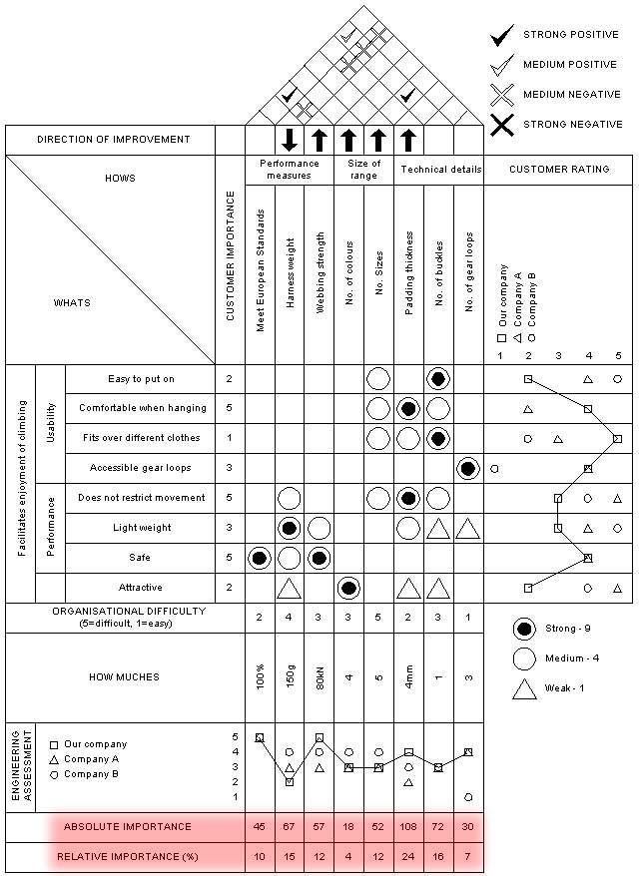

Fig. 1. House of Quality [17]

Table 1. ServQual dimensions

ServQual Elements (variables) | Operationalization Items | Question number in questionnaire
Reliability | - Consistence in quality of services given  - The degree of trust in service  - Attention to specifics of the service delivery by the staff  - Ease of contact | 1-5
Assurance | - Assurance that the rate charge is fair and facilities provided is enough for customers  - Assurance that the location is suitable and parking lot is enough | 6-10
Tangibles | - Visually appealing external outlook of the staff  - Having appropriate places and facilities for effective service  - The facilities are functioning well  - Cleanliness and safety of building, places and facilities | 11-15
Empathy | - Staff have knowledge, polite and necessary service skills  - Approachability  - Staff pay attention to individual needs | 16-20
Responsiveness | - Competence  - Service given tally with company’s advertisement  - The service system for booking, registration and payment is easy and reliable | 20-25

4 Analysis & Discussion

4.1 ServQual Result

The analysis results are in the form of value, it stated the ranking of five dimensions of ServQual according to the most important until the least important dimension. Table 2 concludes the result as the sum of average of each dimensions in ServQual. The lower the rating given the higher the satisfaction. This is because the items in likert scale were gauged on a five-point scale ranging from “1 = strongly agree” to “5 = strongly disagree”. Respondents have rated the importance of the dimensions as reliability as the most vital attribute. While, Table 3 and clearly depicted in Figure 2 shown the value of ServQual’s dimension ranking, which is based on customers’ priority point of view that considered as mostly concerned by the customers. The lower the score rated by the respondents the higher the rank of importance of question.

Table 2. Average value of each ServQual dimensions
No. | Dimension | average
1 | reliability | 2.3
2 | assurance | 2.3
3 | tangible | 2.5
4 | empathy | 2.6
5 | responsiveness | 2.6

Table 3. Value of ServQual’s dimension ranking
Dimension | Rank | Average rating
Reliability | 1. Ease of contact | 1.6
Reliability | 2. Service given tally with advertisement | 1.8
Assurance | 3. Operating hour | 1.9
Assurance | 4. Staff pay attention to individual needs | 1.9
Tangible | 5. Location of service centre | 2.0
Tangible | 6. Parking lot | 2.1
Empathy | 7. Accessibility of staff when needed | 2.2
Empathy | 8. Consistency of service | 2.3
Responsiveness | 9. Up-to-date equipment | 2.4
Responsiveness | 10. Cleanliness and safety | 2.4

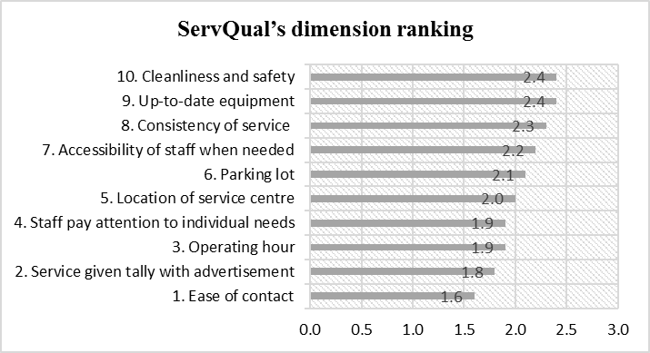

Figure 2: ServQual’s dimension ranking

Fig. 2. ServQual’s dimension ranking

Based on the ranking, the top two factors that need to be considered as the first priority is in Reliability dimension, that give the feeling of ‘the ability to achieve the promised service dependably and accurately’ are:
1. Ease of contact
2. Service given tally with advertisement

4.2 QFD Results

It founds that from the previous ServQual analysis, reliability dimension has been rank as the first priority, so the Table 4 below is the ranking of importance in customer requirement (from ServQual dimension) in HOQ perspective of view.

Table 4. Importance Rating on Customer Needs
 |  | Importance
Reliability | Ease of contact | 10
Reliability | Consistency of service | 8
Assurance | Location of service centre | 5
Assurance | Parking lot | 6
Tangible | Up-to-date equipment | 9
Tangible | Cleanliness and safety | 1
Empathy | Operating hours | 3
Empathy | Staff pay attention to individual needs | 4
Responsiveness | Service given tally with company’s advertisement | 2
Responsiveness | Accessibility of staff | 7

The technical requirement part has been identified on the foundation of service elements. The key question in this step is "how" the staff would be able to provide the required service to their customer. In this study, three important issues are considered which are processes, people and physical evidence [18]. These three issues are used to define the technical requirement as a top roof of House of Quality (Figure 3).
The importance and percentage weight of service design features are measured by using the relative importance values and the relationship matrix developed. This calculation process intertwines customer’s needs with service technical requirements so that resulting value gives the percentage weight of each of the requirements as compared to customer’s needs (Table 5). The impact relationship between ServQual (customer requirement) and technical requirement in HOQ’s perspective can be seen as depicted in Figure 4.

Courtesy | Queue system | Payment system | Self-service kiosk | Reconnection & termination |  | Payment & service counter | New power supply application | Complaint handling | Customer details & information |  | Staff behaviour | Staff knowledge | Information counter | Guideline | Facilities | Safety & security
1 | 2 | 3 | 4 | 5 |  | 6 | 7 | 8 | 9 |  | 10 | 11 | 12 | 13 | 14 | 15
Processes |  |  |  |  | People |  |  |  |  | Physical
Fig. 3. Technical requirement as top roof evaluation in HOQ

Table 5. Percentage Weightage of Service Technical Requirements
No of attributes | 1 | 2 | 3 | 4 | 5 | 6 | 7 | 8 | 9 | 10 | 11 | 12 | 13 | 14 | 15
Importance | 70 | 27 | 99 | 69 | 33 | 25 | 25 | 101 | 13 | 14 | 14 | 12 | 108 | 108 | 63
% | 9 | 3.5 | 13 | 8.8 | 4.2 | 3.2 | 3.2 | 13 | 1.7 | 1.8 | 1.8 | 1.5 | 14 | 14 | 8.1

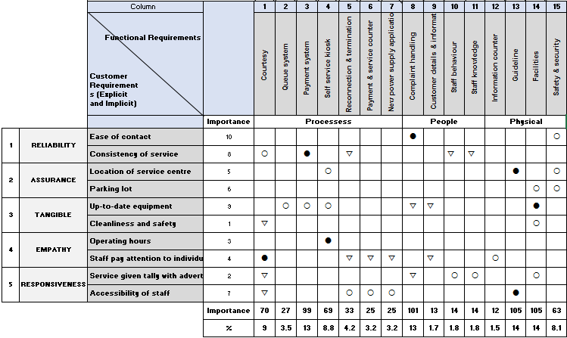
Fig. 4. The relationship of ServQual (customer requirement) and technical requirement in HOQ perspective

Based on the percentage ranking, the top two factors that need to be considered as the first priority are:
1. Facilities (14%)
2. Guideline (14%)

5 Conclusion

ServQual and QFD ought to be consolidated to get alternate points of view regarding the customer behaviour and distinctive methodologies of how a service industry can gauge the customer satisfaction. Grounded on the theoretic background portrayed, the observational discoveries assembled and the later analysis, these models consolidated provide another extremely intriguing perspective. They display the customer satisfaction model and the variables that customer discover more significant to enhance the nature of service quality. ServQual gives this estimation and great information regarding the quality of service and the characteristics, customer needs and desires, after QFD gives the connection between these needs and the service technical requirements that results in an exact of focuses to enhance.
Joining the best of every model it gets to be distinctly simpler to recover the essential data and after that applying all the data accumulated into a technique to quantify the satisfaction. As both of the approaches' analysis, the main priorities need to be taken into consideration are facilities and guideline in service centre. The service centre needs to ease the customer in ‘warm welcoming’ in whatever their purpose to come to the service centre and make them comfortable enough. The expansion of waiting area, expansion of parking lot and place signboard for every facilities can be considered and need more attention to satisfy them.
While before integrating, the priority for ServQual itself rated that, the factor ‘Ease of contact’ is become the vital. These required the further improvement action by the company to fulfil those requirements in satisfaction towards services provided. The previous objective to propose the improvement of the customer satisfaction by using the juxtapostion of ServQual approach and QFD is achieved.

Acknowledgement

A special tribute to Universiti Tenaga Nasional for funding this research under the UNITEN Internal Research Grant.

References

[1] A. Erez, & T. A. Judge. Dispositional source of job satisfaction: The role of self-deception (CAHRS Working Paper #94-14). Ithaca, NY: Cornell University, School of Industrial and Labor Relations, Center for Advanced Human Resource Studies (1994).
[2] M. Ramees Rahman, & Safeena, P. K. Customer Needs and Customer Satisfaction. In Theeranaipunya – A Capacity Building Training Programme Equipping the Fisherwomen Youth for the Future Kerala, India: Central Marine Fisheries Research Institute. Pp. 259-262 (2016).
[3] M. Colgate & M. Norris. Why Customers Leave - or Decide Not To Leave - Their Bank. University Of Auckland: Business Review, Vol. 2(2), Pp. 40-51(2000).
[4] N. Nabi. Customer Expectations of Service Quality: A Study on Private Banks of Bangladesh. World Review of Business Research, Vol. 2(2), Pp.172-186 (2012).
[5] A. Bollen & Emes, C. Understanding Customer Relationships: How important is the personal touch? London: Ipsos MORI. (2008).
[6] R. L. Oliver. Satisfaction: A Behavioural Perspective on the Consumer. New York, NY: McGraw-Hill (1997).
[7] P. Kotler. Marketing Management: Analysis, Planning, Implementation and Control (1st ed.). Englewood Cliffs, N.J.: Prentice-Hall (1991).
[8] R. L. Oliver & J. E. Swan. Consumer Perceptions of Interpersonal Equity and Satisfaction in Transactions: A Field Survey Approach. Journal of Marketing, Vol.53 (2) (1989).
[9] Y. A. Yi. Critical Review of Customer Satisfaction. In V. Zeithaml (Ed.), Review of Marketing, Chicago: American Marketing Association. Pp 68-123 (1991).
[10] A. Shahin. SERVQUAL and model of service quality gaps: A framework for determining and prioritizing critical factors in delivering quality services. Service quality – An introduction Andhra Pradesh: ICFAI University Press. Pp. 117-131 (2006).
[11] A. Parasuraman., V. Zeithaml, & L. A Berry. Conceptual Model of Service Quality and Its Implications for Future Research. Journal of Marketing, Vol. 49(4) (1985).
[12] L. Bernal., T. Byrnes., U. Dornberger., & A. Suvelza. Quality Function Deployment (QFD) for services. Leipzig: University of Leipzig (2009).
[13] Y. Akao. Quality function deployment (1st ed.). Cambridge, Mass.: Productivity Press.(1990).
[14]Becker and Associates. Steps to the House of Quality (2000).
[15]M. Moradi & S. A. Raissi. Quality Function Deployment Based Approach in Service Quality Analysis to Improve Customer Satisfaction. International Journal of Applied Operational Research, Vol 5(1), pp. 41-49(2014).
[16] F. Syaifoelida., P. Azman., I. Ismail., M. R. Eqwan. The Quantification of Two Grading Elements in Satisfaction based on ServQual Approach by Using IPA and Kano Method: Automotive Industry. International Journal of Business and Economic Affairs (IJBEA), Vol. 1(1), pp. 60-66 (2016).
[17] A. J. Lowe & K. Ridgway. Quality Function Deployment. University of Sheffield. (2000).
[18] N. Seth., S.G. Deshmukh & P. Vrat. Service Quality Models: A Review. International Journal of Quality Reliability Management. Vol. 22(9), pp. 413-449 (2005).

