A NOVEL APPROACH FOR AUTOMATIC MACHINING FEATURE RECOGNITION WITH EDGE BLEND FEATURE

CHEN WONG KEONG^{1,} YUSRI YUSOF^{2,}
¹Politeknik Kuching Sarawak, Department of Mechanical Engineering, 93050 Kuching, Sarawak, Malaysia
²Universiti Tun Hussein Onn Malaysia, Faculty of Mechanical and Manufacturing Engineering, 86400 Parit Raja, Johor, Malaysia

Abstract. This paper presents an algorithm for efficiently recognizing and determining the convexity of an edge blend feature. The algorithm first recognizes all of the edge blend features from the Boundary Representation of a part; then a series of convexity test have been run on the recognized edge blend features. The novelty of the presented algorithm lies in, instead of each recognized blend feature is suppressed as most of researchers did, the recognized blend features of this research are gone through a series of convexity test before this blend features are used in automatic machining features recognition. A new graph-based method is also introduced with taking account of this edge blend features used in automatic machining feature recognition. This study has contributed to CAD/CAPP integration based on STEP standard in the life cycle of product development.

1 Introduction
Most of the solid modelling is represented in B-rep. Point, edge, and face are the most basic elements in the B-rep model which could provide effective topological data of the solid model for feature recognition analysis. Most of researchers prefer taking the topological relationship of adjacent entities in feature recognition. A thorough review on feature recognition methodologies has been done by several researchers [1-4]. Ansaldi et al.[5] proposed a face adjacency graph structure with a rule-based algorithm for generating graphs of the topological relationship of adjacent faces for several types of features. Although, the algorithm was valid for recognizing several types of features, but it failed to recognize complex features. Joshi et al.[6] proposed the attributed adjacency graph (AAG) method, which is based on the face adjacency graph structure and adds rules in accordance with edges and face conditions for recognizing features types. Tian et al.[7] defined three types of edges and developed rules for identify holes. Recently, a new algorithms is proposed to tool approach direction identification, dimensional and geometric tolerances determination, reference faces identification have been studied by [8]. However, these aforementioned methods consider only those machining features without fillets or blend faces.
Fillets (or blend faces, BFs) always created in CAD models to increase machinability, but their presence changes the geometric relationship of adjacent faces, which can complicate the topological structure of faces used in machining feature recognition. Therefore, blend faces must first be recognized, before the topological relationship between the edges and faces of a target feature to be examined. Cui et al. classified three types of blend face: edge blend faces (EBFs), vertex BFs (VBFs), and mixed BFs. They proposed an algorithm using smooth edges, support faces, and span angle, and the area of target feature for automatically recognizing BFs. Venkataraman et al. explained that edge blend faces as face blend faces, and cliff blend faces as face-edge blend faces. They developed an algorithm to evaluate the curvature of smooth edges and automatically detect edge blend faces.
In this research, a new mechanism is proposed for recognizing edge blend face (or specifically called fillet feature) in the solid models. Furthermore, instead of suppressing the recognized edge blend faces as mostly done by researchers[9] in machining feature recognition, attributes of recognized edge blend face is determined as convex/ concave to the adjacent planes, through convexity test. Finally, this edge blend face feature is added to graph-based method for automatic machining feature recognition with edge blend features.

Basic concepts
Before describing the algorithm for recognizing edge blend face, we first introduce some basic concepts as described by [9].
- Blend face: the face generated by blending operation, such as f₃ in figure 1. The surface of a blend may be a NURBS surface of a complex quadric surface.
- Support face: the face that is not a blend face but adjacent with a blend face at its smooth edge. Taking blend face f₃ as an example, f₁ and f₂ are two support faces of it.
- Edge blend face: the blend face that replaces a sharp edge between two faces as shown in figure 2.
- Vertex blend face: the blend face that is not edge blend face, it connects smoothly several edge blend faces that meet at a common vertex.
- Blend feature: a set of connected blend faces corresponding to a vertex or an edge of the product model.
- Edge blend feature: the blend feature corresponding to an edge of the suppressed model, such as the grayer face in figure that forms an edge blend feature.
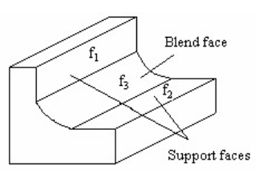 | 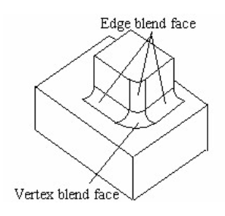
Fig 1. Blend face and its support faces [9] | Fig 2. Vertex blend face and edge blend face[9]

3 Algorithm for recognizing edge blend face with convexity characteristics
START

Read CAD STEP Part21 file

L/C
CS
AF
FB
EL
OE
EC
A2P
CP
D
OR
OR
OR
OR
OR
OR
OR
OR
OR

Identify ALL cylindrical surfaces

Determine cylindrical surfaces with two LINE edge only

Each LINE is TANGENT with a PLANE surface

Determine normal direction of the related PLANE surface

Convexity/ concavity test based on the normal direction of the related PLANE surface connected to a cylindrical surface

Automated machining feature recognition

STOP

Basic Entity of CAD STEP Part21 file
CS: closed shell
FB: face bound
EL: edge loop
OE: oriented edge
EC: edge curve
L/C: line or circle
A2P: axis2 placement
CP: Cartesian point
D: direction

Fig 3. Algorithm for recognizing edge blend face with convexity test
Figure 3 shows a new proposed algorithm on how to recognize an edge blend face with convexity attribute and used in automatic feature recognition. First, all CYLINDRICAL surface entities are identified from B-rep of solid models in CAD STEP Part21 file. Then, only CYLINDRICAL surface entities with two LINE edges which is tangent with adjacent PLANE are selected for following analysis. The normal direction of the adjacent PLANE is recognized. Convexity test is done based on the direction of the related PLANE surface which is connected a CYLINDRICAL surface. Then, edge blend face is assigned with the attribute as convex or concave based on the result of convexity test. The recognized edge blend faces with attributes will be used in automated machining feature recognition processes.

3.1 Determination of convexity/concavity of an edge or edge blend faces
Convexity of every edge of the object must be determined before other procedures taken for automatic machining feature recognition. Figure 4 shows some of the important parameters used for determining the convexity of an edge.

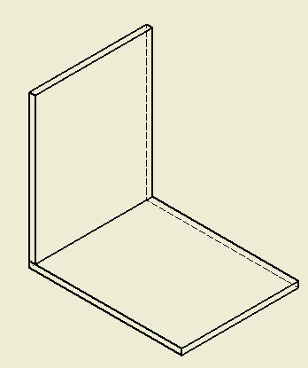
f_{j}

f_{i}

Fig 4. Important parameters for determining the convexity/concavity of an edge or edge blend face

The direction c of the edge shared by two faces can be determined by finding the result of cross product operation between two normal vectors of two faces as shown below.
c = f_{i} × f_{j} (3.1)
Taking the edge direction of f_{i} as a reference,
If c direction is same with oriented edge f_{i} direction,
Then the edge is CONVEX
If c direction is NOT same with oriented edge f_{i} direction,
Then the edge is CONCAVE

The usage of the concavity index for the effective recognition of the concave, open manufacturing features like open pockets, through slots and steps have been presented by [10]. The determination of this index using B-Rep representation is presented in detail by [10]. Besides that, algorithm for the recognition of manufacturing features defined in the STEP-NC standard. However, the recognition of the concave for edge blend faces have been neglected in previous study. As a result, this proposed research has adopted the convexity test for edge, used in determining the concave of edge blend faces.

3.2 A novel graph-based method for machining feature recognition with edge blend faces
At this stage, a novel method for machining feature recognition have been proposed with considering the edge blend faces in rectangular closed pocket recognition. However, graph based method seldom discussed the concavity or convexity edge blend feature present in the feature recognition process. In this case, concave edge blend face will be assign as -1 and convex edge blend face as 1. Lastly, a new graph method which includes the edge blend feature which is mark as darken edge in the graph is presented as shown in figure 5.
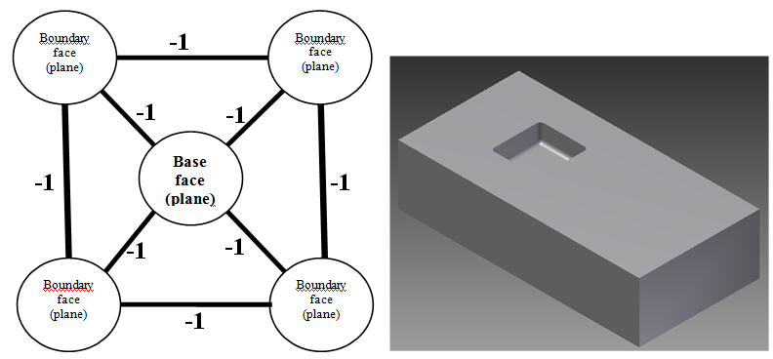

Fig 5. New graph-based method for pocket feature recognition with edge blend face

4 Implementation
The Microsoft Window based MS Access is used to develop the product model database system, and this system able to extract the geometry and topological data from EXPESS entities of CAD STEP Part21 for mapping to relational model. Each extracted entity is mapped to a table with columns for attributes. A column with a unique identifier is present for each instance in each of the table. Attributes with primitive values are stored in place, and composite values like entity instances, selects, and aggregates are stored as foreign keys containing the unique instance identifier. Structured Query Language (SQL) is used for both data definition and data manipulation in this system. One of the advantage of this database is it can be easily migrated into other advanced RDBMS [11]. Figure 6 shows the developed database system used for recognize pocket feature with edge blend face successfully.

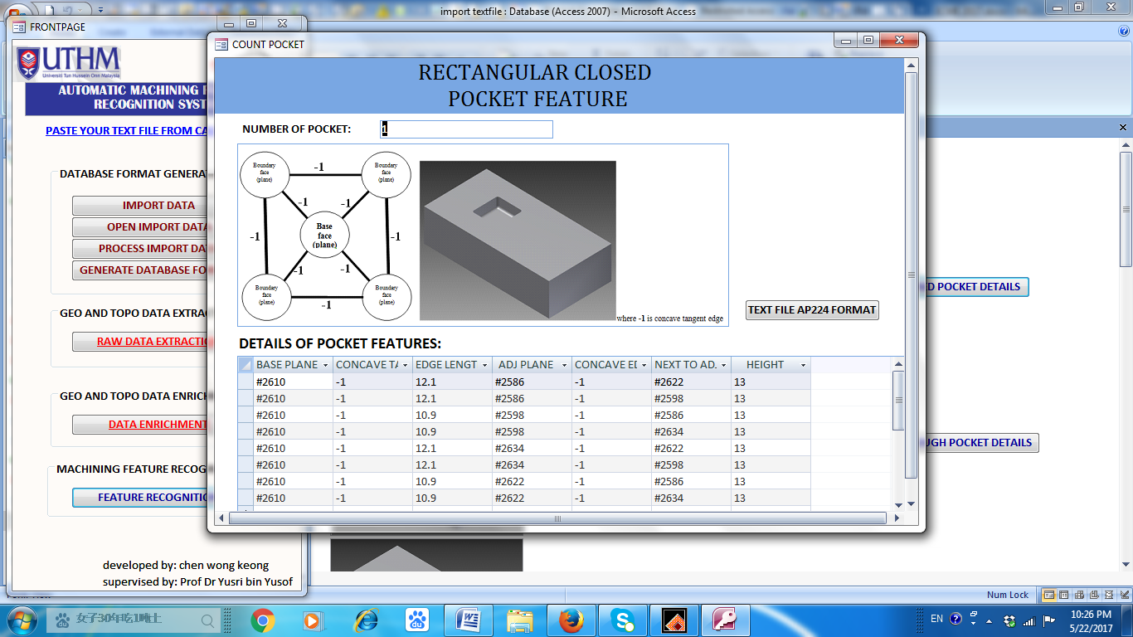
Fig 6. Details of recognized pocket feature with edge blend face in developed system

5 Conclusion and recommendation

In conclusion, this research concentrates on automatic machining feature recognition with edge blend face of geometry and topological data from CAD STEP Part21 file using EXPRESS schema entities are in the backend. Edge blend face (e.g. fillet feature) is one of the important elements have to be considered in machining feature recognition. However, it is seldom discussed in graph based method. In this research, a novel graph based method with edge blend face has been proposed with new table mapping used for machining feature recognition. This implementation provides flexible environment to the people, who are using STEP data and manage the EXPRESS entity data. This recognized machining feature with edge blend face is useful for subsequent manufacturing process, especially in computer-aided process planning (CAPP) and computer-aided manufacturing (CAM).

Acknowledgements This work was supported by the Malaysian Government under Science Fund of Ministry of Science, Technology and Innovation (MOSTI) with vote No S021, Malaysian International Scholarship (MIS) under Ministry of Education Malaysia (MOE), and Universiti Tun Hussein Onn Malaysia (UTHM).

References
1. Grabowik, C., K. Kalinowski, I. Paprocka, and W. Kempa. A survey on methods of design features identification. in IOP Conference Series: Materials Science and Engineering: IOP Publishing (2015)
2. Verma, A.K. and S. Rajotia, A review of machining feature recognition methodologies. Int. J. Comput. Integr. Manuf. 23(4): p. 353-368 (2010)
3. Babic, B., N. Nesic, and Z. Miljkovic, A review of automated feature recognition with rule-based pattern recognition. Computers in Industry. 59(4): p. 321-337 (2008)
4. JungHyun, H., M. Pratt, and W.C. Regli, Manufacturing feature recognition from solid models: a status report. Robotics and Automation, IEEE Transactions on. 16(6): p. 782-796 (2000)
5. Ansaldi, S., L.D. Floriani, and B. Falcidieno, Geometric modeling of solid objects by using a face adjacency graph representation. SIGGRAPH Comput. Graph. 19(3): p. 131-139 (1985)
6. Joshi, S. and T.C. Chang, Graph-based heuristics for recognition of machined features from a 3D solid model. Computer-Aided Design. 20(2): p. 58-66 (1988)
7. Tian, F., X. Tian, J. Geng, Z. Li, and Z. Zhang. A Hybrid Interactive Feature Recognition Method Based on Lightweight Model. in 2010 International Conference on Measuring Technology and Mechatronics Automation (2010)
8. Manafi, D., M. Nategh, and H. Parvaz, Extracting the manufacturing information of machining features for computer-aided process planning systems. Proceedings of the Institution of Mechanical Engineers, Part B: Journal of Engineering Manufacture, (2016)
9. Cui, X., S. Gao, and G. Zhou, An Efficient Algorithm for Recognizing and Suppressing Blend Features. Computer-Aided Design and Applications. 1(1-4): p. 421-428 (2004)
10. Pobożniak, J., Using Concavity Index For Manufacturing Feature Recognition. Technical Transactions,(7) (2015)
11. Babu, K.S., D.D.N. Rao, D.A. Balakrishna, and C.S. Rao, Development Of A Manufacturing Database System For Step-Nc Data From Express Entities. International Journal of Engineering Science and Technology 2 (11): p. 6819-6828 (2010)

yusri@uthm.edu.my

