Study on the biodegradability and water adsorption of LDPE/Sago starch blend

Shaharuddin Kormin¹, Faridah Kormin², Mohammad Dalour Hossen Beg³, Mohd Bijarimi Mat Piah³
¹Faculty of Manufacturing and Mechanical Engineering, University Tun Hussein Onn, 86400 Parit Raja, Batu Pahat, Johor, Malaysia
²Faculty of Science, Technology and Human Development, University Tun Hussein Onn, 86400 Parit Raja, Batu Pahat, Johor, Malaysia
³Faculty of Chemical and Natural Resources Engineering, Universiti Malaysia Pahang Lebuhraya Tun Razak, 26300 Kuantan, Pahang, Malaysia

Abstract.The aim of this study is to develop starch filled-LDPE composites with enhanced degradable properties. The degradable test has been carried out by hydrolysis and natural weathering exposure. The water uptake of the composites has been determined. The degradability of the compatible thermoplastic LDPE/starch was investigated by weight loss percent (WLP). Simple and alkaline hydrolysis of the composites apparently involves surface starch granules; embedded granules are not easily accessible because of the poor moisture absorption of the matrix. Exposure of the composites to natural weathering resulted in massive deterioration typified by turbidity, discoloration, embrittleness and dimensional changes. Moisture uptake increased with increased starch content and immersion time. The time taken for the composites to equilibrate was about three months even when they were immersed completely in water. The mechanical properties of the composite also dropped with increasing moisture uptake. SEM imaging was also carried out on the samples before and after degradation. High content of starch also was found to increase the rate of biodegradability of LDPE/sago starch mould. It can be proved by exposure of the mould to natural, degradable and fungi environment.

Keyword: Low density polyethylene, sago starch, hydrolysis, natural weathering,

1. Introduction

During the latter of this century, synthetic polymers have become major new materials for a wide range of applications, such as packaging, industrial, medical etc. Low density polyethylenes (LDPE) are the most commonly used synthetic plastics [1]. They are slow in degradability in natural environments, causing serious environmental problems. In this regard, there is growing interest in non-degradable synthetic polymer biodegradation using starch [2]. The addition of starch as a filler for producing biodegradable composites has been studied by many researcher. Starch is identified as a key natural product for the production of biodegradable plastic. Lowering the amount of synthetic polymer by blending with starch is a strategy widely adopted for research.[3]
Degradation is irreversible change in chemical and physical properties of a polymer with time generally leading to deterioration in mechanical properties. This is normally measured as decrease in tensile, toughness and impact resistance. The time taken for the properties of polymer to become unacceptable is the durability of the polymer [4-5]. The process of degradation describes the chain scission process during which polymer chains are cleaved to form oligomers and finally to form monomer [5]. The increased outdoor use of plastic has created a need for a better understanding of the effect of the environment factor has significant effect on appearance and properties of composites. The severity of the damage depends largely on factors such as the nature of environment, types of polymeric material, and duration of exposure. The effect can be anywhere from discolouration, embrittlement, and cracking to a complete breakdown of the polymer structure [5-6]
The main objectives of this paper were to investigate effect of hydrolysis and natural weathering environment on the biodegradability of LDPE/sago starch blend at certain period of time.

_______________________________________
*Corresponding author : faridahk@uthm.edu.my
2. Experimental

2.1 Materials

Sago starch as filler used in this study was food grade stuff. Sago starch was purchased from G-far keropok enterprise (Malaysia). The moisture content of the starch was 13% and the granule sizes ranged from 9 µm to 35 µm. Low density Polyethylene (LDPE) with melting temperature of 140°C, was collected from Petlin Malaysia Sdn Bhd (Malaysia). Maleic Anhydride Grafted Polypropylene (MAPP) was chosen as a coupling agent which supplied by MTBE (M) Sdn Bhd.(Malaysia). Aspergillus niger was purchased from National Pharmaceutical Control Bureau (Malaysia).

  - Sample preparation for sago starch/LDPE blend

The starch and Low density polyethylene was dried before sample preparation in an oven at 70 °C for 24 h and then cooled in a desiccator for 1 h to ensure it was moisture free. The sample was mixed and placed in a airtight plastic container to equilibrate for 12 h at 25 °C and then extruded. Table 1 represents the different composition of the blend. The compounding of LDPE/starch blend will be done using Brabender twin screw extruder. The compounding process will carried out at a speed of 80 rpm and the temperature will be set at 150ºC/150ºC/140ºC/140ºC [7] (Shah et al., 1995). The sample was fed manually as much as the extruder would process. The extrudates will be palletized using a pelletizer machine for each formulation and were stored in a airtight plastic container.

  - Injection molding

After the storing process, the pallets were injection moulded with injection moulding machine equipped with a diameter 35 mm screw. Dumbbell test specimens were injection moulded for the tensile, flexural and impact measurements. The injection moulding pressure was 1400 bars, and the holding pressure was varied from 600 to 1000 bars. The injection moulded specimens were stored in a airtight plastic container.

Table 1 Composition (w/w) of LDPE/Sago starch blend
No | Samples | LDPE  (w/w %) | Sago Starch  (w/w %)
1 | Native LDPE | 100 | -
2 | LDPE/SS:95/5 | 95 | 5
3 | LDPE/SS:90/10 | 90 | 10
4 | LDPE/SS:85/15 | 85 | 15
5 | LDPE/SS:80/20 | 80 | 20
6 | LDPE/SS:75/25 | 75 | 25
7 | LDPE/SS:70/30 | 70 | 30

2.4 Water absorption
Water absorption test was carried out according to ASTM Standard D750-95 [16]. The mould item products, in the size of 2.0 x 3.5 cm, were dried for 6 hours at 50˚C before they were cooled and weighed. The samples were soaked in distilled water at 23±1˚C. The samples were periodically weighted every 2 days to record any change in their weights. The percentage of the water absorption by films was then calculated using the following formula:

(1)

Where W_{f} is the final increased weight percentage, W_{w}, the wet weight and W_{c}, the conditioned weight of the testing samples.

2.5 Biodegradation studies

2.5.1 Hydrolysis
2.5.1.1 Simple hydrolysis
The method used was according to the one proposed by Arvanitoyannis et al. (1997) [1]. The samples in the size of dumbbell shapes were soaked in 20 ml distilled water at 70˚C. The changes in the weight were measured every 3 hours in order to record the weight losses versus time.

2.5.1.2 Alkali hydrolysis

The method used was that of Arvanitoyannis et al. (1997). The samples with the size of dumbbell shape were soaked in 20 ml 0.1 sodium hydroxide at 70˚C. The changes in weight were measured every 3 hours to record the weight losses versus time.

2.5.2 Natural weathering test

The surfaces of the dumbbell samples mounted on racks were exposed to naturally actinic radiation in UMP gambang, kuantan for 6 month. The rack will be adjusted to face the equator at an angle of 45º and the rack is situated at an open area whereby it is free from being overshadowed by other objects. The specimens will be exposed to all environmental effects such as rain, sunlight and wind. The average temperature was 27.15±0.50ºC with relative humidity 60%. A control experiment on similarity prepared samples was carried out indoor to compare with those under outdoor exposure, which indicates their shelf life. Weight loss of the polymer with respect to time was recorded as a measure of degradation.

2.6 Weight Loss Percent (WLP)

The weight loss percent was determined as the following method: Prior to the experiment, the mould samples were accurately weighed. After the mould samples were placed at the degradable environments, they were also accurately weighed. The ratio of the weight reduction of the mould after degradation to the original weight of the mould prior to degradation was defined as weight loss percent. The formula of WLP was as follows:

(2)

Where WLP (%) refers to the weight loss percent of the degradable mould; W_{e} refers to the weight of the mould after degradation; W_{o} refers to the weight of the mould before degradation.

2.7 Scanning electron microscope (SEM)

Morphological studies were carried out on the tensile fracture surface of test specimen. The morphological surface of the samples before and after biodegradation was studied by using EVO 50 (ZEISS brand) at 300KV. Test samples were first sputter-coated with gold to prevent any electrical discharge during testing. The coated sample was then observing the microstructures of the specimen.

3. Result and discussion

3.1 Water absorption

Starch content influences the water absorption of LDPE/Sago starch blend. This phenomenon can be observed through Figure 1 that shows the variation in water absorption with time of immersion. Water absorption increased with immersion time and increasing sago starch content. Rapid water absorption was observed for all samples within the first few days of immersion, but this decreased slowly with time. This phenomenon has been observed at different relative humidity. The absorption of water is related to its rate of diffusion into the composites. Starch based synthetic materials tend to absorb water because the hydroxyl group in starch can form a hydrogen bond with water. Since the starch is hydrophilic, it has a highly tendency to attract water molecules. There are also high amylopectin in sago starch (73%) that influenced the water absorption. researcher reported that the starch blends containing high amylopectin content absorbed more water.

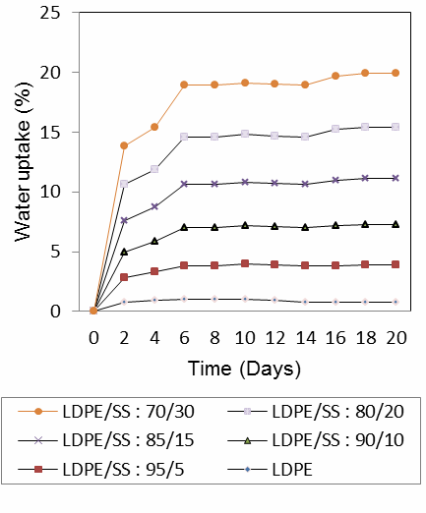
Figure 1 Percentages of water absorption for LDPE/Starch blend with time of Immersion

3.2 Biodegradation studies

3.2.1 Hydrolysis

The data obtained from the simple hydrolysis test are shown in figure 2(a). Native LDPE significantly experienced a slower weight loss as compared to LDPE filled sago starch blend. LDPE with higher amount of starch showed higher weight losses. This might be due to the loss of starch which got dissolved in water.
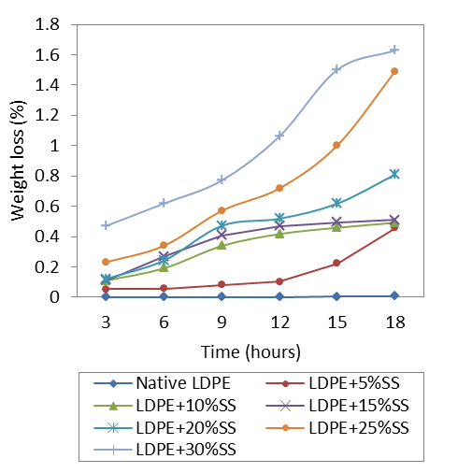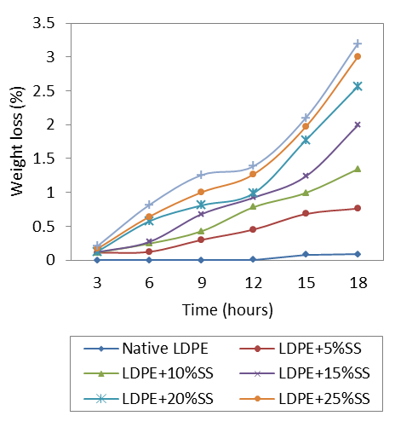
(a) (b)

Figure 2: Percentage weight loss versus degradation time on LDPE/Sago starch (5wt% to 30wt%) a) Simple hydrolysis b) Alkaline hydrolysis.

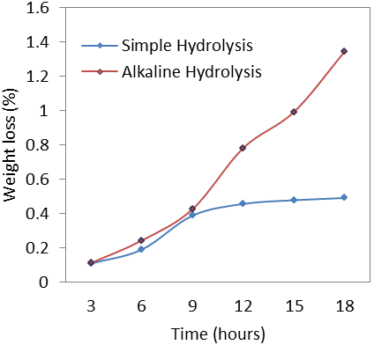

Figure 3: Percentage weight loss versus degradation time of LDPE/SS:90/10 starch blend on hydrolysis.

Figure 2(b) illustrates the results of the alkali hydrolysis test. All the LDPE/SS blend showed a drastic weight loss versus hydrolysis time, compared with the native LDPE without sago starch. As seen in a figure 3, the alkali hydrolysis caused a higher weight loss as compared to the simple hydrolysis. Thus, NaOH was found to enhance the solubilization of gelatinized starch in the polymer blend [1]. The purpose of using these methods for assessing the biodegradability of blend was to prove that the synthesized composites could be degraded in water with different values of pH. Higher pH values could accelerate the degradability of starch based mould.

Figure 4 is a SEM micrograph of LDPE/Sago starch blend (containing 10 w/w% starch) after 18 hour of hydrolysis. SEM photographs demonstrated degradation of starch particles within the LDPE. Starch particles in all specimens degraded regardless of degradable environments. Large crack and hole appear on the surface of the matrix which apparently resulted in its collapse, thus exposing the embedded starch granules. Fracture surface of alkaline hydrolysis show many crack, void and holes compare to fracture surface of simple hydrolysis. This proves that higher pH value can affect the degradation of the composites.

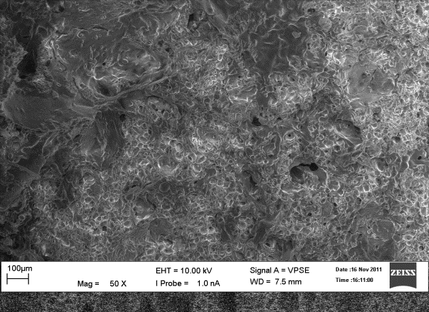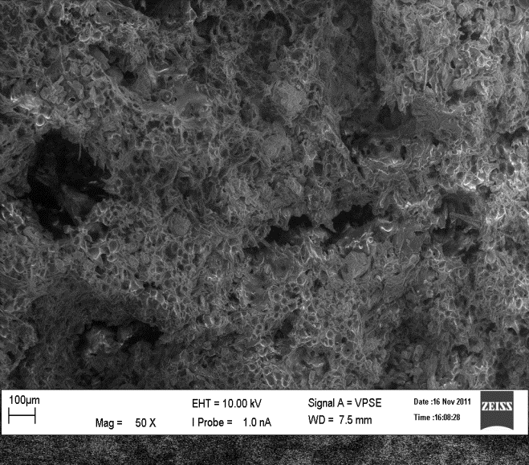
a)
b)

Figure 4: SEM micrograph (50x) fracture surface of LDPE/SS:90/10 starch blend; a) simple hydrolysis b) alkaline hydrolysis after 18 hour hydrolysis testing.

3.2.2 Natural weathering test

All LDPE/starch specimens were exposed to natural weathering for a period of 6 months and weight loss was recorded every months. The samples were not discoloured indicating that samples were not chemically interacted, but reduction in weight was observed. This is due to bleaching, dissolving or degradation of starch microorganism attack and enhancing biodegradation. Figure 5 show the percentage of weight loss of LDPE/Sago starch blend after within 6 month natural weathering exposure. It shows the weight loss within the period of investigation ranged from 5% to 16% in the six month. The blends containing a higher percentage of starch (20% and 30% starch content) degraded rapidly in first 30 days, during which the maximum starch content was accessed.

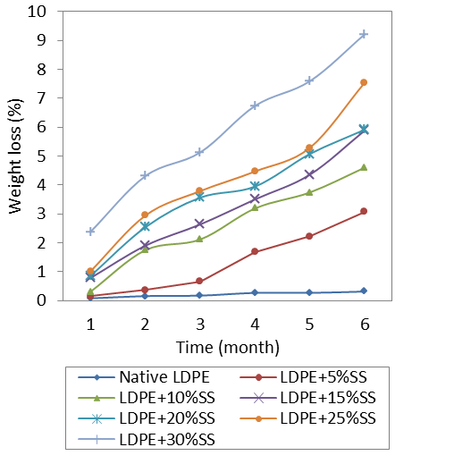
Figure 5: Percentage weight loss versus degradation time of LDPE/Sago starch (5wt% to 30wt%) on natural weathering.

Figure 6 is a SEM micrograph of native LDPE and LDPE/Sago starch blend (containing 10 w/w% starch) before and after six month natural weathering. Large crack and hole appear on the surface of the matrix which apparently resulted in its collapse, thus exposing the embedded starch granules.

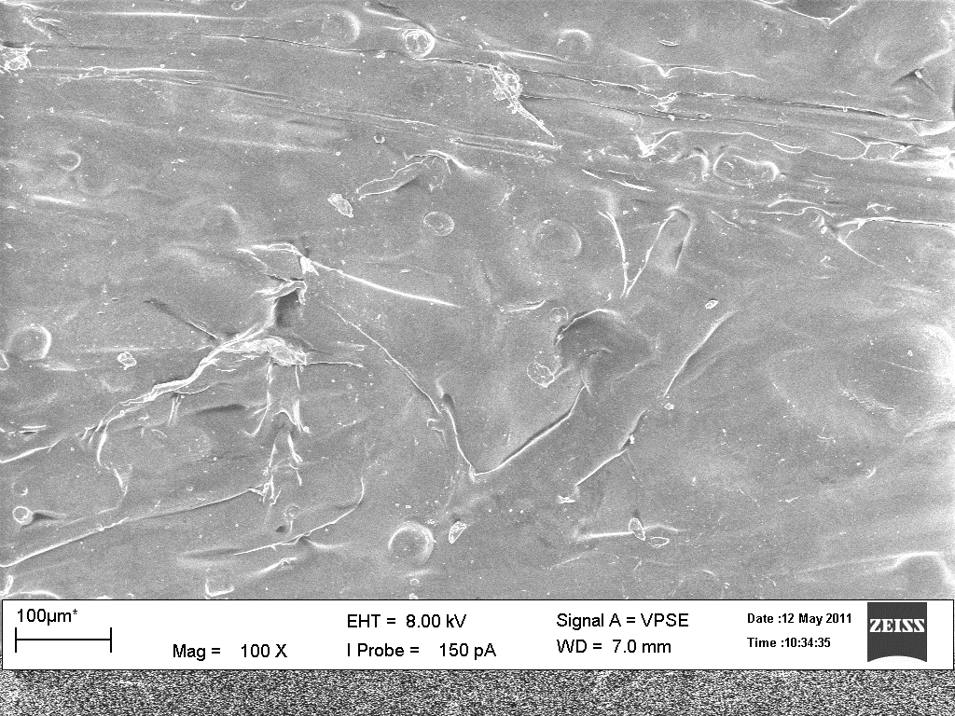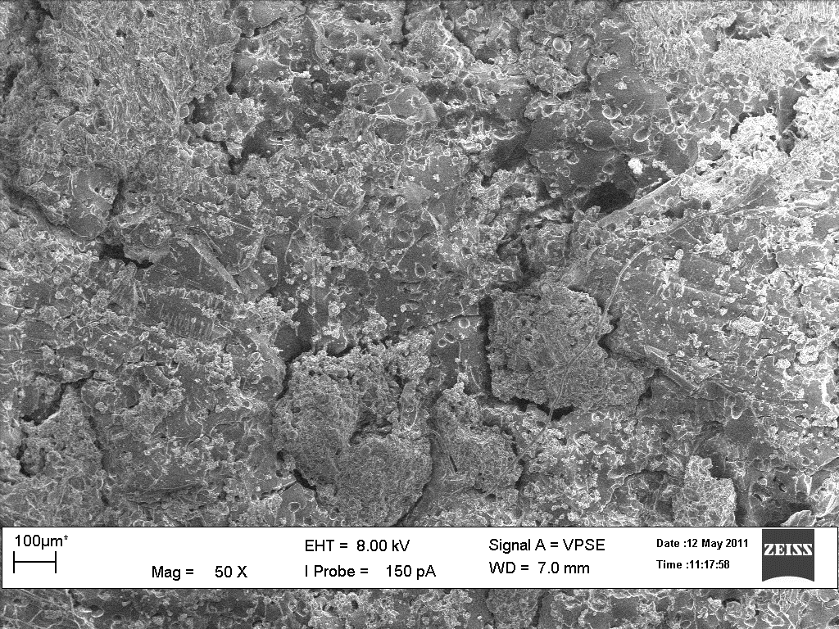
a)
b
Sago granule
Crack and hole

Figure 6 SEM micrograph (50x and 100x) of LDPE/Sago starch blend surface a) LDPE/SS:90/10 before natural weathering exposure b) LDPE/SS:90/10 after 6 month natural weathering exposure.

4. Conclusion

Starch is blended with synthetic polymer to induce degradability of synthetic polymers. Addition of sago starch to LDPE alters the mechanical properties of LDPE but enhanced biodegradability of the composites. Sago starch filled-LDPE composites absorb moisture in proportion to the amount of starch added. The ability of the composites to absorb moisture not only reduces their mechanical properties but also renders them susceptible to fungal attack, thus limiting their use. Degradation studies show that the composites exhibit varying degrees of degradation. Alkaline hydrolysis produced high dramatic changes and conduct fast degradation compared to simple hydrolysis. Natural weathering exposure and soil burial resulted in weight loss, a reduction in mechanical properties, surface tearing and the production of holes.
Microbial degradation in laboratory by exposure to Aspergillus Niger was done and this confirmed the microbial degradability of sago starch based LDPE. Consumption of sago starch as a biodegradable agent initiates the biodegradation process. According to this research, sago starch based low density polyethylene is a microbial biodegradable polymer.

Acknowledgement

The authors gratefully acknowledge to the Faculty of chemical engineering and natural resources, UMP Pahang for financial, material and instrument support. We also thank to Petlin Polyethylene Sdn Bhd (Malaysia) and TATI university colleague for supply of materials and instrument support. Special thank to Dr. Mohammed Dalour Hossen Beg, senior lecturer, UMP Pahang for his kind and unconditional support.

;
References

1. Arvanitoyannis, I., Billiaderis, C. G., Ogawa, H., & Kawasaki, N. Journal of Carbohydrate Polymers, 36, 89–104.
2. Tharanathan, R. N. (2003). Biodegradable films and composite coatings: Past, present and future. Trends in Food
Science and Technology, 14, 71–78
3. Mali, S., & Grossmann, M. V. E. (2003). Effects of yam starch films on storability and quality of fresh
strawberries. Journal of Agricultural and Food Chemistry, 7005–7011.
4. R. Chandra and R. Rustgi. Prog. Polym. Sci, 23, pp 1273-1335, 1998.
5. O. Akaranta and G. E. Oku. Carbohydrate Polymers, 39, pp 89-91, 1999.
6. I. M. Thakore, S. Iyer, A. Desai, A. Lele, and S. Devi, Journal of Applied Polymer Science, 74, pp 2791-2802,
7. P. B. Shah, S. Bandopadhyay, and J. R. Bellare, Polymer Degradation and Stability. 47, pp 165-173, 1995
8. R. Nawang, I. D. Danjaji, U. S. Ishiaku, H. Ismail, and Z. A. Mohd Ishak, Polymer Testing, 20, pp 167-172, 2001.

