**UAV telemetry communications using ZigBee protocol**

**T H Nasution1, I Siregar2, M Yasir1**

1Department of Electrical Engineering, Universitas Sumatera Utara, Medan, Indonesia

2Department of Industrial Engineering, Universitas Sumatera Utara, Medan, Indonesia

Email: tigor.nasution@usu.ac.id

**Abstract.** Wireless communication has been widely used in various fields or disciplines such as agriculture, health, engineering, military, and aerospace so as to support the work in that field. The communication technology is typically used for controlling devices and data monitoring. One development of wireless communication is the widely used telemetry system used to reach areas that cannot be reached by humans using UAV (Unmanned Aerial Vehicle) or unmanned aircraft. In this paper we discuss the design of telemetry system in UAV using ZigBee protocol. From the test obtained the system can work well with visualization displays without pause is 20 data per second with a maximum data length of 120 characters.

# Introduction

Along with the development of the times and technology needs of rapid information is needed in various fields, agriculture, industry, medical, meteorological stations, and remote area [1] so that it can support the performance of the field. The technology is typically used for controlling devices and data monitoring [2]. However, in monitoring and measurement, not all conditions are possible to be carried out directly due to geographical and distance factors, it can inhibit the data. Constraints on these measurements can be overcome by remote measurement method (telemetry) using UAV (Unmanned Aerial Vehicle) [3,4]. The telemetry process is the measurement of the parameters of an object (objects, space, natural conditions) whose measurement results will be sent elsewhere either via cable or wireless [5,6]. The telemetry communications UAV is carried out wirelessly.

Previously there were several studies on UAV telemetry. Some researchers have discussed the model of communication or transmission media [7,8]. Research on the telemetry model in the UAV for monitoring has also been conducted [9]. Some have discussed the use of telemetry in UAVs to monitor the disaster area [10]. These researches continue to grow along with the development of wireless communication technology.

In contrast to previous studies, in this paper we designed a telemetry communication system in UAV using ZigBee protocol. Zigbee is widely used for wireless technology, because it has many advantages including ultra-low power consumption, low cost, and eases of design [11]. The ZigBee protocol is adopted for wireless communication to achieve high integration, applicability, and portability [12]. The system consists of a GCS (Ground Control Station) that will communicate with UAVs. The GCS interface is built using Microsoft Visual Studio with C # language running on the computer and connected to the UAV wirelessly using XBee Pro RF Transceiver 2.4 GHz. GCS can display visualization of UAV flight parameters through instrument panel that displays airspeed, heading (yaw), cornering and pitch and roll, barometric height, turn and bank rate, as well as climb speed according to data Obtained from IMU10ODF sensors as well as data from GPS.

# Materials and Method

In this study, the functionality of the system created focused on the functionality of the data telemetry system. To support maximum telemetry system UAV data function required RF devices, long range antenna and GCS. The RF device used is the XBee module (ZigBee) and the antenna used is the 2.4 GHz yagi antenna. While the required GCS device has the following specifications:

* Visual instrument panel featuring basic flight instruments such as altitude indicator, airspeed indicator, artificial horizon, vertical speed indicator (climb speed), attitude indicator / artificial horizon, indicator Direction (compass / heading indicator), and GPS lock status.
* Control engine on UAV (ON, FIRE, STOP / PARACHUTE).

The GCS system is made up of two major parts of hardware and software. GCS hardware part serves to capture data sent by UAV via RF transmitter (ZigBee) and convert to form data that can be processed by software. In addition to processing data obtained telemetry to visualize, the software also serves to store and provide feedback in the form of commands such as turning on, off, and activate the data transmission. The design scheme of this system can be seen in figure 1.

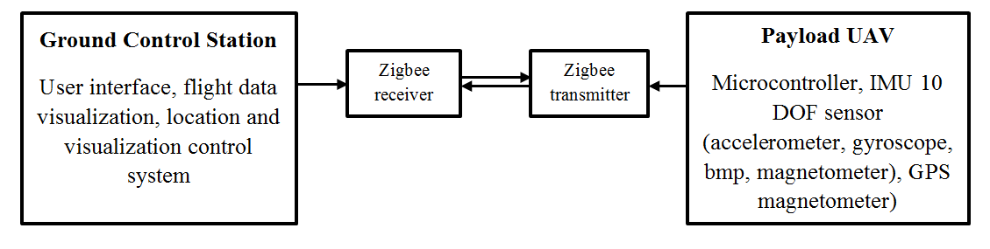

Figure 1. The design scheme of this system

## *XBee Pro*

XBee Pro is a module that allows Arduino Uno to communicate wirelessly using ZigBee protocol. ZigBee operates using on IEEE 802.15.4 specifications operating at 2.4 GHz, 900 and 868 MHz frequencies. XBee Pro can be used instead of serial cable. XBee Pro is expected to reduce costs and become low-power connectivity for equipment that requires batteries to live for several months to several years, but does not require high data transfer rates. XBee Pro enables wireless communications within reach of up to 100 meters indoor and 1500 meters outdoor. In this we use the XBee S2Pro radio module as shown in figure 2.

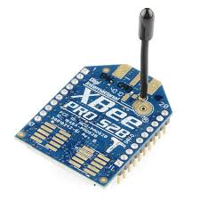

Figure 2. XBee S2Pro

Remote monitoring and measurement systems consist of two of the same XBee Pro modules previously programmed as a receiver-transmitter and transmitters [13]. There are several topology forms commonly used, among others, mesh topology, peer, star, and cluster trees. Topology on XBee Pro network Topology pair is a simple network using only two XBee or node. One node must be the coordinator so that the network can be established. And the other is configured as a router or end device. We use the XCTU application to setup both modules.

## *Sensor IMU 10 DOF*

The IMF sensor module (inertial measurement unit) 10 DOF gy-80 sensor consists of 4 sensors namely, 3 Gyro axis, 3 Axis Accelerometer, 3 Axis Magnetometer, and barometer as shown in figure 3. All sensors communicate using I2C bus protocol so it takes 4 Paths is:

1. GND – Ground
2. 2Supply voltage or source voltage +3.5 V to +5 V.
3. 3SCL for I2C clock
4. SDA for I2C data.

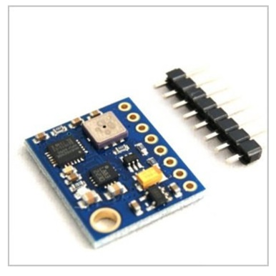

Figure 3. Sensor IMU 10 DOF

## Designing Software

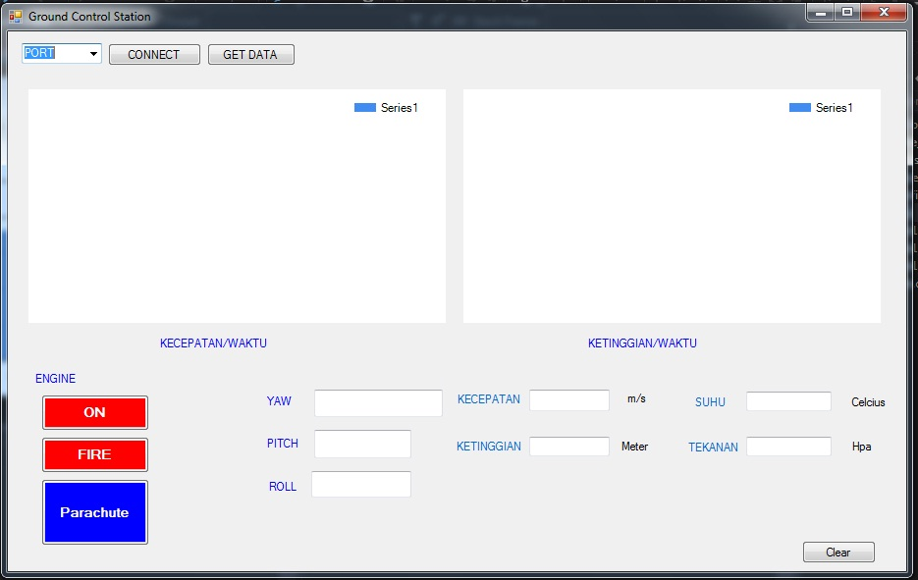

Figure 4. User Interface

To meet the needs in accordance with the needs, the software interface designed to be made into several parts such as figure 4. Speed graph of time will display acceleration UAV to monitor the stability of flying. The time height graph is designed to show the vertical speed of the object. Engine is a feature that functions as ON, Fire, Stop / Parachute. While data sent sensors and GPS will be displayed as well.

As planned, software that is also a graphical user interface with UAV is developed using C # language in Microsoft Visual Studio 2010 Ultimate software licensed for free from MSDNAA

In addition to being displayed visually through the visual instrument panel, flight parameter data obtained from IMU10ODF is also displayed numerically. As shown in the figure 4 is a display of IMU10DOF data located under the visual instrument panel

# Results and Discussions

The functional test results of all instruments and visualizations on the GCS interface can respond well to the entire range of data provided through the serial port. Maximum data rate that can be processed so that displaying visualization without pause is 20 data per second with maximum data length of 120 characters. The results of the data responses obtained can be seen in Table 1.

Table 1. the results of the data responses

|  |  |  |  |  |  |  |  |  |
| --- | --- | --- | --- | --- | --- | --- | --- | --- |
| YAW | PITCH | ROLL | temperature | PRESSURE | ALTITUDE | LATITUTE | LONGITUDE | ALTITUDE(gps) |
| 20.18 | -39.84 | -18.31 | 30.16 | 788.49 | 2227.34 | 3.568529 | 98.655136 | 54.75 |
| -6.42 | -24.83 | -25.71 | 30.16 | 820.03 | 1863.53 | 3.568530 | 98.655136 | 55.17 |
| -13.80 | -9.14 | -27.96 | 30.12 | 851.57 | 1515.84 | 3.568531 | 98.655136 | 54.67 |
| -18.02 | -13.33 | -33.03 | 30.12 | 883.12 | 1183.30 | 3.568530 | 98.655136 | 55.17 |
| -43.84 | -19.23 | -0.21 | 30.08 | 914.66 | 864.52 | 3.568530 | 98.655143 | 54.75 |
| -50.79 | -26.35 | -19.03 | 30.08 | 946.21 | 558.68 | 3.568530 | 98.655143 | 55.09 |
| -76.76 | -43.69 | -10.95 | 30.06 | 977.75 | 264.75 | 3.568529 | 98.655143 | 54.17 |
| -88.44 | -75.42 | 3.41 | 30.06 | 1009.30 | -18.12 | 3.568527 | 98.655136 | 54.75 |
| -90.55 | -39.52 | 19.75 | 29.99 | 1009.31 | -18.24 | 3.568526 | 98.655136 | 54.41 |
| -80.03 | 11.20 | 16.11 | 29.99 | 1009.32 | -18.30 | 3.568525 | 98.655136 | 54.75 |
| -109.13 | -37.27 | 2.70 | 29.98 | 1009.33 | -18.41 | 3.568525 | 98.655143 | 55.17 |
| -130.43 | 24.25 | -48.27 | 29.98 | 1009.33 | -18.43 | 3.568525 | 98.655143 | 55.09 |
| -149.17 | 27.33 | -62.23 | 29.99 | 1009.34 | -18.50 | 3.568525 | 98.655143 | 55.09 |
| -129.09 | 48.95 | -25.40 | 29.99 | 1009.34 | -18.47 | 3.568523 | 98.655143 | 55.25 |
| -145.83 | 21.81 | -13.79 | 29.97 | 1009.34 | -18.48 | 3.568526 | 98.655136 | 55.33 |
| -178.39 | 60.05 | -0.64 | 29.97 | 1009.34 | -18.49 | 3.568531 | 98.655143 | 56.09 |
| -115.09 | 65.98 | -22.11 | 29.94 | 1009.34 | -18.53 | 3.568534 | 98.655143 | 56.09 |
| -140.48 | 24.70 | -5.07 | 29.94 | 1009.33 | -18.37 | 3.568537 | 98.655151 | 56.17 |
| -127.56 | 21.16 | -4.19 | 29.94 | 1009.31 | -18.24 | 3.568536 | 98.655151 | 56.17 |
| -125.72 | 34.37 | -10.97 | 29.94 | 1009.29 | -18.09 | 3.568538 | 98.655166 | 56.17 |
| -168.86 | 14.50 | 49.57 | 29.90 | 1009.28 | -17.93 | 3.568539 | 98.655174 | 56.34 |
| -105.48 | 27.38 | 39.16 | 29.90 | 1009.26 | -17.78 | 3.568538 | 98.655181 | 56.34 |
| -98.14 | 29.89 | 20.79 | 29.90 | 1009.24 | -17.64 | 3.568536 | 98.655189 | 55.75 |
| -60.56 | 6.40 | 13.84 | 29.90 | 1009.23 | -17.54 | 3.568535 | 98.655197 | 55.67 |
| -65.98 | 6.14 | -23.27 | 29.87 | 1009.22 | -17.45 | 3.568534 | 98.655204 | 55.67 |
| -63.83 | -0.51 | -34.10 | 29.87 | 1009.21 | -17.38 | 3.568533 | 98.655212 | 55.67 |
| -23.97 | 7.72 | -4.92 | 29.87 | 1009.21 | -17.34 | 3.568531 | 98.655220 | 55.25 |
| 20.41 | 3.03 | -16.62 | 29.87 | 1009.20 | -17.31 | 3.568528 | 98.655227 | 55.75 |
| 34.16 | 17.63 | -35.00 | 29.81 | 1009.20 | -17.28 | 3.568530 | 98.655235 | 55.50 |
| 2.30 | -15.22 | -38.66 | 29.81 | 1009.19 | -17.22 | 3.568531 | 98.655242 | 55.75 |
| -18.55 | -25.34 | -59.63 | 29.82 | 1009.19 | -17.18 | 3.568527 | 98.655250 | 56.17 |
| -22.07 | -14.32 | -44.55 | 29.82 | 1009.18 | -17.13 | 3.568523 | 98.655265 | 56.09 |

When testing is obtained the calculation of the average number of incoming data every second is 8 data with a data width of 90-120 characters. For data variation is given treatment on sensors in IMU10DOF module to see the response. Variations in attitude data variables (yaw pitch and roll) are obtained by changing the position of the IMU Razor 9 DOF sensor connected to IMU10DOF.

# Conclusion

From the tests performed, the system can run as expected. GCS can communicate with UAV by receiving data obtained from IMU10DOF sensors. The system can work by displaying data on the GCS interface with 20 data per second with a maximum data length of 120 characters. From these results it can be concluded that the ZigBee protocol can be used for telemetry in the UAV.

**Acknowledgments**

The authors gratefully acknowledge that the present research is supported by Ministry of Research and Technology and Higher Education Republic of Indonesia. We thank the Vice Rector for Research, Service, and Cooperation University of Sumatera Utara that have supported this research activity. All the faculty, staff members and lab technicians of Electrical Engineering Department, whose services turned my research a success. My Wife, Erna Kurnia and children, Zafran Ahmad Nasution and Zaura Aisya Nasution, family members and friends, without whom I was nothing; they not only assisted me financially but also extended their support morally and emotionally. The support is under the research grant TALENTA USU of Year 2017.

**References**

x

|  |  |
| --- | --- |
| [1] | R. Rahmat, M. Syahputra, and M. Lydia, "Real Time Monitoring System for Water Pollution in Lake Toba," in *2016 International Conference on Informatics and Computing (ICIC)*, Mataram, 2016, pp. 383-388. |
| [2] | T. H. Nasution et al., "Electrical appliances control prototype by using GSM module and Arduino," in *2017 4th International Conference on Industrial Engineering and Applications (ICIEA)*, Nagoya, 2017, pp. 355-358. |
| [3] | T. Raj and F. H. Hashim, "Development of an autonomous flight controller circuit with real time data transmission," in *2016 International Conference on Advances in Electrical, Electronic and Systems Engineering (ICAEES)*, Putrajaya, 2016, pp. 115-119. |
| [4] | J. A. Alfredsen, T. A. Johansen and K. R. SkØien A. Zolich, "A communication bridge between underwater sensors and unmanned vehicles using a surface wireless sensor network - design and validation," in *OCEANS 2016*, Shanghai, 2016, pp. 1-9. |
| [5] | S. Ponomarev and T. Atkison, "Industrial Control System Network Intrusion Detection by Telemetry Analysis," *IEEE Transactions on Dependable and Secure Computing*, vol. 13, no. 2, pp. 252-260, March 2016. |
| [6] | Komkrit Chooruang and Pongpat Mangkalakeeree, "Wireless Heart Rate Monitoring System Using MQTT," *Procedia Computer Science*, vol. 86, pp. 160-163, March 2016. |
| [7] | Li Bing, "Study on Modeling of Communication Channel of UAV," *Procedia Computer Science*, vol. 107, pp. 550-557, January 2017. |
| [8] | M. Rice, M. S. Afran, and M. Saquib, "Equalization in aeronautical telemetry using multiple transmit antennas," *IEEE Transactions on Aerospace and Electronic Systems*, vol. 51, no. 3, pp. 2148-2165, July 2015. |
| [9] | M. Satrio, A. A. Rafsanjani and R. R. T. Sadewo G. Nugroho, "Avionic system design Unmanned Aerial Vehicle for disaster area monitoring," in *015 International Conference on Advanced Mechatronics, Intelligent Manufacture, and Industrial Automation (ICAMIMIA)*, Surabaya, 2015, pp. 198-201. |
| [10] | J. Tristancho, C. Barrado, S. P. Mansilla, and E. Pastor, "A telemetry modeling for intelligent UAV monitoring," in *2009 IEEE/AIAA 28th Digital Avionics Systems Conference*, Orlando, 2009, pp. 7.C.1-1-7.C.1-4. |
| [11] | K. L. Chen, Y. R. Chen, Y. P. Tsai, and N. Chen, "A Novel Wireless Multifunctional Electronic Current Transformer Based on ZigBee-Based Communication," *IEEE Transactions on Smart Grid*, vol. 8, no. 4, pp. 1888-1897, July 2017. |
| [12] | L. H. Wang, T. Y. Chen, K. H. Lin, Q. Fang, and S. Y. Lee, "Implementation of a Wireless ECG Acquisition SoC for IEEE 802.15.4 (ZigBee) Applications," *IEEE Journal of Biomedical and Health Informatics*, vol. 19, no. 1, pp. 247-255, January 2015. |
| [13] | J. C. Chou et al., "Wireless Sensing System for Flexible Arrayed Potentiometric Sensor Based on XBee Module," *IEEE Sensors Journal*, vol. 16, no. 14, pp. 5588-5595, July 2016. |

x