Effect of Milling times and Carbon content on Structural and Magnetic properties of Fe-Mn Alloys

K. Tarigan1, Y. Kusuma1, D. Sebayang1 and D. S. Yang2

1Department of Mechanical Engineering, Mercu Buana University, Jakarta 11650, Indonesia.

2Physics Division, School of Science Education, Chungbuk National University, Cheongju 361-763, Korea

Email: kontan.tarigan@mercubuana.ac.id

**Abstract:** The structural and the magnetic properties of nanocrystalline *Fe47.5Mn47.5C5*alloys were prepared by using a mechanical alloying technique, used the commercial *Fe, Mn,* and *C* powders as precursors. It was studied in detail as function of the milling times of *1-* to *48* hrs. The structural analysis based on X-ray diffraction and extended X-ray absorption fine structure spectroscopy revealed that the alloying process took place after 36 hrs milling. Concerning the magnetic behavior, the data obtained from a vibrating sample magnetometer showed that both the magnetic saturation and the coercivity depended strongly on the milling time and the crystallite size. With these results, by adjusting the milling time shows that an appropriate structural transformation and appropriate magnetization value.

1. Introduction

In recent years, nanocrystalline and amorphous magnetic materials have been studied for many applications in industrial products. The wide range of applications arises from the versatile nature of these materials which can provide fast magnetization reversal with minimal magnetic losses. Mechanical alloying (MA) is able to produce nanostructure materials with unique chemical, structural, electrical and magnetic properties, due to type of disorder created by the high density of defects and the small crystal size [1-3].

MA has been shown to be capable of synthesizing a variety of equilibrium and non-equilibrium alloy phases starting from blended elemental or pre-alloyed powders. The non-equilibrium phases synthesized include supersaturated solid solutions, meta-stable crystalline and quasi-crystalline phases, nanostructures, and amorphous alloys. MA produces nanostructured materials by the structural disintegration of coarser-grained structure as a result of severe plastic deformation. MA is able to produce nanostructure materials with unique chemical, structural, electrical and magnetic properties, due to type of disorder created by the high density of defects and the small supersaturated solid solution, amorphous phases and nano powders, starting from a crystal size. Nowadays, MA has been used to prepare metastable phases such as mixture of elemental components or inter-metallic compounds [4-5].

In fact, MA process is an effective way to fabricate nanocrystalline alloys, and their physical properties are related to structural variations. Some regularity in atomic arrangement in solids can be classified by the short-range order (SRO) and long-range order (LRO). Among these, LRO is frequently examined by X-ray diffraction studies while SRO could be examined by extended X-ray absorption fine structure (EXAFS). EXAFS give useful information related to the local structure around specific atoms [6-8]. In recent years, nanocrystalline and amorphous magnetic materials have been studied for many applications in industrial products, including transformers, motors, and a wide variety of magnetic components in sensors, power electronics, electrical energy control/management systems, telecommunication equipment and pulse power devices. The wide range of applications arises from the versatile nature of these materials which can provide fast magnetization reversal with minimal magnetic losses [9-10].

Recently, research shows that additional of C to FeCo lead to decrease in both the magnetic anisotropy and coercivity by reducing the crystallite size [11]. Xing Lu, et al. [12] reported that the C is the most effective element among Mn, Al, Cr and C to reduce magnetic saturation. So, effects of C in Fe-Mn alloys, especially very important to analysis.

1. Experimental Method

Fe47.5Mn47.5C5 metastable alloys were prepared by mechanical alloying using SPEX 8000 mixer with stainless steel balls and vial. The starting material was a mixture of pure Fe(53 um, 99 %), Mn(75 um, 99 %) and C(105 um, 99 %) powders which were used commercial powders as the precursors. The weight ratio of balls-to-powder mixture was 5:1. Fe47.5Mn47.5C5 alloys were mixed and ground for different times 1-, 6-, 12-, 24-, 36- and 48 hrs. The process was performed in Ar ambient to prevent oxidation during the alloying process. Magnetic measurements were carried out on VSM in magnetic field of 10 kOe. Structure data were obtained by using the X-ray diffractometer (XRD) Cu-Kα radiation. The data were analyzed using Material Data Inc. (MDI) software. EXAFS data were collected with energy of 2.5 GeV, and a maximum current of 200 mA. EXAFS spectra were obtained at Fe K-edge (7112 eV) in the transmission mode at room temperature. The sample chamber was filled with pure nitrogen gas. Then the EXAFS data were analyzed using IFEFFIT software, an interactive program for XAFS analysis.

1. Results and Discussion

**Fig. 1** shows XRD patterns of mechanically alloyed Fe47.5Mn47.5C5 powders. In the beginning of process, its shows the presence of Fe (Im-3m), Mn (I-43m) and C (P63mc) phases. Their diffraction peaks become weaker and broader when the milling time is increased. This is due to the structure deformed. Carbon peaks disappear from beginning of milling, it diffused as interstitial to Fe and Mn structures as host structure, also of variation in crystallite size. Started from 36 hrs milling where the main peak is shifted to smaller angle and some peaks disappeared. The single phase occurred after 36- and 48 hrs milling. It looks like the structures of 36- and 48 hrs milling are fixed; the peaks are tended to form a space group of fm3m. The structure is changed to manganese structure after 36 hrs and more completed after 48 hrs milling.

The EXAFS give direct information about the variation of local structure. Its use to examine the local structure around the Fe ions in the Fe47.5Mn47.5C5 alloys. **Fig. 2** shows the normalized near edge spectra for the processed samples were similar to each other but above the edge the spectra gradually changed. This suggests that the electronic configuration for the Fe central atoms was unchanged but the surrounding around the Fe atoms was changed during the MA processing.

**Fig. 3** shows the EXAFS spectra of Fe47.5Mn47.5C5 alloys for 1- to 48 hrs. The reduction of amplitude is related to the disorder of local structure, and the variation of the phase is related to the change of chemical order [13]. In Figure shows the significant change in the amplitude and the phase took place after 36 hrs milling. Its mean there is a huge changed in local structure. The systematic variations of the amplitude and the phase in the EXAFS spectra confirmed that alloying at atomic scale occurred during the MA process. The EXAFS spectra were obtained from the absorption spectra by removing the background with AUTOBK.

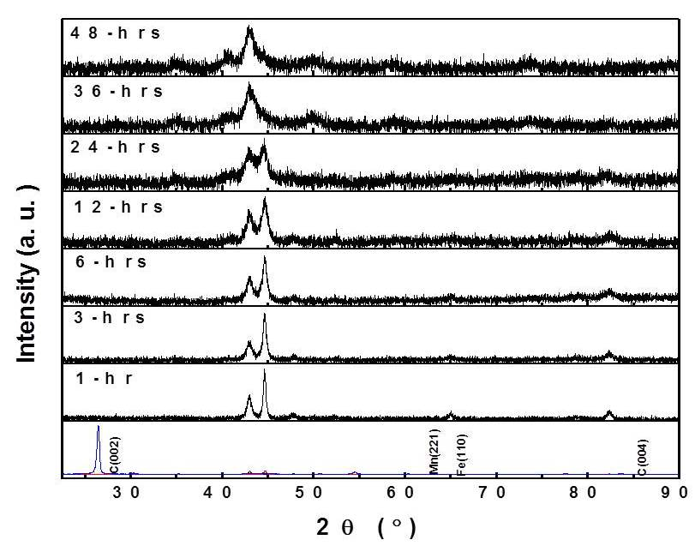

**Fig.1:** XRD profiles of Fe47.5Mn47.5C5 mechanically alloyed as a function of milling times.

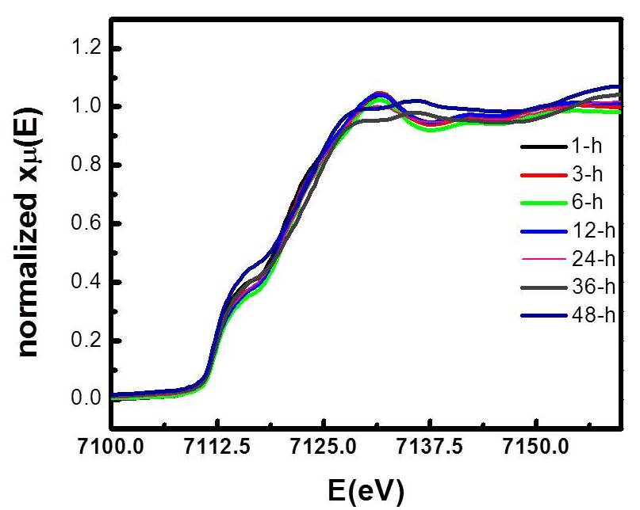

**Fig.2:** The EXAFS spectra of Fe47.5Mn47.5C5, each line represents the processing time.

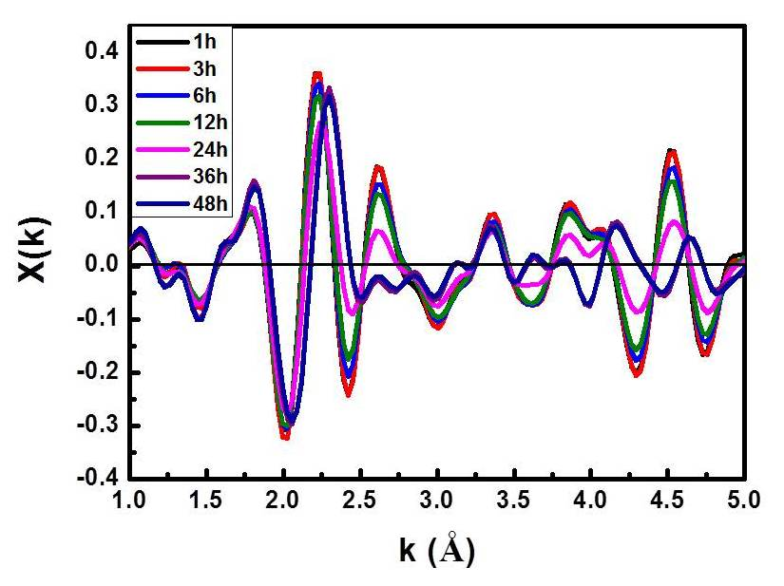

**Fig. 3:** The k-weighed EXAFS spectra of 1-hr to 48 hrs milling.

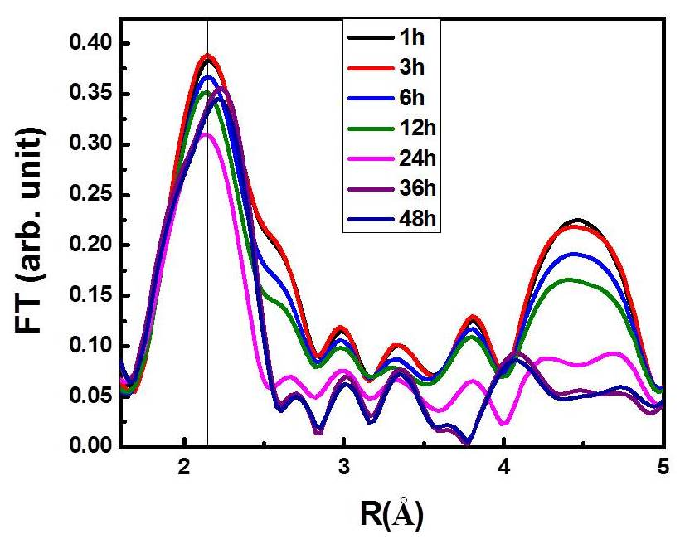

**Fig. 4:** Fourier transform of EXAFS spectra for Fe47.5Mn47.5C5 alloys measured at Fe K edge as a function of milling times.

The decrease of the amplitude before 36 hours indicates that the fracture was dominant. After 36 hours milling, the phase was shifted significantly. This indicates that the Mn and C atoms were diffused into the Fe structure and new materials were produced during this process. The amount of the new alloy increased as the processing time 36 hrs and afterword, but for 36- and 48 hrs milling the alloys were look like stabled.

**Fig. 4** shows that the Fourier (FT) of EXAFS spectra measured at Fe K-edge. The radial atomic density has been seen in spectrum FT. In the Figure**,** the magnitude of the first peak in the

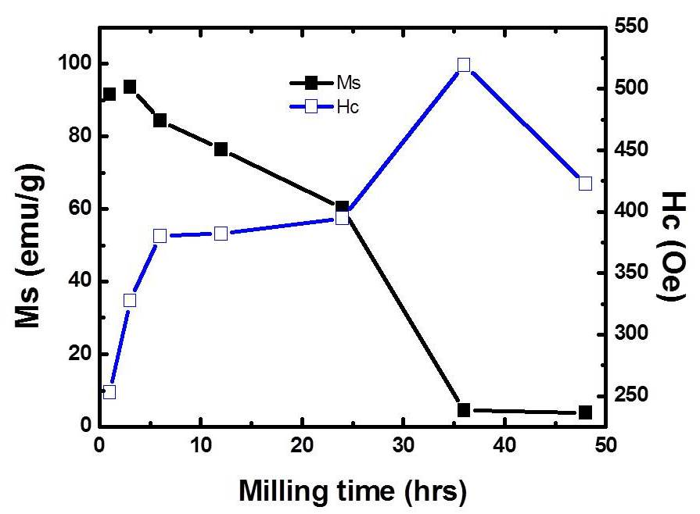

**Fig. 5:** Variation of magnetization and coercivity for Fe47.5Mn47.5C5 alloys as a function of milling times.

Fourier transformed spectrum decreased gradually as the processing time increased. This suggests that the number of Fe-Fe direct bond decreased due to both the fracture of crystalline and the alloying with other kind atoms. The short and long range orders were reduced gradually. The spectrum around of 2.2 A have changed for 36- and 48 hrs, it mean for the milling time have occurred the new phase. At 4.5 Å, the spectrum have changed for 36-, and 48 hrs, the new phase have occurred. In 36 hrs milling and after, both short and long range order are changed in amplitudes and phases. It means there is a huge change in local structure.

The magnetic saturation (*Ms*), and the Coercivity (*Hc*) are found from the hysteresis loop depend strongly on milling times and the C content. **Fig. 5** shows that *Ms* is decreased continuously as the milling times increased. Magnetization rapidly decreased until 24 hrs, but after 36 hrs milling the graph is flat to 48 hrs with *Ms* is 1 emu/g, it means there is transition from Fe grains to the Fe47.5Mn47.5C5 grain. This variation could come from the dilution of magnetic lattice of Fe by Mn and C with increasing milling time. On the other hand, the coercivity (*Hc*) is increased until 36 hrs, then at 48 hrs the coercivity (*Hc*) is decreased because the sample tend go to single domain, so the coercivity drop to smaller. The increase of *Hc* could be attributed to crystallite size reduction for Fe. The coercivity (*Hc*) is reaching a maximum value of approximately 550 Oe after 36 hrs, then it reduce to 400 Oe after 48 hrs milling.

1. Conclusions

The relatively new phase of Fe-Mn-C alloy is explicitly shown in the EXAFS spectra by the variation of amplitude and phase between 36- and 48 hrs milling times. The significant change of the structural phase revealed that new atom neighbors, the atom central Fe substituted by Mn and C atoms were increased during the MA process. The magnetic saturation (*Ms*) is decreased in long milling times as effect of crystallite size decreased. The coercivity (*Hc*) is increased until 36 hrs milling as effect of decreased of grain then it is decreased to 48 hrs milling because of single domain is growth as an effect of the carbons.

1. Acknowledgments

The research was supported by the Community Service Centre - Mercu Buana University (Grant No: 02-5/01/B-SPK/VIII/2016).

References

1. A. Djekoun et. al., Structure and magnetic properties of Fe-rich nanostructured Fe100-X NiX powders obtained by mechanical alloying, Physics Procedia **2** (2009) 693–700.
2. C. Suryanarayana, C. C. Koch, Nanocrystalline materials–Current research and future directions, Hyperfine Interactions **130** (2000) 5–44.
3. Gema González et. al., Mechanical Alloying of FeCoCr, Revista Latinoamericana de Metalurgia y Materiales 2011; **31** (1): 64-70.
4. C. Suryanarayana, Mechanical alloying and milling, Progress in Materials Science **46** (2001) 1-184
5. I. Chicinaş, Soft magnetic nanocrystalline powders produced by mechanical alloying routes, Journal of Optoelectronics and Advanced Materials **8**, No. 2, (April 2006) 439-448.
6. M. M. Rico et al., Magnetic and Structural Properties of Mechanically Alloyed FexMn0.70—x Al0.30 (x = 0.40 and 0.45) Alloys, Physica Status Solidi (a) **189**, No. 3, (2002) 811–816.
7. Yong-Goo Yoo, Bingzhi Jiang, J.M. Greneche, Dong-Seok Yang and Seong-Cho Yu, Local structures of nanostructured (FexCo1-x )75C25 alloys, J. Magn. & Mag. Mat., **304** (2006) e715~e717.
8. Hongwei Shi, Debo Guo, Yifang Ouyang, Structural evolution of mechanically alloyed nanocrystalline FeAl intermetallics, J. Alloys Comp. **455** (2008) 207-209
9. R. Hasegawa, Present status of amorphous soft magnetic alloys, Journal of Magnetism and Magnetic Materials **215–216** (2000) 240-245.
10. Michael E. McHenry, Matthew A. Willard, David E. Laughlin, Amorphous and nanocrystalline materials for applications as soft magnets, Progress in Materials Science **44** (1999) 291-433.
11. V. Edon et al, Journal of Applied Physics 107, 09A321 (2010) 09A321-1-3.
12. Xing LU, Zuoxiang QIN, Yansheng ZHANG, Xingyu WANG and Fengxian LI, J. Mater. Sci. Technol., Vol. 16 No.3, 2000 pp. 297-301.
13. D. S. Yang, et al., EXAFS Study for a Magnetic Shape Memory Alloy Ni-Mn-Ga, Journal of the Korean Physical Society, Vol. 50, No. 4, April 2007, pp. 1062∼1067.